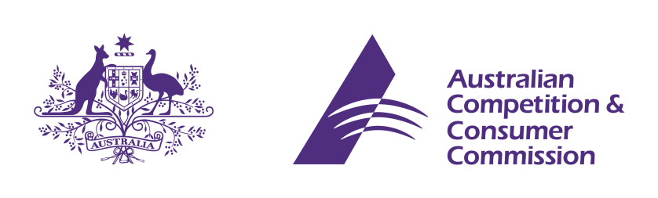

Statement of Issues: corrigendum

25 July 2014

Aquis - proposed acquisition of the Reef Casino
- The ACCC has identified factual errors that were present in the Statement of Issues when it was published on 3 July 2014. These errors are outlined below. The ACCC does not consider that these errors affect its assessment of the proposed acquisition, as set out in the Statement of Issues.

Existing Australian casinos
- Table 1 states that Treasury Casino in Brisbane has 861 gaming tables and 360 gaming machines. It also states that Sky city Darwin has 54 hotel rooms.
- As per the source for Table 1, it should read that Treasury Casino has 86 tables and 1360 gaming machines, while Sky city Darwin has 154 hotel rooms.
- Table 1 also states that Jupiters Townsville is owned by Colonial Leisure Group. It should read that Jupiters Townsville is currently owned by Echo Entertainment, but that Echo Entertainment has entered into an agreement with Colonial Leisure Group for the sale of Jupiters Townsville.
- Consequently, paragraph 20 should read “Echo currently owns the Star (NSW), Jupiters Gold Coast, Jupiters Townsville and Treasury (QLD) casinos. In January 2014 Echo announced an agreement to sell Jupiters Townsville to Colonial Leisure Group. Echo earns over 32% of total Australian casino revenues.”

Gaming machine venues in Cairns
- Table 2 (at page 17 of the Statement of Issues), states that the Reef Casino has 519 approved gaming machines. Table 2 should read that the Reef Casino is approved to operate 660 gaming machines. An amended version of Table 2 appears below.
Site Name | Approved Gaming Machines | % of Total Approved Gaming Machines
Aquis Resort (if developed) | 1500 | 39%
Reef Hotel Casino | 660 | 17%
Cazalys Cairns | 300 | 8%
Brothers Leagues Club Cairns | 170 | 4%
Fuller Sports Club | 90 | 2%
Fretwell Park | 60 | 2%
Centrals Trinity Beach Australian Rules & Sporting Club | 58 | 1%
Other (combined 33 venues) | 1056 | 27%
Total | 3894 | 100%
- Consequently, the third sentence in paragraph 76 should read “The proposed acquisition would have the effect of eliminating that competitor to the Aquis Resort, and increasing the percentage of the approved gaming machines in Cairns that are under Aquis’ control from 39% to 56%.”
- Similarly, the first sentence of paragraph 73 should read “As mentioned above at paragraphs 12 and 13, the Reef Casino presently has 519 gaming machines (with approval for 660) and the Aquis Resort has sought approval for 1500 gaming machines.”

Table 1 was reproduced from page 23 of the PricewaterhouseCoopers Independent Expert’s Report in respect of the proposed acquisition.
While the Reef Casino has approval to operate 660 gaming machines, it currently operates 519 gaming machines.
The Fuller Sports Club is owned by the Brothers Leagues Club Cairns.

