Statement of Issues
10 July 2014

Coles Supermarkets Australia Pty Ltd - proposed acquisition of four Progressive Supa IGA stores in Western Australia (including two liquor licences)

Introduction
Outlined below is the Statement of Issues released by the Australian Competition and Consumer Commission (ACCC) on the proposed acquisition of four Progressive Supa IGA stores in Western Australia (including two liquor licences) by Coles Supermarkets Australia Pty Ltd (Coles) from Progressive Trading Pty Ltd (Progressive).
In particular, Coles proposes to acquire from Progressive:
  - a Progressive Supa IGA supermarket located at Busselton, including a liquor licence (Busselton store)
  - a Progressive Supa IGA supermarket located at Halls Head, including a liquor licence (Halls Head store)
  - a Progressive Supa IGA supermarket located at Bunbury Forum (Bunbury Forum store)
  - a Progressive Supa IGA located at Dianella (Dianella store).
These four separate but related proposed acquisitions will be considered within this Statement of Issues. Together the target supermarkets are referred to as the target stores and the acquisitions as the proposed acquisition.
A Statement of Issues published by the ACCC is not a final decision about a proposed acquisition, but provides the ACCC’s preliminary views, drawing attention to particular issues of varying degrees of competition concern, as well as identifying the lines of further inquiry that the ACCC wishes to undertake.
In line with the ACCC’s Merger Review Process Guidelines (at www.accc.gov.au/processguidelines) the ACCC has established a secondary timeline for further consideration of the issues. The ACCC anticipates completing further market inquiries by 24 July 2014 and anticipates making a final decision on 14 August 2014. However, the anticipated timeline can change in line with the Merger Review Process Guidelines. To keep abreast of possible changes in relation to timing and to find relevant documents, market participants should visit the Mergers Register on the ACCC's website at www.accc.gov.au/mergersregister.
A Statement of Issues provides an opportunity for all interested parties (including customers, competitors, shareholders and other stakeholders) to ascertain and consider the primary issues identified by the ACCC. It is also intended to provide the merger parties and other interested parties with the basis for making further submissions should they consider it necessary.

Background
On 14 April 2014, the ACCC commenced a public review of the proposed acquisition.

The parties

The Acquirer: Coles Supermarkets Australia Pty Ltd
Coles is owned by Wesfarmers Limited, an Australian listed public company with diverse business operations in the retail, resources, insurance, chemicals, energy fertilisers and industrial sectors.
Coles is a leading food, liquor and convenience retailer, with a presence in every Australian state and territory. Coles currently has a total of 756 supermarkets across Australia (85 of which are in Western Australia) and 810 liquor stores across Australia (102 of which are in Western Australia).

The Vendors

Progressive Trading Pty Ltd
- Progressive is an IGA Banner Group consisting of eight stores in Western Australia, four of which are subject to the proposed acquisition. Progressive is 45.4% owned by Metcash Trading Ltd (Metcash), 27.3% owned by BMS Retail Group Pty Ltd, and 27.3% owned by Mr Dominic Oliveri (Chief Operating Officer of Progressive).
- Coles proposes to acquire the four Western Australian Supa IGA supermarkets identified at [2] above, which are currently operated by Progressive.

Metcash Trading Limited
- Metcash is an ASX-listed marketing, wholesaling and distribution company that services independent supermarket, liquor and hardware retailers. Metcash is a wholesaler to independent supermarkets under the IGA brand (including Supa IGA), and to liquor retailers under various national brands, including Cellarbrations, IGA Liquor (formerly IGA Plus Liquor), and Bottle-O. Metcash provides marketing support and other services to these supermarkets and liquor retailers. In some cases it also owns an interest in the retailer.

Other industry participants
- Woolworths Limited (Woolworths) is Australia’s largest grocery retailer. It operates over 800 supermarkets across Australia. It also owns liquor retailers Beer Wine Spirits (BWS) and Dan Murphy’s.
- Foodworks is the trading brand for Australian United Retailers Limited (AURL), an independent retail supermarket group. AURL has approximately 650 supermarkets, food and convenience stores across Australia, with 400 of these operating under the “Foodworks” brand. In Western Australia, AURL operates both “Foodworks” and “Farmer Jacks” branded supermarkets, with Farmer Jacks being larger format stores, with a focus on fresh produce, meat and deli.
- ALDI Australia is a privately-owned global supermarket operator that entered Australia in 2001. It has over 300 stores across New South Wales, the Australian Capital Territory, Queensland and Victoria. In February 2013, ALDI announced plans to expand its operations into South Australia and Western Australia. Recent media releases from ALDI have suggested that it plans to open around 70 stores in Western Australia, but there is no indicative timeframe as to the date of any store openings.
- ALDI can be characterised as a limited assortment discounter. Limited assortment discounters emphasise private label products, do not provide the same depth of range as full-line supermarkets (such as Woolworths and Coles) and are generally smaller stores.

The transaction
- Coles entered into an agreement with Metcash and Progressive in relation to the proposed acquisition. After the acquisition, the target stores would be converted to Coles-branded supermarkets.

Market inquiries
On 14 April 2014 the ACCC commenced market inquiries regarding the proposed acquisition. A range of interested parties provided responses.

The future with and without the proposed acquisition
Section 50 of the Competition and Consumer Act 2010 (the Act) prohibits mergers or acquisitions that would have the effect or be likely to have the effect of substantially lessening competition in a market. In assessing a proposed acquisition pursuant to section 50 of the Act, the ACCC considers the effects of the acquisition by comparing the likely future competitive environment post-acquisition if the acquisition proceeds (the “with” position) to the likely future competitive environment if the acquisition does not proceed (the “without” position) to determine whether the proposed acquisition is likely to substantially lessen competition in any relevant market.
- The ACCC’s preliminary view based on its market inquiries to date is that, without the proposed acquisition, Progressive is likely to continue trading in the target stores. Alternatively, the target stores may be acquired by an alternative independent supermarket operator. On this view, the target stores would continue to operate as independent supermarkets in the local markets absent the proposed acquisition.
The ACCC invites comments from market participants on its proposed future with and without the proposed acquisition. In particular market participants may wish to comment on:
- The extent to which the target stores are likely to be viable as independent supermarkets, either under current ownership or under the ownership of an alternative independent buyer.
- Whether there are, or could be, other potential acquirers of one or more of the target stores and the likely timeframes for any such acquisition.

Areas of overlap
The ACCC considers that the key areas of competitive overlap between the parties to the proposed acquisition are:
supermarket retailing
takeaway liquor retailing
wholesale acquisition of products sold in supermarkets
wholesale acquisition of takeaway liquor products.

Market definition

Local markets for supermarket and takeaway liquor retailing
- The ACCC’s preliminary view is that the relevant local retail markets for assessing the competition effects of the merger are as follows:
  - local markets for supermarket and takeaway liquor retailing in the area surrounding the Busselton store
  - local markets for supermarket and takeaway liquor retailing in the area surrounding the Halls Head store
  - a local market for supermarket retailing in the area surrounding the Bunbury Forum store
  - a local market for supermarket retailing in the area surrounding the Dianella store.

Local retail supermarkets markets: geographic dimension
- Consistent with past reviews of supermarket acquisitions in urban areas, as a starting point the ACCC has considered the impact of the proposed acquisition in the local markets by assessing overlap and competitors within 3-5km of the target stores.

Local retail supermarkets market: product dimension
- Consistent with its findings in previous matters, the ACCC’s preliminary view is that the product dimension of the relevant market is the retail supermarket market.
- The ACCC’s preliminary view is that specialist retailers are not sufficiently close substitutes to supermarkets to be included in the relevant market.
- The ACCC’s preliminary view is that not all supermarkets are equally close substitutes for each other. The ACCC considers that the closest constraint on a supermarket at the target site would be likely to come from other full-line supermarkets in the local area, rather than from limited assortment discounters and convenience oriented supermarkets. The ACCC will comment on the relative constraint imposed by these different types of supermarkets in the competition analysis below.

State-wide markets
- The ACCC also considered the following state-wide (Western Australia) markets to be relevant to assessing the proposed acquisition:
  - state-wide markets for supermarket and takeaway liquor retailing
  - a state-wide market for the wholesale acquisition by supermarket retailers and wholesalers of products sold in supermarkets
  - a state-wide market for the wholesale acquisition by takeaway liquor retailers and wholesalers of takeaway liquor products.
The ACCC invites comments from market participants on its proposed definition of the relevant markets.

Statement of issues
For the purposes of this Statement of Issues, the issues in this matter are divided into two categories, 'issues that may raise concerns' and 'issues unlikely to pose concerns'.

Issues that may raise concerns – local markets for supermarket retailing
- Paragraphs [30] to [36] discuss the ACCC’s approach to assessing the competitive effects of the proposed acquisition in each local supermarket market. Particular features of each local market are discussed from [37].
- The ACCC is concerned that the proposed acquisition would replace the differentiated offer of Progressive Supa IGA stores with the offer of Coles, which is already present in each local market. The four Progressive Supa IGA stores have a differentiated promotion, product range and service offering which represents a competitive response to rival supermarket chains and provides additional choice to consumers. In addition, the proposed acquisition would remove the only independent full-line supermarket in the Busselton and Bunbury local markets. Given the markets are characterised by high barriers to entry, new entry at a sufficient scale to replace the lost competitive tension is unlikely.

Removal of Progressive Supa IGA as a competitor to Coles
Supa IGA supermarkets are generally classed as ‘full-line’ supermarkets, which aim to fulfil the needs of customers doing their ‘weekly shop’ in addition to the needs of those doing a ‘top-up shop’. The ACCC’s market inquiries indicate that Supa IGAs have a product range as broad as Woolworths and Coles. Some market participants have submitted that Supa IGAs have the ability to tailor their range to the local market better than either Coles or Woolworths (discussed further at [42] below). The proposed acquisition will remove the unique product offerings of the target stores.
The ACCC understands that Supa IGA supermarkets have a broader range of promotions than IGA supermarkets, and they compete with Coles and Woolworths on the basis of these specials (as part of their differentiated offer). The proposed acquisition would remove the Supa IGA promotional cycle from each local market except for the Dianella local market.
The ACCC is continuing to consider the extent to which the target stores’ product range and promotions have a real and meaningful effect on local competition. The ACCC is also considering whether there is potential for an alternative buyer to acquire one or more of the target stores and compete with Coles and Woolworths in the local markets.
The ACCC is also considering the competitive constraint that will remain on Coles in each local market after the proposed acquisition. In this respect, the ACCC considers smaller supermarkets (such as smaller format IGAs) are less likely to constrain Coles, compared to larger supermarkets. Smaller supermarkets are generally focused on convenience-based offerings with a smaller product range. Consumers are likely to purchase from these smaller supermarkets for ‘top-up shops’, rather than for their weekly shop.
- Some market participants have raised concern that the proposed acquisition would reduce choice available to consumers in each local market. Where a target store has an offer differentiated from its local competitors, it provides choice to consumers. The proposed acquisition would replace any such differentiated offer with the offer of Coles, which is already available in each local market.

Barriers to entry
The ACCC’s market inquiries suggest that there are high barriers to entry in local supermarket markets. In particular, some market participants have identified the following factors as barriers to entry in the local markets surrounding each of the target stores:
  - there are already several supermarkets in the local market
  - there are no other sites available or coming up for development in the next few years that are suitable for a full service supermarket
  - there are high capital costs for developing a new full service supermarket, as well as high strategic risks associated with entering an established area well-served by existing supermarkets.

Busselton market for supermarket retailing
Busselton is a regional hub approximately 220km south of Perth and forms part of the Cape region of South West Western Australia.
The Busselton store operated by Progressive is located in a relatively new shopping centre (opened December 2003) at 30 Kent Street, in central Busselton. It sells a full range of supermarket products, including fresh produce, with a bakery, delicatessen, meat and seafood counter. Progressive also has a pending liquor licence at the Busselton store location, discussed below at [62-65].
- The following table shows the supermarkets in Busselton.
Table 1: Supermarkets in Busselton
Supermarket | Selling floor area (m²)
Busselton Progressive Supa IGA | 3068
Coles Busselton | 2124
Woolworths Busselton | 1900
Woolworths Busselton (Kent St) | 3220
Supermarkets smaller than 1000m²
IGA Busselton | 506
IGA Geographe | 550

- The location of these supermarkets is shown in the following map.
Map 1: Busselton
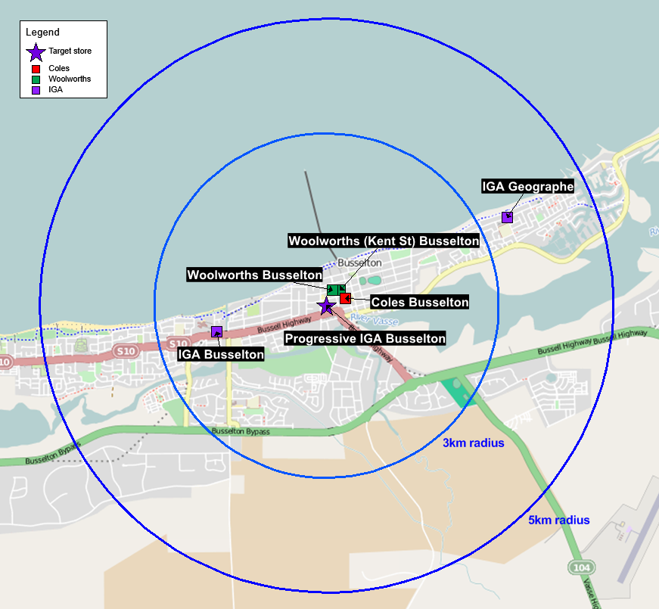
Following the proposed acquisition of the Busselton store, Coles would own two out of four supermarkets with a selling floor area of over 1000m² within a 3km radius and within a 5km radius. Woolworths would be the only competing operator of such supermarkets. The proposed acquisition would remove the only Supa IGA from Busselton.
Market participants have submitted that the Busselton store is the only large supermarket that sources from local producers. The ACCC understands from its market inquiries that the Busselton store stocks a variety of local products from regional areas, such as milk and cheese products, which are not available in Coles or Woolworths (although some of these products may be available from other stores in the area). This market feedback suggests the Busselton store has a differentiated offer from Coles and Woolworths, at least to some extent.

Halls Head market for supermarket retailing
- Halls Head is a coastal suburb of Mandurah, immediately west of Mandurah’s central business district. Mandurah is a city approximately 75km south of Perth.
- The Halls Head store operated by Progressive is located at the Centro Shopping Centre at 14 Guava Way, Halls Head. It sells a full range of supermarket products, including fresh produce, with a bakery, delicatessen, meat and seafood counter. Progressive also has a liquor store attached to the Halls Head store, discussed below at [66-68].
- The following table shows the supermarkets in Halls Head.
Table 2: Supermarkets in Halls Head
Supermarket | Selling floor area (m²)
Halls Head Progressive Supa IGA | 2770
Coles Mandurah Forum | 2319
Coles Erskine | 2189
Woolworths Mandurah Forum | 2909
Woolworths Mandurah Central | 1750
Woolworths Miami Plaza | 2175
Foodworks Halls Head | 1500
IGA Seascapes | 1000
Supermarkets smaller than 1000m²
IGA Halls Head (Old Bridge) | 460
IGA Mandurah | 800
IGA Miami | 500

- The location of these supermarkets is shown in the map below.
Map 2: Halls Head
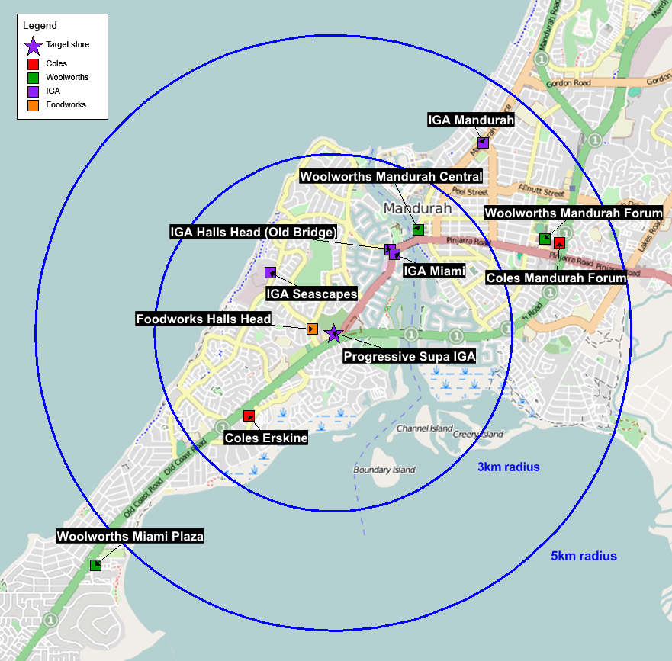
Following the proposed acquisition of the Halls Head store, Coles would own two out of five supermarkets with a selling floor area of at least 1000m² within 3km radius, and two out of eight such supermarkets within approximately 5km radius (including Woolworths Miami Plaza). The proposed acquisition would remove the only Supa IGA from Halls Head.
While the proposed acquisition would remove the Supa IGA promotional cycle and Progressive Supa IGA product range from the Halls Head local market, Foodworks Halls Head would remain as a full-line independent supermarket. The ACCC understands that Foodworks differentiates itself from Coles and Woolworths by focussing on fresh produce, meat, and deli products. However, this Foodworks is smaller than the target Supa IGA.

Bunbury market for supermarket retailing
- The city of Bunbury is a regional city about 190km south of Perth.
- The Bunbury store operated by Progressive is located at the Bunbury Forum shopping centre on Sandridge Road, Bunbury. It sells a full range of supermarket products, including fresh produce, with a bakery, delicatessen, meat and seafood counter. It has no liquor licence.
- The following table shows the supermarkets in Bunbury.
Table 3: Supermarkets in Bunbury
Supermarket | Selling floor area (m²)
Bunbury Progressive Supa IGA | 2146
Coles Bunbury Centrepoint | 2738
Coles South Bunbury | 1949
Woolworths Bunbury Forum | 2785
Woolworths Bunbury Plaza | 1493
Woolworths South Bunbury | 1740
Supermarkets smaller than 1000m²
IGA Bunbury | 700

- The location of these supermarkets are shown in the map below. The map also shows the Bunbury Fresh Food Market (2000m² selling floor area).
Map 3: Bunbury
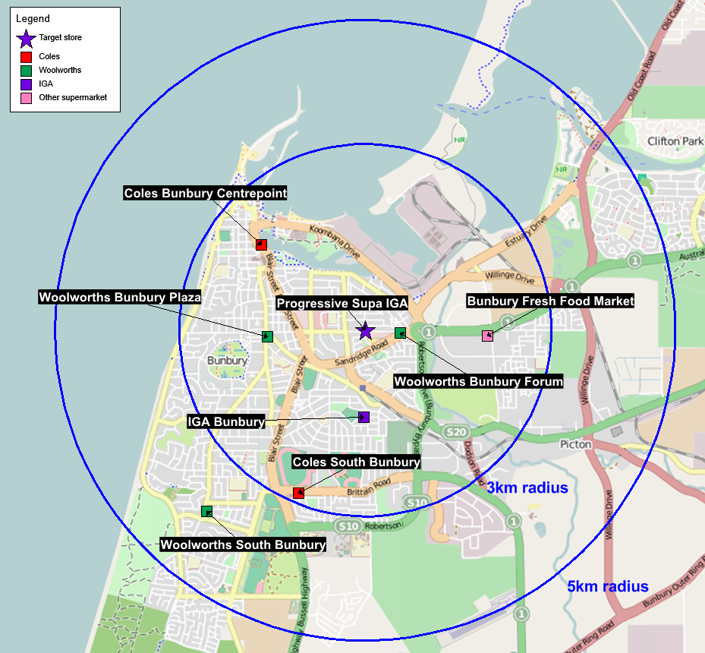
- Following the proposed acquisition of the Bunbury store, Coles would own three out of five supermarkets with a selling floor area of more than 1000m² within a 3km radius, and three out of six such supermarkets within a 5km radius. The proposed acquisition would remove the only Supa IGA from Bunbury, which may leave Woolworths as the only competing operator of such supermarkets.
- While the Bunbury Fresh Food Market has a strong focus on fresh produce, the ACCC understands that it may not have all the features of a full-line supermarket. Supermarkets offer customers the ability to purchase grocery and household items across multiple product categories and departments, and in this regard, they can be distinguished from fresh food market retailers such as Bunbury Fresh Food Market. The ACCC is continuing to consider the competitive constraint provided by Bunbury Fresh Food Market.

Dianella market for supermarket retailing
- Dianella is a suburb of Perth, within the local government area of the city of Stirling.
- The Dianella store operated by Progressive is located in the Centro shopping centre, 366 Grand Promenade, Dianella. It is a full-line supermarket, including fresh produce, bakery, delicatessen, meat and seafood counter. It has no liquor licence.
- The following table shows the supermarkets in Dianella which have a selling floor area of more than 1000m². There are also 11 IGAs with a selling floor area of less than 1000m² which are not shown in the table or map below.
Table 4: Supermarkets in Dianella
Supermarket | Selling floor area (m²)
Dianella Progressive Supa IGA | 3042
Coles Balcatta | 2369
Coles Flinders Square | 2048
Coles Inglewood | 1935
Coles Maylands | 1838
Coles Mirrabooka | 3076
Coles Morley | 2269
Coles Noranda Square | 1965
Coles North Perth | 1893
Woolworths Dianella | 2585
Woolworths Dog Swamp | 2334
Woolworths Mirrabooka | 3190
Woolworths Morely | 2656
Woolworths Mount Hawthorn | 2081
Woolworths Noranda | 2963
Farmer Jacks Morley | 2000
IGA Inglewood Fresh | 1120
Supa IGA Mirrabooka | 1200

- The locations of these supermarkets are shown in the map below.
Map 4: Dianella
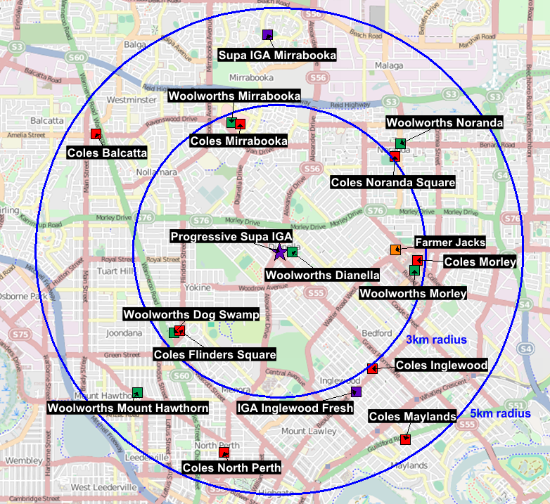
- Following the proposed acquisition of the Dianella store, Coles would own five out of ten supermarkets (including Coles Noranda Square) with more than 1000m² selling floor area within a 3km radius, and nine out of 18 such supermarkets within a 5km radius. The proposed acquisition would reduce the number of Supa IGAs from two to one within 5km of the target store (the closest other Supa IGA is more than 3km from the target store).
- The ACCC is considering the extent of any competitive constraint that may be provided by Supa IGA Mirrabooka and the new Farmer Jacks in Morley, in addition to the constraint that would be provided by the Woolworths supermarkets in the area.
- The ACCC understands from its market inquiries that the Dianella Supa IGA has a dedicated section offering international foods, in particular a wide variety of imported European and continental foods.
The ACCC invites comments from market participants on the effect of the proposed acquisition on competition in each of the local supermarket markets. In particular market participants may wish to comment on:
- The extent to which the target stores contribute a retail offering that is differentiated from Coles, Woolworths and other independent supermarkets in the local markets.
- The extent to which customers value the price, promotions, service and product offering of the target stores, and make decisions about where to shop on the basis of those attributes.
- Details about the product range of the target stores, including the extent of its product range and whether it offers products that are not otherwise available in the local market.
- The likelihood of new entry of an independent full-line supermarket in the local markets should the proposed acquisition proceed.
- The extent to which Coles is constrained in each local market by remaining independent retailers such as the Foodworks in Halls Head, the Bunbury Fresh Food Market in Bunbury, the Supa IGA in Mirrabooka (Dianella market) and Farmer Jacks in Dianella.

Issues unlikely to pose concerns

Busselton market for takeaway packaged liquor retailing
- Progressive has received conditional approval for a liquor licence in the Busselton store. It is proposed that the acquisition would include the pending liquor licence. Coles would operate the liquor licence under its Liquorland banner.
- Coles does not currently operate any liquor outlets in the Busselton area, nor are there any liquor aisles within the Coles supermarkets in this area. Therefore the ACCC’s view is that Coles’ acquisition of the pending licence would represent new entry in the local liquor market.
- Woolworths has two BWS outlets within a 5km radius of the target, and there are three independent bottleshops in the same area.
As the proposed acquisition of this pending liquor licence by Coles represents new entry into the liquor retail market in Busselton, the ACCC’s preliminary view is that the transaction is unlikely to result in any substantial lessening of competition in the Busselton market for takeaway packaged liquor retailing.

Halls Head market for takeaway packaged liquor retailing
- Progressive has a liquor store within the Halls Head store. It is proposed that Coles will also acquire this liquor store and operate it as a Liquorland. The ACCC understands Coles already operates two Liquorland stores in nearby Mandurah (between 3km and 5km from the target site), but does not currently operate any liquor licences within 3km from the target site.
- There are several competing liquor stores within 5km of the target site, including four Woolworths stores (two BWS stores and two Dan Murphy’s) and five independent stores operating under various banner groups (Cellarbrations, Bottlemart, Cape Cellars, Liquorstax and Liquor Barons).
- Following the acquisition, Coles will own three of 11 major liquor stores within 5km of the target site. The ACCC’s preliminary view is that the Woolworths-owned liquor stores and the independent stores operating under banner groups will provide sufficient competitive constraint on the proposed Liquorland at the target site.
The ACCC invites comments from market participants on the effect of the proposed acquisition on competition in the local takeaway packaged liquor markets.

State-wide markets
- The ACCC’s market inquiries to date suggest that the volumes of groceries sold through the four target stores are such that the proposed acquisition is unlikely to have a material impact on the state-wide retail or wholesale markets with respect to supermarkets and/or liquor.
- In particular, Progressive will continue to operate stores in a number of suburbs in Western Australia (Armadale, Belmont, Innaloo, and Spearwood). There would also be 54 remaining Supa IGAs in Western Australia.
- As such, the ACCC’s preliminary view is that the proposed acquisition is:
  - not likely to affect competition in the state-wide supermarket retail market because it does not result in a reduction in the number of retail chains competing with Coles at a state-wide level
  - not likely to have a significant impact on the buying power and economies of scale available to other supermarkets having regard to the magnitude of the change in purchasing volumes.
- Further, the ACCC’s preliminary view is that the addition of two Coles-owned liquor stores in Western Australia is:
  - not likely to substantially lessen competition in the state-wide retail market for takeaway packaged liquor, given that the proposed acquisition will not remove any existing liquor store or chain of stores either directly or indirectly
  - not likely to substantially lessen competition in any wholesale acquisition market, as the proposed acquisition will only increase Coles’ buying power by a relatively small amount.
The ACCC invites comments from market participants on the effect of the proposed acquisition on competition in the state-wide (Western Australia) markets for:
- supermarket and takeaway liquor retailing
- wholesale acquisition by supermarket retailers and wholesalers of products sold in supermarkets
- wholesale acquisition by takeaway liquor retailers of takeaway liquor products.

ACCC's future steps
The ACCC will finalise its view on this matter after it considers market responses invited by this Statement of Issues.
The ACCC now seeks submissions from market participants on each of the issues identified in this Statement of Issues and on any other issue that may be relevant to the ACCC's assessment of this matter.
Submissions are to be received by the ACCC no later than 24 July 2014. The ACCC will consider the submissions received from the market and the merger parties in light of the issues identified above and will, in conjunction with information and submissions already provided by the parties, come to a final view in light of the issues raised above.
The ACCC intends to publicly announce its final view by 14 August 2014. However the anticipated timeline may change in line with the Merger Review Process Guidelines. A Public Competition Assessment for the purpose of explaining the ACCC's final view may be published following the ACCC's public announcement.

