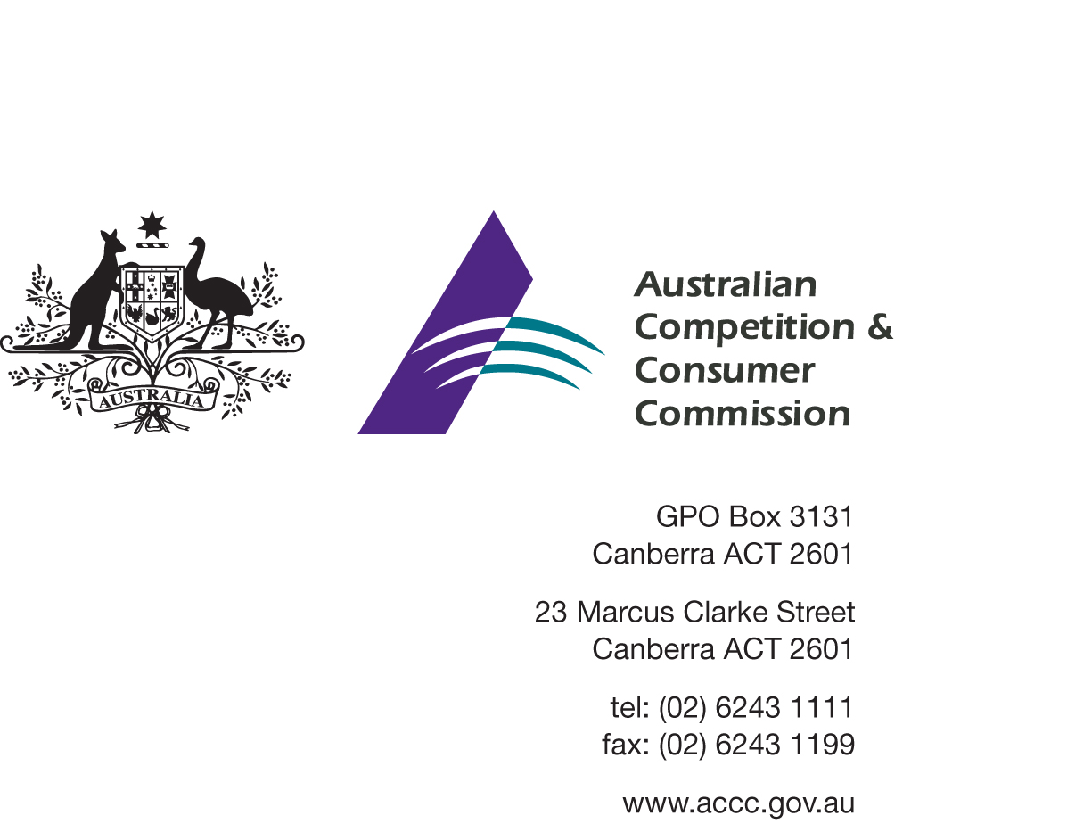Our Ref: 56192
Contact Officer: Tanya Hobbs
Contact Phone: 02 6243 1029

17 December 2014
Mr Simon Uthmeyer
Partner
DLA Piper
simon.uthmeyer@dlapiper.com
Dear Mr Uthmeyer

Etihad Airways PJSC & Alitalia applications for authorisation A91468 & A91469 - draft determination and interim authorisation
The Australian Competition and Consumer Commission (the ACCC) has issued a draft determination in respect of the applications for authorisation lodged by Etihad Airways PJSC & Alitalia on 6 November 2014. For the reasons set out in its draft determination, the ACCC proposes to grant authorisation for ten years. The ACCC has also decided to grant interim authorisation in respect of the applications.

Next steps
Once the ACCC issues a draft determination, the Applicant or any interested party may make a written submission and/or request that the ACCC convene a ‘pre-decision conference’.
If you wish to make a submission in response to the ACCC’s draft determination, please lodge your submission by 16 January 2015. “Submissions should be emailed to adjudication@accc.gov.au with the subject “A91468 & A91469 – Etihad Airways PJSC & Alitalia – submission”.
A pre-decision conference provides the opportunity for interested parties to make oral submissions in relation to the draft determination. Conferences are conducted informally and while legal or professional advisers are able to attend they are not entitled to participate in the discussion.
If you wish the ACCC to hold a pre-decision conference in relation to the draft determination you must notify the ACCC in writing by 16 January 2015
The ACCC will consider any submissions it receives, including any oral submissions made should a pre-decision conference be called, and will then release a final determination in relation to these applications.
Submissions will be placed on the ACCC’s public register subject to any request for exclusion. Please see the ACCC’s publication Guidelines for excluding information from the public register.

Timetable
The ACCC will continue to progress its assessment of the application in a timely manner. An updated indicative timetable is set out below for your information.
Indicative date | Stage in assessment process
6 Nov 2014 | Lodgement of application and supporting submission, including request for interim authorisation.
17 Dec 2014 | ACCC decision regarding interim authorisation and draft determination.
Dec 2014 – Jan 2015 | Public consultation on draft determination including any conference if called.
Jan – Feb 2015 | Final determination.
This letter has been placed on the ACCC’s public register. If you wish to discuss any aspect of this matter please do not hesitate to contact Tanya Hobbs on 02 6243 1029 or adjudication@accc.gov.au.
Yours sincerely
[SIGNED]

Gavin Jones
Director
Adjudication Branch

