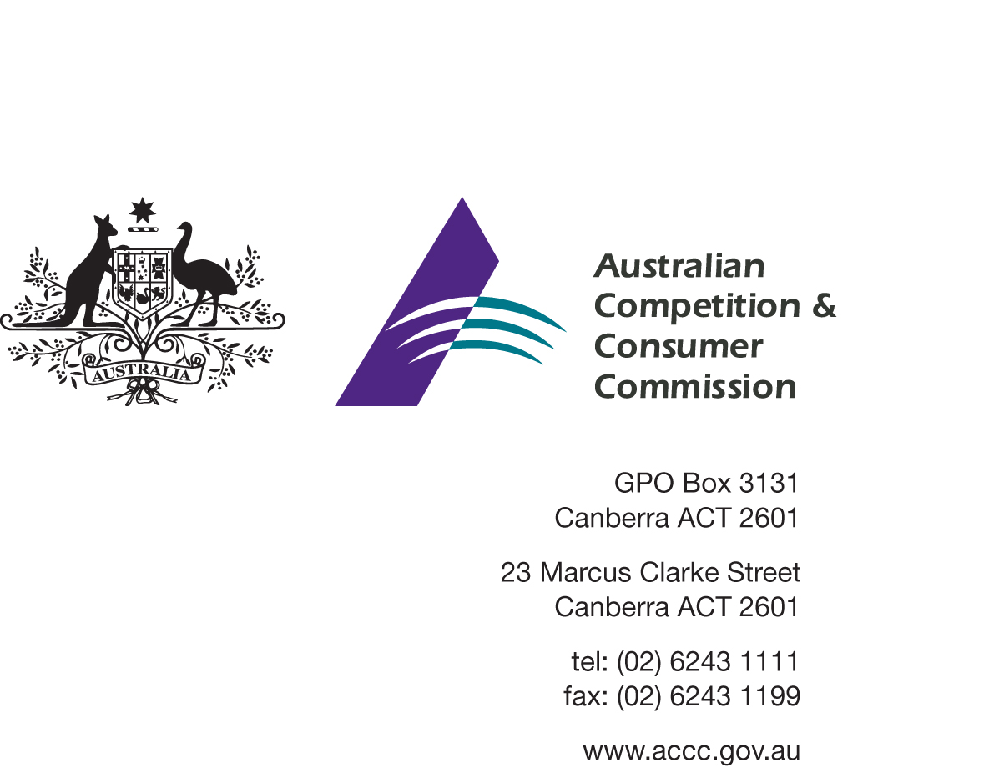Our Ref: 56245
Contact Officer: Tanya Hobbs, Georgina Brett
Contact Phone: 02 6243 1029, 03 9658 6439
19 November 2014
Anna Pritchard
Head of Legal - Competition
Qantas Airways Limited
annapritchard@qantas.com.au
Guo Lijun
General Counsel
China Eastern Airlines Corporation Limited
ztao@ceair.com
Dear Ms Pritchard and Mr Guo

Qantas & China Eastern applications for authorisation A91470 & A91471
– interested party consultation
I refer to the above mentioned applications for authorisation lodged with the Australian Competition and Consumer Commission (the ACCC) on 18 November 2014 by Qantas Airways Limited & China Eastern Airlines Corporation Limited (the Applicants).

Interested Party consultation
Please find enclosed, for your information, a copy of the letter the ACCC sent today to potentially interested parties as part of its public consultation process.
All publicly available submissions will be posted on the ACCC internet site at www.accc.gov.au/AuthorisationsRegister. Alternatively, at the end of the consultation period the ACCC can arrange for you to receive a copy of all publicly available submissions received in relation to the application.

Timetable
The ACCC will progress its assessment of the application in a timely manner. An indicative timetable is set out below for your information.
Indicative date | Stage in assessment process
18 Nov 2014 | Lodgement of applications and supporting submission.
19 Nov 2014 | Public consultation process begins.
19 Dec 2014 | Closing date for submissions on the applications for authorisation.
16 Jan 2015 | Applicants respond to issues raised in the public consultation process.
Feb/Mar 2015 | Draft determination.
March 2015 | Public consultation on draft determination including any conference if called.
April/May 2015 | Final determination.

Confidentiality request
I have considered your request that the confidential version of the supporting submission to the applications be excluded from the ACCC’s public register.
As you are aware, the ACCC is generally required under section 89 of the Competition and Consumer Act 2010 (the Act) to place documents provided to it in relation to an application for authorisation on the ACCC’s public register. The Act provides that a person submitting a document in relation to an authorisation application may request that the document or parts thereof be excluded from the public register by reason of the nature of certain information contained in the document.
As a person authorised to make a decision for and on behalf of the ACCC in relation to such a request, I advise that the confidential version of the supporting submission to the applications will not be placed on the public register.
This letter has been placed on the ACCC’s public register. I note that you also provided a public version of your supporting submission. This version will be placed on the public register in the form it was provided to the ACCC.
If you wish to discuss any aspect of this matter, please do not hesitate to contact Tanya Hobbs on 02 6243 1029 or adjudication@accc.gov.au.
Yours sincerely
[SIGNED]

Dr Richard Chadwick
General Manager
Adjudication Branch

