The ACCC’s Pilot Broadband Performance Monitoring & Reporting Program
Report on findings
September 2015

Version Control
11 September 2015 | Version 1

Contents
The ACCC’s Pilot Broadband Performance Monitoring & Reporting Program 0
Executive Summary 4
1. Introduction 8
1.1. Previous consultation 8
1.2. June 2014 Position Paper 8
2. Pilot Program 10
2.1. Purpose of the Pilot Program 10
2.2. Other monitoring programs in Australia 10
2.3. The consumer experience in Australia 10
2.4. Summary of the Pilot Program testing methodology 12
2.5. Technical approach 12
2.5.1. Hardware 12
2.5.2. Technology neutral 13
2.5.3. Metrics 13
2.6. Impact on volunteers 14
2.6.1. Summary of key learnings, challenges and solutions 14
2.7. Sample size and selection 14
2.7.1. Summary of key learnings, challenges and solutions 15
2.8. Volunteer recruitment and management 15
2.8.1. Summary of key learnings, challenges and solutions 15
2.9. Data analysis and reporting 16
2.9.1. Summary of key learnings, challenges and solutions 16
3. Summary of findings & observations 17
3.1. Addressing information asymmetry 17
3.2. Major findings of the Pilot Program 18
3.3. Downstream & upstream speeds 19
3.3.1. What is being tested? 20
3.3.2. Average downstream and upstream speeds by technology 21
3.3.3. Average downstream speed by technology and RSP 24
3.3.4. Average downstream speed by technology and hours of the week 28
3.3.5. Average downstream and upstream speed of NBN-based services 29
3.3.6. Conclusions about downstream and upstream speed test results 31
3.4. Latency 32
3.4.1. What is being tested? 33
3.4.2. Latency in Australia by technology and RSP 33
3.4.3. International latency (milliseconds) by technology and RSP 34
3.4.4. Correlation between domestic latency and downstream speed 36
3.4.5. Conclusions about latency test results 40
3.5. Video streaming 41
3.5.1. What is being tested? 41
3.5.2. Average bitrate reliably streamed by technology and RSP 42
3.5.3. Startup delay by technology and RSP 43
3.5.4. Conclusions about video streaming results 44
3.6. Web browsing 45
3.6.1. What is being tested? 45
3.6.2. Local website loading time by technology and RSP 46
3.6.3. International website loading time by technology and RSP 48
3.6.4. Website-specific observations 50
3.6.5. Conclusions about web browsing results 53
3.7. Packet loss 53
3.7.1. What is being tested? 53
3.7.2. Packet loss by technology and RSP 54
3.7.3. Conclusions about packet loss results 55
3.8. VoIP emulation (jitter) 56
3.8.1. What is being tested? 56
3.8.2. Jitter by technology and RSP 56
3.8.3. Conclusions about jitter results 58
3.9. DNS response times and failure rate 59
3.9.1. What is being tested? 59
3.9.2. DNS response times by technology and RSP 59
3.9.3. DNS failure rate by technology and RSP 61
3.9.4. Conclusions about DNS response times and failure rate results 62
4. Considerations for an ongoing program 63
4.1. Objectives of an ongoing program 64
4.1.1. Improving consumer information 64
4.1.2. Improving visibility over performance of fixed broadband access networks 64
4.1.3. Promoting effective competition 65
4.2. Funding for any ongoing BPMR program 65
4.3. RSPs involvement in program 66
4.4. Sample selection 67
4.4.1. Sample size 67
4.4.2. Constitution of the volunteer panel 67
4.4.3. Option 1: Restricting the volunteer panel to consumers on high speed networks 67
4.4.4. Option 2: Volunteer panel that is representative of current national broadband market, including NBN and legacy services 68
4.4.5. Conclusion 68
4.5. Metrics for testing performance 69
4.5.1. Conclusion 69
4.6. Reporting approach 70
4.6.1. Conclusion 71
4.7. Raw data 71
4.7.1. Option 1: Release raw data directly to the public 71
4.7.2. Option 2: Allow a third party testing provider to sell the raw data to interested parties 72
4.7.3. Conclusion 72
5. Enquiries and further information 72

Executive Summary
Since late 2013, the ACCC has consulted on the possible introduction of a fixed broadband performance monitoring and reporting (BPMR) program in Australia. The impetus for a BPMR program is borne out of a desire to promote competition and consumer outcomes by providing transparency over the quality of broadband services that are on offer to consumers via different technologies, wholesale access networks and retail internet service providers (RSPs).
Competition in the retail fixed broadband market in Australia is limited by an asymmetry of information between RSPs and consumers on service performance. This asymmetry of information also exists between RSPs, who have information about the performance of their own networks, but not their competitors’ networks. As a result, the lack of information about broadband performance: diminishes the likelihood of RSPs competing on service performance; increases the likelihood that consumers may be misled about (or misunderstand) the quality and capabilities of their service; and limits a consumer’s ability to select the most appropriate service for their needs. The prospects for competition in the retail fixed broadband market would be improved by addressing this information gap.
A BPMR program can be designed to address many of these concerns, by increasing the available information about service performance and quality, not simply price, and thereby delivering real benefits to both consumers and RSPs. The international experience lends considerable support to this course of action. Broadband monitoring programs have been established in the United Kingdom (2008), United States of America (2010), New Zealand (2010) and Singapore (2011), with Canada poised to commence reporting on its program in 2016. While the particular models adopted by each country differ, they all share common aims of improving the transparency of information and encouraging performance-based competition for broadband services.
The Pilot Program has provided:
- practical experience in running a broadband monitoring and reporting program in line with the ACCC’s specifications.
- valuable and reliable real world data to support the potential benefits that an ongoing program would deliver.
- some insights into the key factors that currently affect broadband performance in an Australian context.
In addition, the Pilot Program has demonstrated that:
- the principles outlined in the ACCC’s 2014 Position Paper establish a sound basis for an ongoing program
- probe-based, hardware testing works well in the Australian setting
- the Pilot Program provided results that were consistent with expectations regarding the performance of different technologies and experiences in other jurisdictions
- a BPMR program can be run efficiently
- relevant and useful data can be obtained that can be used to fulfil the objectives of educating and informing consumers, rewarding RSPs for efforts to improve services and informing policy decisions.
While the ACCC is not at the advanced stage of our international counterparts, we have undertaken considerable consultation with stakeholders on the potential framework for an ongoing BPMR program, as follows:
- August 2013: ACCC released consultation paper on a possible model for implementation of a fixed broadband monitoring and reporting program.
- October 2013: After receiving and considering submissions from stakeholders, the ACCC published an open letter expanding on its policy objectives.
- December 2013 to March 2014: closed consultation process held to enable key industry stakeholders to discuss their views and input with the ACCC.
- June 2014: ACCC released a Position Paper specifying the key attributes that any program that was ultimately implemented would need to have.
As a natural extension of the consultation process so far, the ACCC conducted a Pilot Program to test how a BPMR program would work in an Australia context, based on the principles established in the June 2014 Position Paper. The Pilot Program was run over a three month period for March, April and May 2015.
This report sets out the key findings from the Pilot Program with a particular focus on the technical and practical elements of introducing an ongoing BPMR program in Australia. Using the data from the Pilot Program we have sought to illustrate the factors which impact broadband performance. The key metrics focussed on for the Pilot Program (discussed at section 3) include:
- downstream/upstream speeds
- webpage load times
- video streaming performance
- latency
- packet loss
- VoIP emulation (jitter)
- DNS response times and failure rate.
The results for the metrics tested should be considered together rather than in strict isolation. The metrics, when considered together, depict factors that are important to a consumer’s overall broadband experience and can assist in assessing the comparative service performance of RSPs. End-user perceived performance is influenced by many components between the end-user device (e.g. home computer) and the source of the data being sent or received from another part of the network. In some cases it may be the access network which is the limiting factor, while in other cases it will be other components (such as the RSP network dimensioning or the capabilities of the end server) that are affecting performance.
It will be important in any ongoing BPMR program that consumers are provided with information that relates to their experience and the typical applications that they are likely to use. The analysis undertaken as part of the Pilot Program has revealed that some metrics may be more closely related to the end-user experience than others and their relevance to end-user experience may vary between applications, such that a metric may be relevant to one application but not to another. Where this is the case, it has been noted in the discussion of each metric in the body of the report so that it is clear how the metric results relate to typical end-user applications.
The major findings from the Pilot Program results were:
- A range of factors are relevant to broadband performance: The analysis demonstrates there are a range of technical elements that were tested that are relevant to broadband performance, with some being relevant to most consumers (e.g. downstream and upstream speeds and web-browsing performance), while others being more relevant to those who use specific applications or need to access data stored offshore (e.g. latency and packet loss). This information would help consumers select a service appropriate for their needs and budget, and to evaluate the likely performance of their existing services
- Downstream and upstream speeds: The analysis shows various methods of presenting downstream and upstream speed results, which provide information about the capabilities of different broadband technologies and how RSPs perform in relation to the technologies they offer. Comparing performance during peak and off-peak periods also provides useful information about how performance generally deteriorates during peak hours.
- Latency: Metrics other than speed may be relevant to the end-user experience for certain applications. Results for international latency are more likely to be of value for jurisdictions where consumers want to access substantial portions of data that is not hosted domestically. The differences in latency performance can be observable for these consumers, for example, in relation to internationally-based websites and online gaming.
- Web browsing performance: The analysis shows various methods of presenting web browsing results that provide information about how RSPs perform in relation to the technologies they offer. Comparing performance during peak and off-peak periods provides useful information about how performance generally deteriorates during peak hours.
- Other metrics, including packet loss and VoIP emulation (jitter): Comparing these metrics during peak and off-peak periods provides useful information about how performance generally deteriorates during peak hours. These metrics are relevant to the operation of specific applications (e.g. some time-sensitive applications) and poor performance in these metrics is likely to be noticeable by end-users when using certain applications.
This report of the Pilot Program has been written with policy-makers, consumer representative bodies and industry as the key intended audience. It currently replicates the form of information that is contained in the reports of some of the other international regulators testing broadband performance. This in turn reflects the type of data, in terms of depth and detail, which is likely to be required by RSPs and other third parties (such as industry groups, academics and policy-makers). However, in order to meet the objective of improving access to information for consumers, any such reporting in an ongoing program would ideally be supplemented by information that is targeted and accessible to consumers and which facilitates the broadest distribution of this information to consumers (discussed in section 4).
The ACCC’s experience of conducting the Pilot Program provides further confirmation that an ongoing BPMR program in Australia is a viable option that should be pursued. An ongoing program would offer measurable benefits to consumers and RSPs with robust and comparable information on the performance of fixed broadband services in Australia.
High quality broadband performance information is not currently easily available to consumers and will become particularly relevant for NBN consumers due to the heightened service performance expectations of the NBN. In addition, it will be a useful tool for verifying claims about speed performance, something that is expected to be a more prominent feature of NBN offers, which are marketed for specific speed tiers.
The following report sets out a summary of findings from the Pilot Program, discusses some of the issues experienced during the trial and the potential models for an ongoing program.

- Introduction
Since late 2013, the ACCC has been consulting on the possible introduction of a monitoring and reporting program that would provide visibility over the comparative performance of different fixed broadband access networks and retail internet service providers (RSPs), and give consumers reliable and independent information on which to base their broadband purchase decisions.
  - Previous consultation
The ACCC released a consultation paper on 14 August 2013 inviting comment on a possible model for implementation of a fixed broadband performance monitoring and reporting (BPMR) program. This paper outlined the policy rationale for such a program, noted similar international examples and sought views on questions of methodology and reporting approach. The ACCC proposed limiting the scope of any program to fixed-line broadband services, at least in the short term, on the basis that the testing methodology would not be suitable for mobile services and their inclusion would significantly increase the costs of implementing the program.
The ACCC received 20 submissions in response to the consultation paper, putting forward a range of views on the need for and preferred approach to broadband performance monitoring.
After considering submissions in response to the consultation paper, the ACCC published an open letter on 29 October 2013 expanding on its policy objectives and responding to some of the issues raised in stakeholder submissions.
Following the release of the open letter, the ACCC conducted a ‘closed’ consultation process from December 2013 through March 2014. This gave key industry stakeholders the chance to discuss their views with the ACCC in more detail and to provide further input on specific issues associated with the design and implementation of a broadband monitoring and reporting program.
  - June 2014 Position Paper
The ACCC released a Position Paper on 4 June 2014 (Position Paper) that concluded the consultation process to date and specified the key attributes that any program implemented in the future would need to have.
These attributes are set out in section 3 of the Technical Appendix (Appendix A) to this report and include:
- technical approach
- impact on volunteers
- sample size and selection
- volunteer recruitment and management
- data analysis
- reporting approach.
In addition, the Position Paper set out the objectives that an ongoing program would seek to achieve:
- improving consumer information: give consumers independent and reliable information on fixed broadband service performance to assist them in their purchasing decisions.
- providing visibility over the performance of fixed broadband access networks: including those operated by NBN Co and retail broadband services offered by RSPs to consumers over those networks
- promoting effective competition: on the basis of service performance between RSPs
These objectives are considered in more detail in section 4 of this report and are a useful starting point from which to consider both the results of the Pilot Program and the case for an ongoing program.
As a natural extension of the ACCC’s work in pursuing an ongoing program, the ACCC recently completed a Pilot Program which adopted the attributes previously espoused in the June 2014 Position Paper. The three month Pilot Program was conducted in Melbourne with a particular focus on the technical and practical elements of introducing an ongoing BPMR program. In section 3 below, the results of the Pilot Program are explored in detail with a particular focus on how these results could be of continuing benefit in an ongoing BPMR program.

- Pilot Program
This section sets out the purpose of the Pilot Program and aspects of its design that are useful to consider prior to analysing the actual results.
  - Purpose of the Pilot Program
The Pilot Program was undertaken as a proof of concept to inform the viability of implementing a comprehensive BPMR program in Australia, similar to ones that currently operate internationally. The Pilot Program enabled the ACCC to test whether the proposed broadband performance monitoring and reporting framework, as outlined in the June 2014 Position Paper, is likely to be achievable in the Australian fixed broadband market and whether any changes needed to be made to any ongoing program.
The Pilot Program provided the ACCC with practical experience of how a monitoring and reporting program would operate and to identify at an early stage any potential issues with the testing methodology.
  - Other monitoring programs in Australia
While there are several international examples of long-standing (and imminent) BPMR programs, a comprehensive and large-scale BPMR program has never been implemented in Australia using hardware-based testing equipment. The ACCC is aware that some providers have carried out performance testing on a small scale. The most recent example of this is the Netflix ISP Speed Index, which appears to be a software based program that launched in Australia in April 2015. The Netflix ISP Speed Index is limited to testing how RSPs perform in streaming Netflix videos but does not measure RSPs’ performance more generally, nor does it differentiate between technologies or geographies. In February 2014, the Department of Communications launched its MyBroadband website, which enables consumers to test their broadband speeds using a software based approach, similar to those available online.
  - The consumer experience in Australia
Consumer experience of broadband performance in Australia is a key focus of both the Pilot Program and consideration of an ongoing program. In practice, this means:
- identifying and measuring the key factors (or metrics) which contribute to a quality broadband experience, including the ability to make meaningful comparisons about broadband performance.
- considering what misconceptions and confusion may currently exist for many consumers regarding what may impact on the performance of their broadband service, including factors beyond an RSP’s or network provider’s control.
In the absence of access to information and improved consumer education regarding broadband performance, consumers are at a considerable disadvantage when it comes to understanding the services they already have and understanding the services that they might need in the future. For example, if consumers are able to develop a greater understanding of the broadband performance needed for certain common applications (such as online gaming, video streaming and website browsing), they will be better placed to select an appropriate service.
There is also a risk that in the absence of an improved understanding of broadband performance, consumers will pay for services they do not need and which do not improve their experience. When consumers pay for services they do not need (e.g. constant, very high download speeds when they do not need these speeds for the applications they use), there is also a greater risk they will not be aware of circumstances where their service is not being delivered at the standard for which they have paid. These risks create the possibility of a detrimental, inefficient spend by the consumer and a risk that RSPs are not incentivised to ensure consumers receive the services for which they have paid.
It is also an important aspect of any ongoing program that consumers have access to information regarding aspects of broadband performance that are outside of RSPs’ control, such as understanding the impact of in-home arrangements and in-home wiring (particularly for ADSL services), and how the decisions made by third parties (such as content providers) can sometimes affect the consumer experience.
An objective BPMR program can assist RSPs in confirming with their customers that certain aspects of the customer’s broadband performance are likely to be the result of these other factors and not the RSP’s service. For example, the end-user perceived performance is influenced by many components between the end-user device (e.g. home computer) and the source of the data being sent or received from another part of the network. In some cases it may be the access network which is the limiting factor, while in other cases it will be other components (such as the RSP network dimensioning or the capabilities of the end server) that are affecting performance.
It will be important in any ongoing BPMR program that consumers are provided with information that relates to their experience and the typical applications that they are likely to use. The analysis undertaken as part of the Pilot Program has revealed that some metrics may be more closely related to the end-user experience than others and that the relevance of the results to end-user experience varies between applications. For example, in relation to download speeds results, once the maximum speed has been achieved that is needed for a particular application to function fully, greater speeds do not result in improved end-user performance. Accordingly, the maximum speed consumers require from their service correlates to the type of applications they will be using and the speeds needed to access these applications.
Certain metrics may be relevant to some user applications but not others, depending on the protocols used for the applications. For example, the performance of real time services (such as voice-over-IP) can be improved via the use of protocols on managed networks to limit poor end-user experience, as compared with similar services provided ‘over-the-top’ on a ‘best efforts’ basis. Accordingly, the results for some metrics may not affect all applications equally, even though the function of the services may appear very similar to consumers. It will be important to any ongoing BPMR program that these differences are made clear to consumers. Within this report, the factors relevant to consumer experience have been noted in the discussion of each metric in section 3, so that it is clear how the metric results relate to typical end-user applications.
The ACCC considers the results from an ongoing BPMR program would offer considerable benefits to consumers regarding improving information about their broadband experience and needs. In reporting on the results of any ongoing program, the ACCC would seek to provide information to consumers that is practical and addresses some of the common factors that may be affecting broadband performance that are noted above. Consumers would be aided by being provided with clear information about what types of broadband services suit their needs, for example, what type of applications require what type of speeds and at what point certain speeds may be less relevant to their needs. In addition, the ACCC remains open to expressions of interest from industry and other parties regarding the best means of providing further advice to consumers. For example, RSPs providing consumers with more detailed advice as to which of their services would best suit their customer’s needs based on the data available through any ongoing BPMR program and using the data to verify claims they make to consumers about the quality of their services.
  - Summary of the Pilot Program testing methodology
The ACCC’s Position Paper specified the key attributes that any BPMR program implemented would need. These minimum requirements covered technical approach, the expected test sample, measures to minimise the impact of monitoring on volunteers, data processing and validation, and reporting.
The Pilot Program set out to test whether the Position Paper requirements were practical in the Australian fixed broadband market and to demonstrate what a BPMR program would and would not be able to show. Overall the ACCC’s Pilot Program maintained the same technical requirements established in the Position Paper, however, some aspects were necessarily different due to the nature of the Pilot Program. For example, the Pilot Program did not adopt the same sample size requirements that an ongoing program would and the selection and volunteer recruitment and management was handled in-house by the ACCC.
The ACCC approached a number of providers to submit proposals on providing a Pilot Program. Having considered the proposals, SamKnows (Testing Provider) and Comdate were selected to carry out the Pilot Program because their approach met all of the ACCC’s requirements. We note that SamKnows has built a global internet measurement platform and has significant experience around the world implementing similar programs for communications regulators and RSPs worldwide, including ongoing projects in the UK, US, Brazil, Singapore and more recently, Canada.
In addition to the summary provided below, a detailed description of the SamKnows methodology adopted for the Pilot Program is outlined in further detail in the Technical Appendix (Appendix A).
  - Technical approach
This section outlines the testing methodology adopted in the Pilot Program and provides an overview of the metrics selected and a description of what is being measured and why it is important.
    - Hardware
We adopted a hardware probe-based testing approach in the Pilot Program. The probes, which were provided by SamKnows, performed automated tests on a volunteer’s home connection according to a defined schedule throughout the day, including peak and off-peak times. The use of hardware probes eliminates many of the distortions caused by volunteers’ in-home network configurations (e.g. Wi-Fi and/or access devices).
Testing was based on traffic generated by the probes to simulate end-user behaviour rather than using existing end-user traffic under a passive monitoring approach. Testing was conducted between the end-user modem or router (located in Melbourne) and a test server located in Melbourne. For volunteers with higher monthly data caps, certain tests (i.e. downstream/upstream speeds) were also conducted to a test server located in Hong Kong.
    - Technology neutral
We adopted a test setup in the Pilot Program that was technology neutral and compatible with testing all forms of fixed broadband. The hardware probes were able to provide accurate information for services with speeds in excess of 100Mbps. A test setup that can test all fixed broadband may be particularly important in any ongoing program (depending on the model that is selected) as both legacy and NBN services would operate concurrently in the short to medium term as the NBN rollout progresses.
The testing company was able to use the results to identify when a volunteer had provided incorrect details about their broadband technology (e.g. when results showed higher speeds than what was expected for a particular type of technology). However, we primarily relied on volunteers to advise us of changes to their service configuration (e.g. changed broadband plans or churned to another RSP).
    - Metrics
The Pilot Program tested a range of metrics:
- downstream/upstream speeds
- webpage load times
- video streaming performance
- latency
- packet loss
- VoIP emulation (jitter)
- DNS response times and failure rate
Each of these metrics is summarised and considered in light of the Pilot Program results in section 3 of this report.
We note that the results for each metric have been aggregated in the Pilot Program as follows:
- Fibre and HFC services: the results reflect the average across a variety of speed plans available for each technology (e.g. for HFC services where it is typically capped at around 30 or 100Mbps, the results are averaged across both these services).
- ADSL services: the results reflect the average across a variety of line lengths and quality.
Furthermore, the results for HFC services reflect the HFC networks as currently configured. When the HFC networks move to the NBN they will be reconfigured, that is, current performance is not necessarily indicative of their future performance.
We consider that the metrics tested enabled useful data to be collected on fixed broadband service performance and the selected metrics are in line with those tested in similar programs overseas. The above metrics, especially when considered together, are useful measures of a consumer’s overall broadband experience and the relative comparative service performance of RSPs.
  - Impact on volunteers
One of the benefits of conducting a Pilot Program was gaining first-hand experience in dealing with volunteers and gaining insight into their interaction with the testing equipment and results.
The Pilot Program followed the specifications set out in the June 2014 Position Paper in relation to volunteers. The following requirements were adhered to in order to protect volunteers and ensure that testing did not have a negative impact on their broadband service performance:
  - The testing tool must be easy for volunteers to install and/or setup and must only require technical support from the program manager in limited circumstances.
  - To avoid disruption or degradation to volunteers’ broadband services, tests must only be performed when services are not being actively used.
  - The testing regime must not consume a large amount of data as this may increase costs for volunteers. The test setup should include a mechanism for tailoring the testing regime based on the volunteer’s subscribed data quota (e.g. to run a more limited suite of tests or to run tests less frequently where quota is an issue).
  - The testing tool must not log volunteers’ personal data and the testing company should have appropriate safeguards in place to ensure that security and confidentiality of personal data is maintained.
    - Summary of key learnings, challenges and solutions
In accordance with the above specifications, volunteers were provided with step by step instructions to install the hardware probes and only required technical support in limited circumstances (e.g. only when the probe was incompatible with a volunteer’s router settings). The feedback we received from volunteers indicated that the probes were easy to use and install.
To avoid disruption or degradation to volunteers’ broadband services, the hardware probes monitored home network traffic levels to ensure tests only ran when the volunteer’s internet was not being actively used. However, the probes did not monitor or record any personal information or browsing history.
The testing schedule adopted in the Pilot Program did not consume large amounts of data (approximately 5-7GB per month depending on the connection speed). As the testing company was able to easily tailor the test schedule based on the volunteer’s data cap, the probes were able to automatically conduct an additional set of tests for volunteers with high data caps.
Overall, the feedback from volunteers was very positive and demonstrated that the ACCC’s approach was successful in avoiding a negative impact on volunteers’ broadband service performance. The feedback from volunteers also confirmed that the above requirements aligned with their own expectations of what they would expect from this type of program.
  - Sample size and selection
The Pilot Program tested the services of approximately 90 volunteers located in Melbourne, covering a range of broadband technologies, RSPs and speed tiers.
The technologies tested included: asymmetric digital subscriber line (ADSL), NBN and non-NBN fibre-to-the-premises (FTTP), hybrid fibre coaxial (HFC). The sample of volunteers meant that we collected a range of results for 12 RSPs, which included three HFC providers, three FTTP providers and ten ADSL providers.
The primary purpose of the Pilot Program was to provide the ACCC with technical and practical experience of how a BPMR program would work. The results obtained from the trial were consistent with expectations regarding the performance of different technologies and experiences in other jurisdictions, and therefore likely to be representative of the broader Australian context. However, out of an abundance of caution, we have elected not to identify the RSPs sampled in the trial in order to avoid the potential for incorrect conclusions to be drawn without verification of the results by these RSPs.
    - Summary of key learnings, challenges and solutions
The Pilot Program reinforced the importance of sample size and selection as factors crucial to a successful ongoing program. In particular, the Pilot Program highlighted the need to obtain a representative group of volunteers for an ongoing program, to ensure that there was a statistically significant sample size for each service type and RSP being compared. It is only if a reliable sample size is achieved that an ongoing program would be able to allow meaningful and robust comparison between technologies, individual RSPs and speed tiers. This also goes to strategies for recruitment of volunteers to achieve a representative group, which is discussed in the next section.
  - Volunteer recruitment and management
Volunteers were recruited internally, mainly from within the ACCC, but with some involvement from the ACMA and the TIO and participation was strictly opt-in. We collected the broadband plan details of each volunteer and provided these to the testing company who processed each hardware probe to ensure it was unique to the volunteer. At no point was a volunteer’s identity disclosed to their RSP.
Volunteers did not receive monetary compensation in return for their participation in the Pilot Program but were provided access to detailed information about the performance of their internet connection via the testing company’s online dashboard.
As the Pilot Program was an internal program, the ACCC managed the distribution of hardware probes to volunteers while the testing company monitored the volunteer base to ensure that the probes remained active. We also handled feedback and provided technical support, in consultation with the testing company, for volunteers in the Pilot Program.
    - Summary of key learnings, challenges and solutions
Even on the relatively small scale of the Pilot Program, it was apparent that there is a general interest among individuals in better understanding their broadband service and a willingness to participate in a testing program. Although volunteer recruitment was largely internal to the ACCC, an ongoing program would need to be tailored to invite members of the public to volunteer to participate in testing. The recruitment of volunteers could come about through ACCC promotion and publicity, directing consumers to where they can sign up to an ongoing program. In addition cooperation with and assistance from the RSPs contacting their own customer base would be hugely beneficial to an ongoing program. In this way the ACCC, and RSPs, could target segments of the market that they particularly want to know about, or require further volunteers for in order to meet sample size requirements. Volunteer recruitment for an ongoing program could encompass both of these approaches, whether at the same time or as part of a staged approach.
  - Data analysis and reporting
The data obtained from the Pilot Program enables us to consider the kind of results and analysis that an ongoing program would deliver in the Australian context. However the data used in the Pilot Program is, by its nature, limited in certain ways. The sample size for the Pilot Program was relatively small – accordingly the data has been anonymised so that RSPs are not identified by name and are anonymised using numeric identifiers (e.g. RSP 1, RSP 2, RSP 3 etc.). In addition, RSPs have not been identified by the same numeric identifiers throughout the report (e.g. RSP 1 in one graph is not necessarily the same as RSP 1 in another graph). The data is nonetheless robust and, as noted above, the results obtained from the trial were consistent with expectations regarding the performance of different technologies and experiences in other jurisdictions, and therefore likely to be representative of the broader Australian context. The value of the data lies in its ability to demonstrate how similar information, gathered as part of a larger program, would promote competition and consumer outcomes. Section 3 outlines data that was collated, the kinds of comparisons that could potentially be made and why this information would be useful for competition and consumers.
For the purposes of the Pilot Program, the testing company converted the test data into a manageable format before providing it to the ACCC. The ownership of the Pilot Program raw data resides with the ACCC. While we do not propose to disclose the raw data for the Pilot Program, being an internal program, we would consider disclosing the raw data in any ongoing program.
Several of the overseas regulators with BPMR programs also have open data policies, where they release raw data as well as analytical reports providing commentary on some of the results.
    - Summary of key learnings, challenges and solutions
The results of the Pilot Program indicated that an ongoing program would generate large amounts of data that could be analysed and reported on as well as released separately as raw data. It would be the ACCC’s preference to consider releasing raw data as part of any ongoing program where the data is of a high quality and drawn from a statistically reliable sample. This is for the purposes of transparency but also to enable third parties to analyse and report on the data. The potential options for data analysis and reporting for a future program are considered in further detail in sections 4.6 and 4.7.
Potential ‘outliers’ in the data have not been removed in the analysis of the results from the Pilot Program (see section 3 of this report), however, in any ongoing program there would need to be further consideration in any finalised methodology of when, how and if outlying results should be removed. Any results presented in an ongoing program would likely benefit from a further validation process involving RSPs.

- Summary of findings & observations
This section provides an overview of the underlying reasons for the ACCC’s interest in pursuing an ongoing broadband monitoring program in Australia. The section also includes observations about the results of the ACCC’s Pilot Program in relation to each metric tested. The data from the Pilot Program illustrates the kind of results that could be obtained in an ongoing program and considers the relevance of this data for consumers, RSPs and third parties.
  - Addressing information asymmetry
The ACCC is of the view that the prospects for competition for the retail fixed broadband market in Australia could be improved by addressing the asymmetry of information between RSPs and consumers on service performance. There is currently no clear way for consumers to compare the performance and reliability of different broadband offerings prior to making purchasing decisions and entering into a contract. This information gap is potentially detrimental to consumers and competition.
Providing consumers with greater visibility of the average performance of broadband services will help address the information asymmetry and assist them in making more informed decisions at the pre-purchase stage, as well as enabling them to verify whether they are getting what they paid for.
Greater visibility of how RSPs are performing could also help address any market failure, including by providing incentives for RSPs to differentiate and compete on performance (and not just on price and included data allowance). In this regard, the ACCC consulted with other regulators in other jurisdictions with similar BPMR programs, who noted their programs appeared to have assisted in improving competitive outcomes for consumers, including through such means as RSPs using the reporting results in their advertising, changing their price/quality offerings to consumers in response to the performance results and working to improve performance. In addition, it was noted by a number of regulators that the results could also be used to establish the high service performance of many RSPs and to help consumers become more aware of the factors affecting service performance that are beyond an RSP’s control (such as those issues discussed earlier in section 2.3).
The information gathered from an ongoing program is also likely to be of interest to third parties, such as regulators, industry groups, academics, research organisation, the media and governments. These parties will be able to use this information to inform and strengthen their understanding of the broadband market in Australia, which could then inform the development and implementation of policy and regulation. For example, in international jurisdictions RSPs have relied on broadband testing results to verify both speed claims and statements of comparative performance against other RSPs in their advertising. Importantly, it is likely that any discussion and analysis of the broadband market by these third parties will help raise visibility and public debate on competition and/or consumer issues in the Australian broadband market, which would ultimately benefit end-users.
We consider that the Pilot Program demonstrates that a similar program implemented on a broader scale, and on an ongoing basis, could address some of the market failure issues discussed above.
As noted earlier, the ACCC’s three main objectives for a broadband monitoring program are:
- improving consumer information
- providing visibility over the performance of fixed broadband access networks
- promoting effective competition.
  - Major findings of the Pilot Program
In the next section we have used examples from the data collected in the Pilot Program to demonstrate how each of these objectives can be achieved by a BPMR program for the benefit of consumers, RSPs and third parties. To this end, sections 3.3 to 3.9 below discuss the Pilot Program results in relation to the following metrics (with further technical information available in the Technical Appendix (Appendix A)):
- downstream and upstream speeds
- latency
- video streaming
- web browsing
- packet loss
- VoIP emulation (jitter)
- Domain Name Service (DNS) response times and failure rate
The major findings were:
- A range of factors are relevant to broadband performance: The analysis demonstrates there are a range of technical elements that were tested that are relevant to broadband performance, with some being relevant to most consumers (e.g. downstream and upstream speeds and web browsing performance), while others being more relevant to those who use specific applications or need to access data stored offshore (e.g. latency and packet loss). This information would help consumers select a service appropriate for their needs and budget, and to evaluate and validate the performance of their existing services.
- Downstream and upstream speeds: The analysis shows various methods of presenting downstream and upstream speed results, which provide information about the capabilities of different broadband technologies and how RSPs perform in relation to the technologies they offer. Comparing performance during peak and off-peak periods also provides useful information about how performance generally deteriorates during peak hours.
- Latency: Metrics other than speed may be relevant to the end-user experience for certain applications. Results for international latency are more likely to be of value for jurisdictions where consumers want to access substantial portions of data that is not hosted domestically. The differences in latency performance can be observable for these consumers, for example, in relation to internationally-based websites and online gaming.
- Video streaming: The video streaming test results show that once a user’s speed meets the bitrates required to enable streaming of video at the desired level of quality, higher access speeds do not necessarily improve the video quality, particularly when the selected bitrate is the provider’s maximum bitrate (i.e. highest quality video) offered. The results also show that there is little difference in performance between the technologies if these technologies meet the minimum bitrate requirements of that particular video service. This information would help consumers interested in video streaming select a service appropriate for their needs and budget and to evaluate and validate the performance of their existing services.
- Web browsing performance: The analysis shows various methods of presenting web browsing results that provide information about how RSPs perform in relation to the technologies they offer. Comparing performance during peak and off-peak periods provides useful information about how performance generally deteriorates during peak hours. The analysis shows that end-user experience of particular websites can also be affected by the location of the web servers they are being sent to or changes to the website made by third parties.
- Packet loss: The analysis shows how packet loss results can provide information about how RSPs perform in relation to the technologies they offer. The results also show that packet loss increases during peak hours as networks are busier but the low levels of packet loss are unlikely to be noticeable by end-users. However, if packet loss results are higher than one or two percent, then users are likely to notice some deterioration in their broadband performance experience for some applications.
- VoIP emulation (jitter): The analysis shows how jitter results can provide information about how RSPs perform in relation to the technologies they offer. The results show that differences in jitter between RSPs are likely due to congestion in RSPs’ networks during peak hours. In the case of upstream jitter, variations between RSPs may be due to the implementation of the different technologies. However, the low levels of jitter observed in the Pilot Program results are unlikely to be noticeable by end-users.
- DNS response times and failure rate: The analysis shows how DNS results can provide information about how RSPs perform in relation to the technologies they offer. The results show that DNS response times and failure rates vary between RSPs and peak/off-peak hours, which are likely due to congestion in RSPs’ DNS caches during peak hours. While the Pilot Program results for DNS response times are unlikely to be noticeable by end-users, the results for DNS failure rates are likely to have a visible impact on some end-users’ experience. The Pilot Program results illustrate that DNS testing can inform meaningful comparisons between access technologies and RSPs, and provide useful differentiation of service performance characteristics for consumers and RSPs.
The following sections discuss each of these metrics in greater detail and include illustrated results based on the data from the Pilot Program.
  - Downstream & upstream speeds
This section discusses the Pilot Program results for downstream and upstream speeds, one of the concepts consumers are likely to be most familiar with as a factor relevant to broadband performance. The results generated from the Pilot Program for this metric demonstrate the kind of information that would ultimately be available for an ongoing program and how this would be useful for consumers, RSPs and other interested parties (such as consumer advocate organisations, academics and media organisations). The Pilot Program results confirm that downstream and upstream speeds testing will likely be able to inform meaningful comparisons between access technologies and RSPs, and provide useful differentiation of service performance characteristics.
For consumers, this information on downstream and upstream speeds could help them make more informed choices about whether the speed they are receiving meets their service needs and whether it is likely they will receive the service levels they expect from a particular provider. Consumers often use downstream speed to assess the performance of broadband services and generally understand that the downstream speed should be indicative of the maximum speed their broadband connection will be able to download data from the Internet. Some consumers also use upstream speeds to assess performance, particularly those consumers who frequently perform uploading activities (e.g. uploading content to social media platforms). However, consumers may not be aware that the downstream and upstream speeds available at a consumer’s premise vary by broadband technology, RSP and geographic location. Consumers who have a choice of different technologies and/or RSPs at their premises should have access to information that shows which technology and/or RSP best suits their needs.
For RSPs, information regarding download and upload speeds can help them to both verify their performance and enable them to have comparative data that is of interest to consumers on which they can compete. In a number of jurisdictions where there is broadband performance monitoring, RSPs used the download and upload speed testing results in advertising as a means of supporting advertising claims about the performance of their products. In other jurisdictions, it appears that RSPs have decided not to compete on quality but dropped their prices to reflect the nature of the service they are offering. In a number of jurisdictions, it appeared the download and upload speed performance improved over time across all RSPs and substantial differences in performance diminished between a number of RSPs.
For third parties, such as industry groups, academics, research bodies and the media, information regarding download and upload speeds could improve public discussion of broadband performance-related issues. For example, Which?, the largest consumer body in the UK, recently compared the data collected in Ofcom’s broadband monitoring program against the speeds UK RSPs were marketing to consumers. Which? made recommendations to Ofcom to use the data collected in its program to make certain comparisons that would hold UK RSPs accountable to broadband speed advertising guidelines, and ensure consumers have accurate information about the broadband speeds they are likely to achieve and are paying for. Providing third parties with greater access to information about broadband performance could, in turn, increase consumer understanding of the Australian broadband market.
Other third parties who may be particularly interested in downstream and upstream speeds are regulators, as a means of helping to ensure that RSPs are being held accountable for any performance claims in compliance with relevant legislation. It will also provide regulators and policy makers with greater visibility over the performance of the network, including the ability to provide guidance as to what is expected in relation to speed claims.
    - What is being tested?
Downstream speed measures the capacity of a user’s broadband connection. The test indicates the maximum speed, in megabits per second (Mbps), at which a user’s broadband connection will be able to download data (e.g. a web page, music file, etc) from the Internet. Higher speeds are generally more desirable, as they allow users to retrieve data more quickly (up to the maximum speed required to operate the particular application), which is important for certain high-data applications (such as video streaming services). However, it is worth noting that stability of service is also an important factor (in addition to speed) and as such RSPs may seek to balance stability against the bitrate available to customers. Accordingly, speed results must also be considered in the context of other metrics tested that relate to the stability of a service (e.g. packet loss, latency and DNS failure rates).
Upstream speed measures how fast data can be transmitted from the home to the Internet. The test indicates the maximum speed, in Mbps, at which a user’s broadband connection will be able to upload data (e.g. pictures, music, documents, etc) to the Internet. Historically, the amount of data users download has vastly outweighed the amount of data users upload. This has led technologies to be engineered to be asymmetric (i.e. faster downstream speeds than upstream speeds). Although uploading data is more common now than it may have been historically, the vast majority of broadband services are still asymmetric.
To characterise the user’s maximum access link capacity, measurements were all conducted between the test server hosted in Melbourne and volunteers’ homes. A subset of volunteers with higher monthly data caps also performed tests to an international test server located in Hong Kong. A technical description of the downstream and upstream speed metrics and the methodology for collecting this data is available in the Technical Appendix (Appendix A).
    - Average downstream and upstream speeds by technology
The Pilot Program results indicate that speeds differ between technologies, both for downstream and upstream speeds. This section shows two different graphs of average downstream speed and upstream speed by technology, which demonstrate the different speed performance capabilities of each technology, as well as the difference between downstream and upstream speeds for a particular technology.
Figure 1 below shows the average downstream speed of each technology during peak and off-peak periods and the results show that HFC and fibre technologies are capable of much higher speeds than ADSL. While the difference between higher and lower speed services appears to be quite significant, the impact on end-user experience of particular applications may not be significant (i.e. highly noticeable). Speeds higher than that required for the applications being used by consumers become largely irrelevant to the end-user experience. This is discussed in further detail below in relation to video streaming in section 3.5.
Figure 1: Average downstream speed (Mbps) by technology during peak and off-peak periods
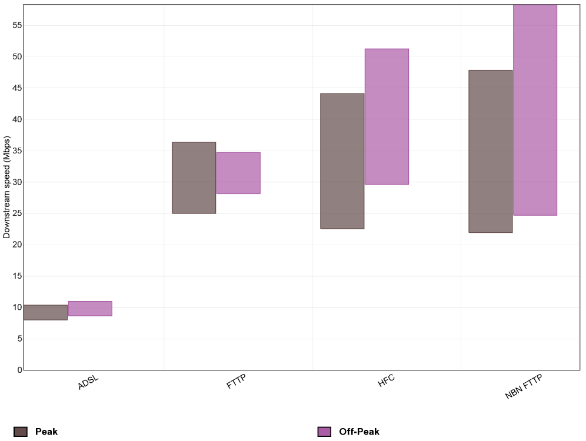
Note: In this section, where a box plot is used, it shows the spread of results amongst the sample; the centre of the box is the mean, whilst the top and bottom of the box signify where 95% of results lay based on the assumption that it is normally distributed, that is, the minimum and maximum values may not represent the actual results collected. Refer to Appendix A for further details about how the data was collated for the Pilot Program. Note also that peak hours are defined as 7-11pm local time.
When comparing Figures 1 and 2, the large gap between downstream and upstream speeds for each technology highlights the asymmetric nature of residential broadband services. Figure 2 below shows the average upstream speed of each technology during peak and off-peak periods and the results show that NBN FTTP services are providing much higher speeds than ADSL, HFC and non-NBN FTTP services.
A comparison between Figures 1 and 2 also demonstrates that while HFC services provide much higher downstream speeds than ADSL services, there is little difference between HFC and ADSL services in the upstream speed results. Calculations based on the data set underlying Figures 1 and 2 show that one RSP’s HFC product has a downstream-to-upstream speed ratio of 32:1 whilst another RSP’s ratio is 27:1. These ratios are extremely high compared to high speed services offered in other countries. Most high speed services in Europe and North America tend to be offered with a ratio of no greater than 10:1; often much lower (even for cable services). A high ratio can become problematic in two circumstances. Firstly, when downloading data at very high speeds, a slow upload speed can cause a download speed delay where there is not enough upstream capacity for packet acknowledgements to be sent back to the sender. This ultimately harms the sender’s sending speed (i.e. the downstream speed). Secondly, it can be an issue for parties seeking to upload a high volume of data at fast rates (for example, transferring large computer files or using two way video conferencing).
Figure 2: Average upstream speed (Mbps) by technology during peak and off-peak periods
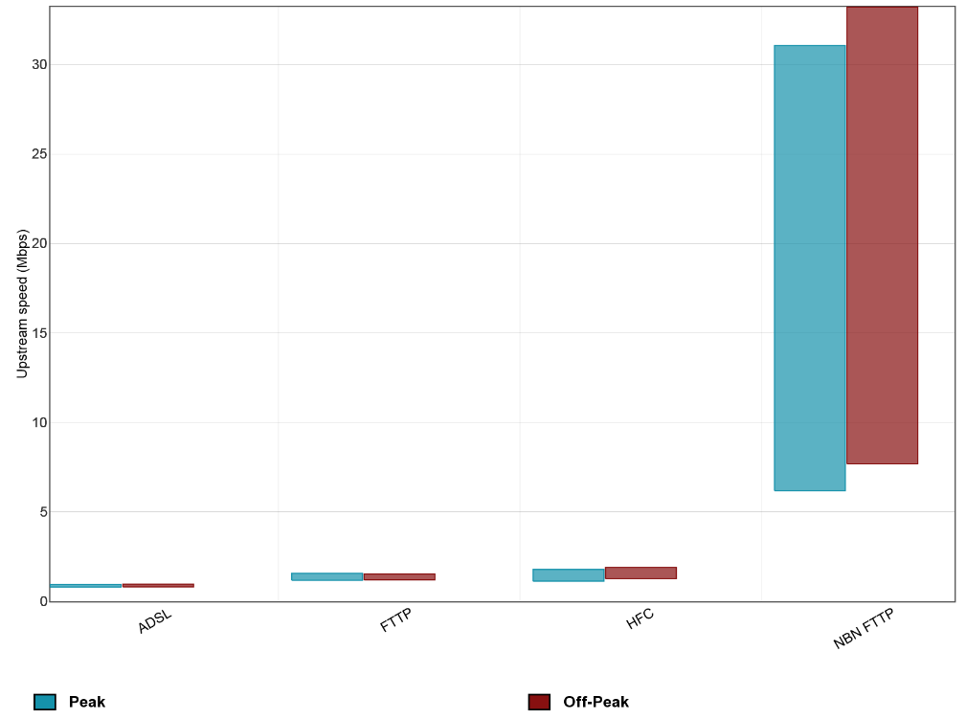
Note: In this section, where a box plot is used, it shows the spread of results amongst the sample; the centre of the box is the mean, whilst the top and bottom of the box signify where 95% of results lay based on the assumption that it is normally distributed, that is, the minimum and maximum values may not represent the actual results collected. Refer to Appendix A for further details about how the data was collated for the Pilot Program. Note also that peak hours are defined as 7-11pm local time.
We note that ADSL speeds can be affected by the distance from the exchange (or node if an ADSL DSLAM is housed in a node) and that VDSL speeds are affected by distance from the node, to the end-user’s premises and therefore any reporting of ADSL and VDSL speed performance in an ongoing BPMR program may need to take into account line lengths. This is discussed further in section 4.4.4 below in relation to options for an ongoing program.
    - Average downstream speed by technology and RSP
The Pilot Program results can be refined further to show the expected speeds on each technology offered by a particular RSP. This section shows three different graphs of average downstream speed of various technologies offered by RSPs; Figure 3 demonstrates how RSPs perform in relation to each technology they offer; Figure 4 demonstrates whether an RSP is performing at the HFC speed tiers marketed to consumers; and Figure 5 highlights the differences in RSPs’ ADSL performance during peak and off-peak periods. The upstream speed results of each technology offered by RSPs are not presented in this section as we consider that this may identify certain RSPs.
Figure 3 shows the average downstream speed of each technology offered by four different RSPs and the results show which RSP provides higher average speeds for each technology. Results of HFC services have not been included in Figure 3 as we consider that this may identify certain RSPs.
Figure 3: Average downstream speed (Mbps) by technology for four RSPs
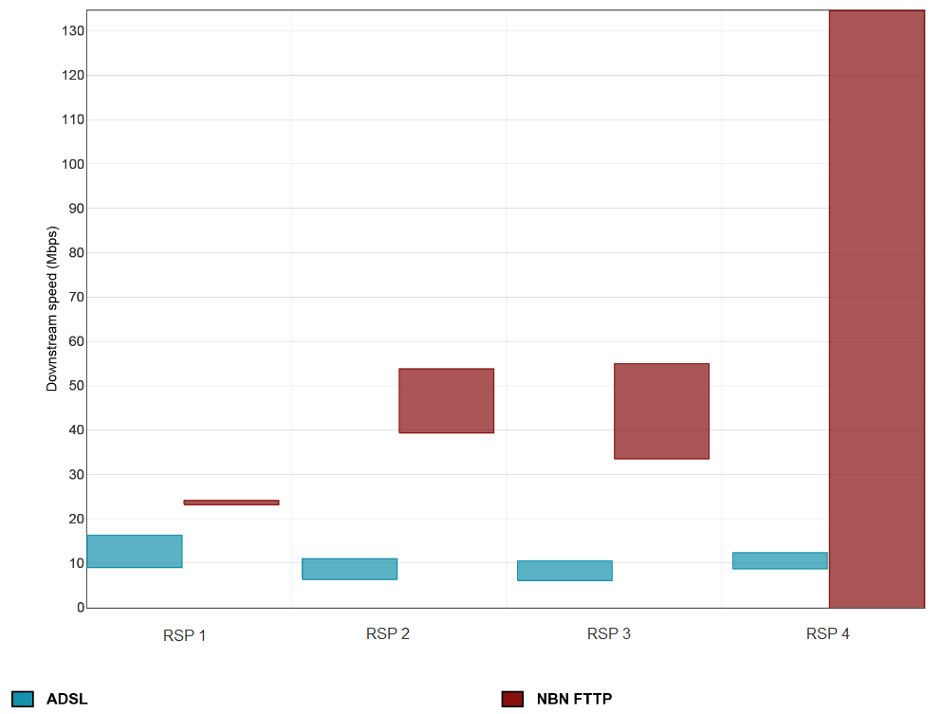
Note: In this section, where a box plot is used, it shows the spread of results amongst the sample; the centre of the box is the mean, whilst the top and bottom of the box signify where 95% of results lay based on the assumption that it is normally distributed, that is, the minimum and maximum values may not represent the actual results collected. Refer to Appendix A for further details about how the data was collated for the Pilot Program.
Figure 4 provides an example of how data in an ongoing BPMR program could be used to show how services sold as specific speed tiers are performing in practice. The Figure 4 example shows whether consumers who purchased 30 or 100Mbps speed tier HFC services from a particular RSP were actually getting that speed over a one week period. If the same results were collected on a larger scale and were verified as being representative of the RSP’s performance throughout the relevant period, it could be concluded that customers on RSP 1’s 100Mbps service are only averaging 70Mbps, which suggests that customers were, on average, not getting the 100Mbps service for which they may have paid. In this regard, an ongoing program would compare the performance of various RSPs in relation to the speed tiers they offer to help consumers verify performance claims made by RSPs about their services both pre and post-purchase.
Figure 4: Average downstream speed (Mbps) of one RSP’s HFC services by service speed tier
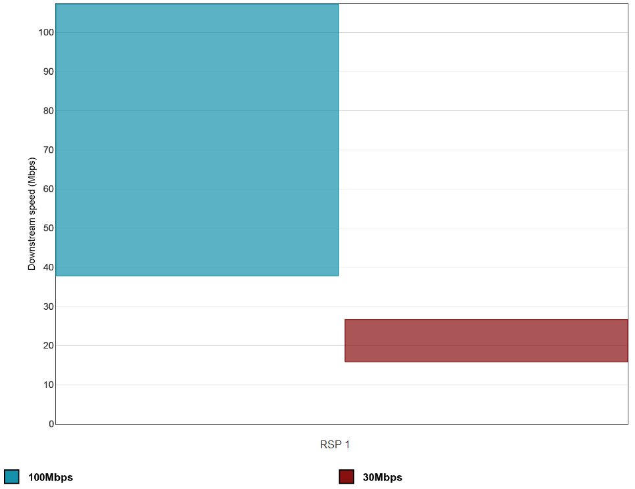
Note: In this section, where a box plot is used, it shows the spread of results amongst the sample; the centre of the box is the mean, whilst the top and bottom of the box signify where 95% of results lay based on the assumption that it is normally distributed, that is, the minimum and maximum values may not represent the actual results collected. Refer to Appendix A for further details about how the data was collated for the Pilot Program.
Figure 5 shows the peak and off-peak download speeds for RSPs that provide ADSL services. We note that Figure 5 shows a mix of ADSL and ADSL2+ services, that is, speeds typically range from 8-24Mbps and is also affected by how far the end-user is located from their local telephone exchange. As such, this is reflected in the spread of results across the RSPs.
Figure 5 shows that some RSPs are providing more stable services (i.e. minimal differences between peak and off-peak performance)—RSPs 2, 3, 4, 5 and 7 appear to be doing better in providing stability in their downstream speeds throughout the day as the results for their off-peak and peak periods are almost mirroring each other.
The comparative information presented in Figure 5 would equip consumers with information to select a service suitable for their needs. For example, a consumer requiring a stable, high speed ADSL service may select RSP 2 but a consumer who wants a high speed service but does not need to use the Internet during peak periods may select RSP 9. On the other hand, a consumer who does not require high speeds and is more focussed on getting a cheaper service may select RSP 10 (if RSP 10 is a budget provider). These three scenarios show that a BPMR program provides information about the options available and as long as RSPs communicate the limitations (e.g. reduced speeds during peak hours) of their services to consumers, the results would reflect the approach RSPs have adopted in balancing network capacity and costs.
Figure 5: Average downstream speed (Mbps) of ADSL services by RSP
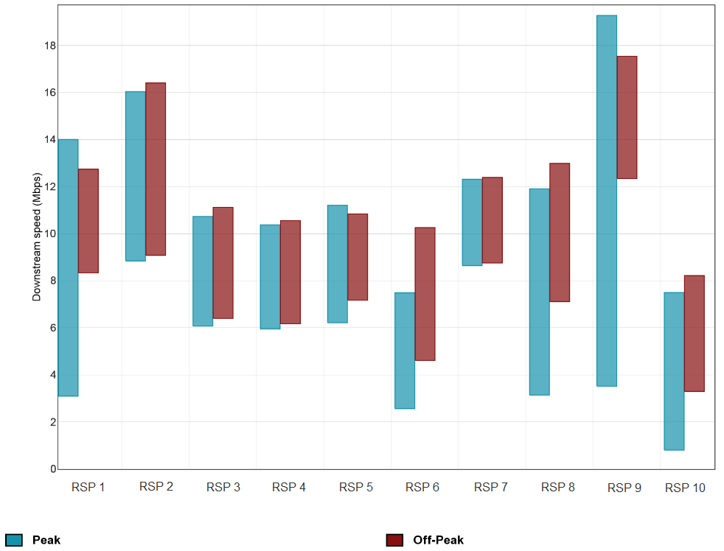
Note: In this section, where a box plot is used, it shows the spread of results amongst the sample; the centre of the box is the mean, whilst the top and bottom of the box signify where 95% of results lay based on the assumption that it is normally distributed, that is, the minimum and maximum values may not represent the actual results collected. Refer to Appendix A for further details about how the data was collated for the Pilot Program. Note also that peak hours are defined as 7-11pm local time.

    - Average downstream speed by technology and hours of the week
Technologies and the services operating on them can tend to have varying performance characteristics within a 24-hour period. A BPMR program could also provide visibility over these differences. This section shows one graph of average downstream speed of HFC and ADSL services, by hours of the day over a one week period.
Figure 6 shows how ADSL and HFC services, offered by three RSPs who provide both services, perform by hour of the week. This example shows that HFC services exhibit significant fluctuations throughout the day. Of interest is that the average downstream speed of HFC service deteriorates significantly during the peak period to the extent that average speeds are sometimes below the speeds of ADSL services. While the results have been averaged across RSPs for presenting the graph in Figure 6, it was observed that some RSPs demonstrated more significant fluctuations in performance than other RSPs. In this regard, any ongoing program would show these differences in performance between RSPs for a particular technology more clearly, as RSPs would be identified.
If the results in Figure 6 were replicated on a larger scale in any ongoing program, it would indicate that ADSL services tend to be more consistent in their performance than HFC services for the three selected RSPs. Service consistency is something that is likely to be of value to consumers.
Figure 6: Average downstream speed (Mbps) of ADSL and HFC services, split by hour of the week
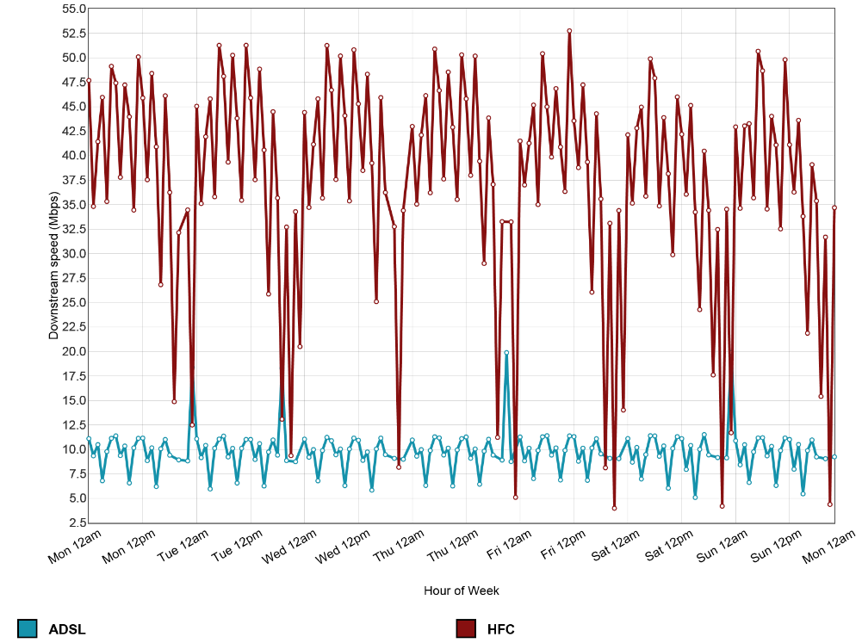
Note: This graph shows results by hour of the week, aggregated over the duration of the Pilot Program. Refer to Appendix A for further details about how the data was collated for the Pilot Program. Note also that peak hours are defined as 7-11pm local time.

    - Average downstream and upstream speed of NBN-based services
The data considered in this section demonstrates that NBN FTTP services are generally quite consistent over a 24-hour period, and that the difference in ranges in speed between downstream and upstream speeds of NBN services is generally lower than HFC services (discussed in section 3.3.2 above). This section shows one graph of average downstream speed of NBN-based services by RSP and another graph of average upstream speed of NBN-based services by RSP. The graphs could also be used to identify when RSPs may not have provisioned enough capacity or whether there are potential underlying network issues.
Figure 7 shows the downstream speeds, and Figure 8 shows the upstream speeds, of broadband services that all use the NBN Co access network. In these two graphs, RSP 4’s NBN FTTP shows very erratic performance during peak periods and at similar times each day of the week. If these results were reflected in a larger sample size, it suggests that RSP 4’s performance may be due to the RSP not provisioning enough capacity at peak times, rather than an underlying access network issue since the other NBN-based services do not appear to experience such erratic performance.
Figures 7 and 8 also demonstrate that the gap between downstream and upstream speeds of NBN services is smaller compared to HFC services. For example, RSP 1 appears to be providing approximately 25/5Mbps services and therefore the downstream-to-upstream ratio is only 5:1, compared to HFC services that were approximately 27-32:1 (refer section 3.3.2 above). The 5:1 ratio is more in line with the ratio in Singapore, which is typically around 2:1.
Figure 7: Average downstream speed (Mbps) of NBN-based services, split by hour of the week and by RSP
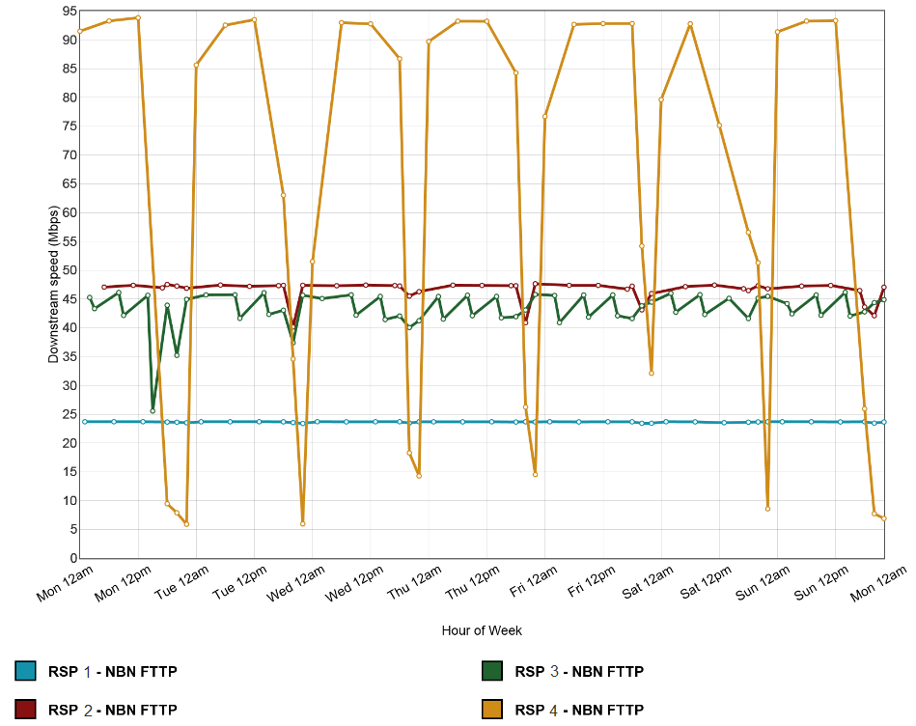
Note: This graph shows results by hour of the week, aggregated over the duration of the Pilot Program. Refer to Appendix A for further details about how the data was collated for the Pilot Program. Note also that peak hours are defined as 7-11pm local time.
Figure 8: Average upstream speed (Mbps) of NBN-based services, split by hour of the week and by RSP
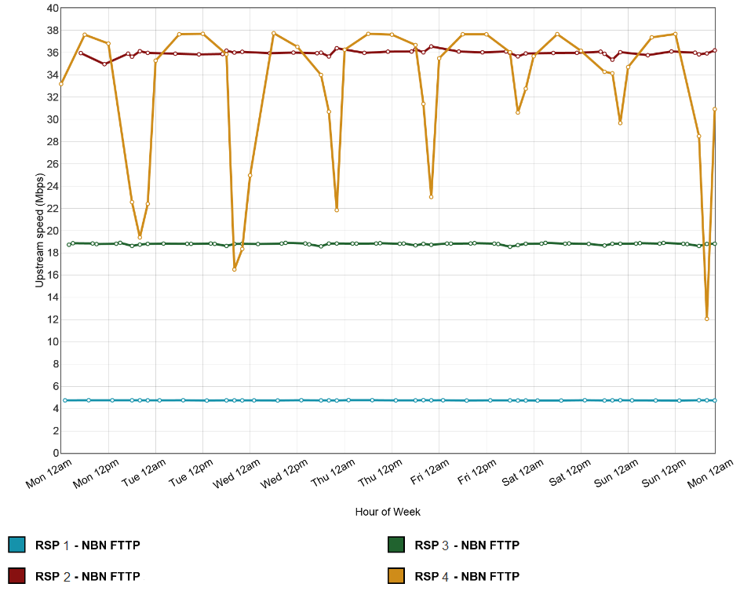
Note: This graph shows results by hour of the week, aggregated over the duration of the Pilot Program. Refer to Appendix A for further details about how the data was collated for the Pilot Program. Note also that peak hours are defined as 7-11pm local time.

    - Conclusions about downstream and upstream speed test results
The above analysis shows various methods of presenting downstream and upstream speed results that provide information about the capabilities of different broadband technologies and how RSPs perform in relation to the technologies they offer. Comparing performance during peak and off-peak periods also provides useful information about how performance generally deteriorates during peak hours. This information would help consumers select a service appropriate for their needs and budget and to evaluate and validate the performance of their existing services.
Broadband services are generally asymmetric and the results show the gap between downstream and upstream speeds is greater for HFC services than other high speed services, such as NBN-based services. Comparisons between the downstream-to-upstream ratios of Australian HFC services and international high speed services (including HFC) show that HFC services provide much higher downstream speeds than upstream speeds in Australia. The limited upstream speeds on ADSL, HFC and some FTTP services could be an issue for some consumers, either by the extent to which delayed packet acknowledgements affect downstream speeds or by limiting the ability to upload a high volume of data at fast rates (for example, transferring large computer files or using two way video conferencing).
While HFC services are capable of much higher speeds than ADSL services, the results suggest that ADSL services tend to be more consistent in their performance. The high speed nature of HFC services is reflected in downstream speeds, while the upstream speeds are much lower and closer to upstream speeds of ADSL services.
In comparing RSPs’ performance on a specific speed tier on a specific technology, the results highlight those RSPs with superior performance and those with poorer performance. In this regard, those RSPs with products that are technically superior will be able to differentiate themselves from their competitors. This is particularly beneficial for RSPs who have invested heavily in their networks. RSPs that do not perform as well would have an incentive to increase their network investment or ensure the quality of their service is reflected in their price and service descriptions in order to remain competitive.
Comparing the speeds of NBN-based services could provide visibility over any potential underlying access network issues. For example, if all RSPs exhibited poor performance, then it may suggest problems with the wholesale access network if the RSPs shared the same access network provider. Knowing the speeds of NBN services would also be particularly useful as the NBN roll-out progresses, as consumers could use this information to help verify the performance claims made by RSPs (e.g. whether a 25/5Mbps service is performing at those speeds).
The Pilot Program results illustrate that downstream and upstream speed testing can inform meaningful comparisons between access technologies and RSPs, and provide useful differentiation of service performance characteristics for consumers and RSPs.
  - Latency
This section discusses the Pilot Program results for latency, a metric that contributes to the performance experience for consumers and which is likely to be relevant for particular groups (e.g. consumers interested in international online gaming and international web browsing). The Pilot Program results confirm that latency testing elicits useful information that can be used to draw comparisons between access technologies and RSPs, and provide further insight into broadband performance for consumers.
Metrics other than speed may be relevant to the end-user experience for certain applications. Latency can be particularly relevant in relation to international website load times and online gaming quality where, given latency is largely a function of distance, the differences in latency performance can be observable for these consumers. Results for international latency are more likely to be of value for jurisdictions where consumers want to access substantial portions of data that may not be hosted domestically. Singapore tests international latency, as the majority of its traffic goes abroad, and it is likely to be of relevance to a sub-set of Australian consumers who access data that is based offshore.
For consumers, information on latency could help them make more informed choices about their service needs and whether it is likely they will receive the service levels they expect from a particular provider. However, consumers may not be aware that the latency available at a consumer’s premise varies by broadband technology, RSP and geographic location. Consumers who have a choice of different technologies and/or RSPs at their premises will likely benefit from having access to information that shows which technology and/or RSP best suits their needs. For RSPs, information regarding latency can help them to both verify their performance and enable them to have comparative data that is of interest to consumers on which they can compete.
    - What is being tested?
Latency is a measure of how long it takes a data packet to travel between two points. Latency is a significant factor in internet performance because if there is a high latency link, then it does not matter how much capacity the broadband connection has; the performance will be limited by latency.
The results presented in this section show ‘round-trip’ latency (i.e. how long it takes for a data packet to travel between point A and point B and then back to point A). The Pilot Program tested the responsiveness of the connection between a user’s home and the Testing Provider’s servers. Latency is recorded in milliseconds, and lower times indicate better broadband performance.
The latency results presented here are of most relevance to an end-user’s experience on an application that use a User Datagram Protocol (UDP) (e.g. some voice and video applications), but may not be as relevant to applications that use a different transmission protocol, or which use techniques to actively manage for latency. Carrier grade voice applications can manage for latency by use of Class of Service and buffering.
Measurements were all conducted between the test server hosted in Melbourne and volunteers’ homes. A subset of volunteers with higher monthly data caps also performed tests to an international test server located in Hong Kong. A technical description of the latency metric and the methodology for collecting this data is available in the Technical Appendix (Appendix A).
    - Latency in Australia by technology and RSP
The data considered in this section demonstrates that latency between volunteers’ homes and the Melbourne test server differed between technologies (in this case ADSL and HFC), RSPs and between peak and off-peak periods. The results show that most services tend to have higher latency during peak hours and that ADSL services typically have higher latencies than HFC services. The differences are likely to be the result of differences in routing and congestion management decisions between the RSPs, although the peak hour ADSL results are still low enough as to be unnoticeable for the majority of users. However, an increase in latency during peak hours is an early indicator of congestion somewhere on the network path, as routers are taking longer to receive the packet and pass it on. Our Testing Provider noted that the Pilot Program results were within similar ranges when compared to the domestic latency results in other jurisdictions in which they operated testing. Congestion is discussed further in section 3.4.4 below.
This section provides the results for latency to the Melbourne test server for ADSL services by RSP. Figure 9 below shows the latency of ADSL services offered by various RSPs during peak and off-peak periods and the results show there is a wide spread of latency results between different RSPs. Average latency for HFC services, which are not displayed in Figure 9, ranged from 10ms to 28ms. Comparing these HFC results with the Figure 9 results indicate that ADSL services overall have higher latency than HFC services. The lowest average peak period latency observed in the results was for an HFC provider at 13ms while the highest peak latency was seen on RSP 3’s ADSL at 36ms. However, as noted above in absolute terms, the latencies presented here would be indistinguishable for the vast majority of user applications.
Figure 9: Melbourne test server latency (milliseconds) of ADSL services by RSP during peak and off-peak periods
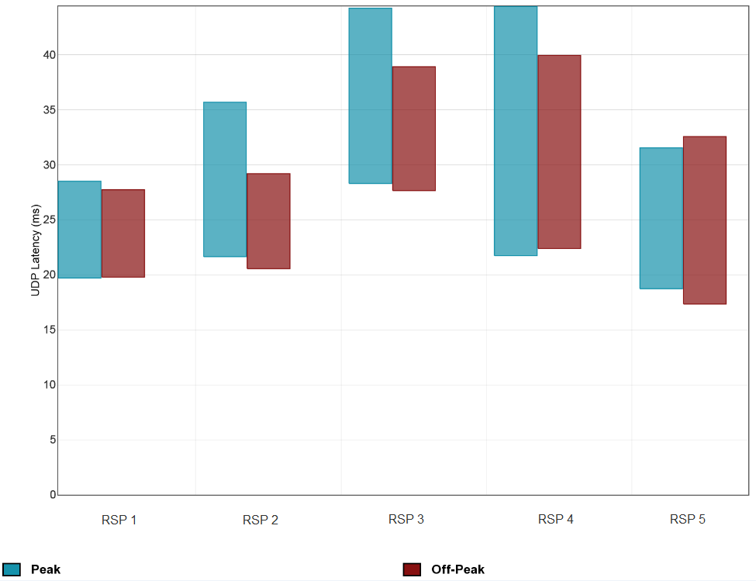
Note: In this section, where a box plot is used, it shows the spread of results amongst the sample; the centre of the box is the mean, whilst the top and bottom of the box signify where 95% of results lay based on the assumption that it is normally distributed, that is, the minimum and maximum values may not represent the actual results collected. Refer to Appendix A for further details about how the data was collated for the Pilot Program. Note also that peak hours are defined as 7-11pm local time.

    - International latency (milliseconds) by technology and RSP
Consumers who frequently browse international websites or play online games on servers hosted internationally may want to select a provider who provides services with low latency on international links. The data considered in this section demonstrates that latency on international links varies between RSPs but there is little difference in latency between technologies (in this case ADSL and HFC). The difference in latency on international links between RSPs is likely a result of different international backhaul arrangements. This section shows one graph comparing latency to the Hong Kong and Melbourne test servers by RSP.
Figure 10 shows the latency to test servers in Hong Kong and Melbourne for ADSL services split by RSP and it demonstrates that international latency variation between RSPs is much more significant than variation in domestic latency between RSPs. As latency is largely a function of distance, the results confirm that international latency is much higher than domestic latency. International latency for HFC services, which are not displayed in Figure 10, provided similar results to ADSL services, with no noticeable differences in performance between the two technologies. These results show that if a website or game server was hosted in Hong Kong, users on RSP 2’s ADSL service would likely experience significantly better performance than users on RSP 4’s ADSL service, despite them having similar latency results within Melbourne. Our Testing Provider has advised that latency results greater than approximately 200ms will be noticeable by end-users when loading web pages. Therefore customers on RSP 1’s ADSL and RSP 4’s ADSL services are more likely to notice slow loading web pages.
Figure 10: Latency (milliseconds) to a Hong Kong and Melbourne test server for ADSL services by RSP
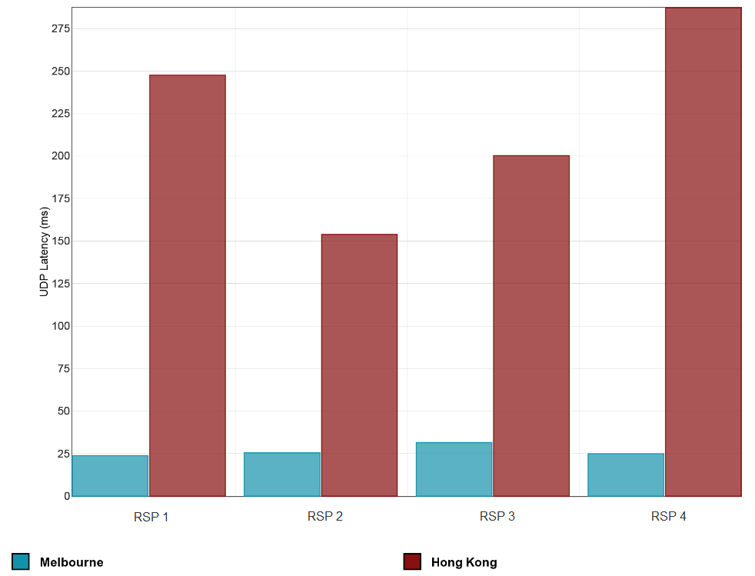 Note: In this section, where a bar chart is used, the top of the box represents the mean. Refer to Appendix A for further details about how the data was collated for the Pilot Program.
Given Australian consumers heavily use applications that use servers located in Asia and the US, we would consider testing latency to other international locations in any ongoing program to show the effects of international latency on different applications.

    - Correlation between domestic latency and downstream speed
Whilst latency is unrelated to capacity (the amount of data that can be transmitted over a broadband connection), increases in latency can have a detrimental effect on achievable speed. Latency is largely a function of distance. If both the user and the measurement server are located close by, which was the case in the Pilot Program, this should result in low latency measurements. However, physical proximity does not guarantee that the path taken will be a direct one. If packets are routed across the country for network management purposes, such as managing traffic peaks or network repair, then latency will be far higher.
The data considered in this section demonstrates that latency could have an effect on throughput experienced by end-users depending on whether network paths selected by RSPs to route their traffic are congested. This section presents four graphs to show the correlation between latency and downstream speed: Figure 11 demonstrates when a significant improvement in latency was caused by a change in traffic routing to a more direct path; Figure 12 demonstrates the improvements in downstream speed for certain users in line with the latency improvements in Figure 11; Figure 13 demonstrates that other users did not see similar downstream speed improvements in line with overall latency improvements in Figure 11; and Figure 14 demonstrates that those same users in Figure 13 did see some improvements in their own latencies.
Figure 11 shows the latency results for various RSPs providing ADSL services. The results highlight the comparatively high latency between RSP 3’s services and the Melbourne test server of approximately 50ms over a particular period. Our Testing Provider has advised that, for connections in urban locations, latency below approximately 50ms should be expected. Figure 11 shows that ADSL services of other RSPs, other than RSP 3, have latency values well below 50ms, whereas RSP 3’s latency results are significantly higher prior to 30 March 2015 (between 48 and 50ms). RSP 3’s results suggest that traffic was not taking the most direct path and was in fact being routed via another city. Our Testing Provider was able to use these results and traceroute data from the hardware probes to determine that traffic between RSP 3 and the Melbourne test server was being routed via Sydney. This added approximately 25ms of unnecessary latency.
Figure 11 also shows that on 30 March 2015, RSP 3 made a routing decision which resulted in the traffic between RSP 3’s customers in Melbourne and the Melbourne test server were no longer routed via Sydney. Figure 11 shows the significant improvement this routing change had on RSP 3’s latency measurement for its services on 30 March.
Figure 11: Latency (milliseconds) of ADSL services to the Melbourne test server of four RSPs, presented on a daily aggregation basis
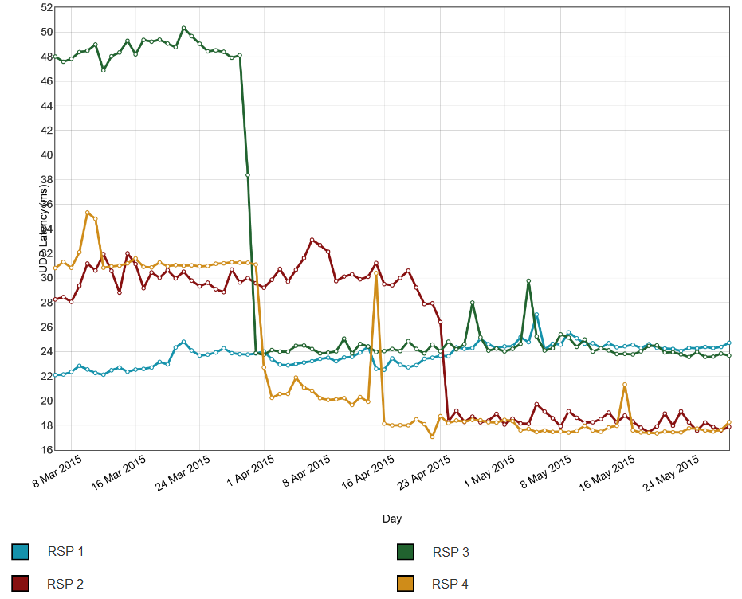
Note: This graph shows results on a daily basis, aggregated over the duration of the Pilot Program. Refer to Appendix A for further details about how the data was collated for the Pilot Program.
The routing issue discussed above affected latency results which, in turn, had a significant effect on the downstream speeds that some RSP 3’s HFC customers experienced. Figure 12 shows the results before and after the routing change, over a one week period, for three HFC customers of RSP 3. The results demonstrate that speed measurements prior to the routing change were very poor during peak hours but improved significantly since.
Figure 12: Average downstream speed (Mbps) of an RSP’s three HFC services, presented on an hourly aggregation basis
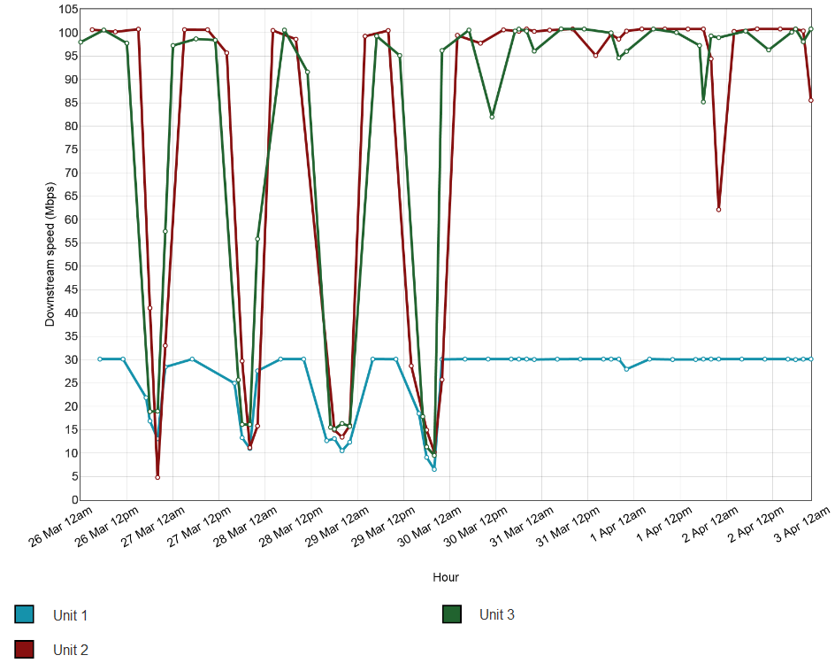Note: This graph shows results on an hourly aggregation basis, aggregated over a one week period during the Pilot Program. Refer to Appendix A for further details about how the data was collated for the Pilot Program. Note also that peak hours are defined as 7-11pm local time.
The improvements in latency and downstream speed observed in Figures 11 and 12 above are so significant that it indicates that the latency was likely to be a symptom of some congestion along the Melbourne-to-Sydney-to-Melbourne path. Even after the routing fix, not all RSP 3’s customers experienced improvements in speed which suggests that some paths through RSP 3’s network were still subject to sizeable congestion. The results in Figures 11-12 together demonstrate that traffic routing decisions can have an effect on latency. While lower latency does not equate to higher throughput, traffic that is passing through fewer routers is less likely to encounter a congestion point.
Figure 12 above shows that congestion had the most effect on downstream speed in the previous network path, and that by changing to an alternate path with less congestion, speeds improved. The Figure 11 and 12 graphs depict the potential for a correlation between latency and downstream speed results – that is, while the poor latency results from RSP 3 alone would not affect user performance, in this instance the cause of the latency issue is also likely to be related to the cause of the slow downstream speeds for some users.
Figure 13 shows that some of RSP 3’s customers did not observe corresponding improvements in speed on 30 March 2015 as those customers in Figure 12. Figure 14 demonstrates that while these customers experienced an improvement in latency performance on 30 March 2015, this did not correlate with improved speed performance. The cause of the fluctuations is unclear, however our Testing Provider suggested it could be the result of congestion in some paths of RSP 3’s network.
Figure 13: Average downstream speed (Mbps) of an RSP’s three HFC services, presented on an hourly aggregation basis
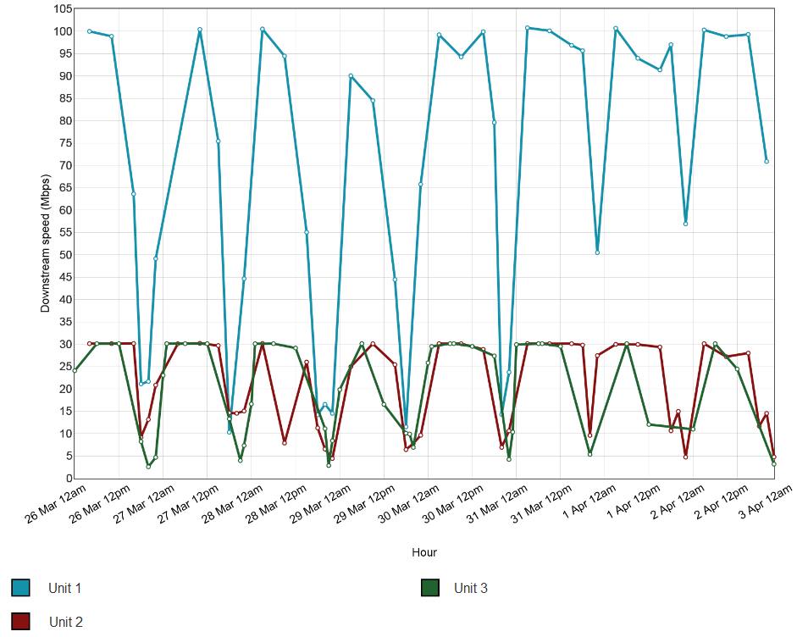
Note: This graph shows results on an hourly aggregation basis, aggregated over a one week period during the Pilot Program. Refer to Appendix A for further details about how the data was collated for the Pilot Program.
Figure 14: Latency (milliseconds) of an RSP’s HFC customers depicted in Figure 13, presented on an hourly aggregation basis
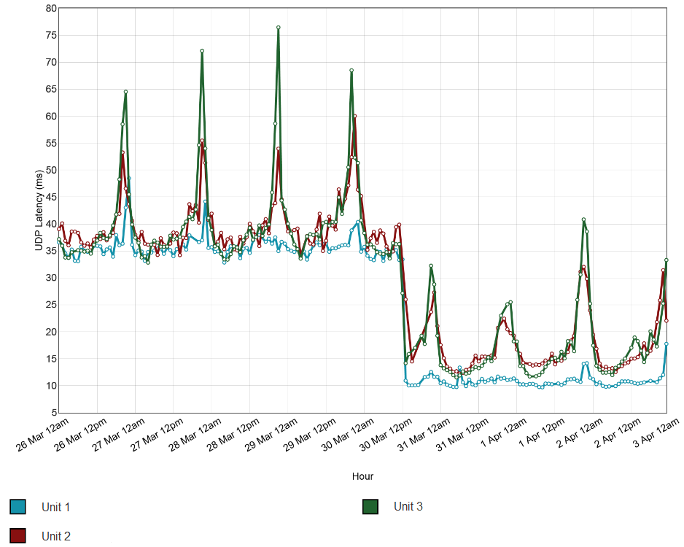
Note: This graph shows results on an hourly aggregation basis, aggregated over a one week period during the Pilot Program. Refer to Appendix A for further details about how the data was collated for the Pilot Program.

    - Conclusions about latency test results
The above analysis shows various methods of presenting latency results that provide information about how RSPs perform in relation to the technologies they offer. Comparing performance during peak and off-peak periods also provides useful information about how performance generally deteriorates during peak hours. This information would help consumers interested in online gaming and international web browsing select a service appropriate for their needs and budget and to evaluate and validate the performance of their existing services.
While HFC services typically have lower latencies than ADSL services due to inherent differences between the technologies, the results show there is little difference between the technologies for international latency. The results also show that high international latency on international links may have a direct impact on international online gaming and international web browsing performance.
The results show that lower latency does not automatically equate to improved download speeds. However, traffic passing through fewer routers is less likely to encounter a congestion point. The Pilot Program results illustrate that latency testing can inform meaningful comparisons between access technologies and RSPs, and provide useful differentiation of service performance characteristics for consumers and RSPs.
  - Video streaming
This section discusses the Pilot Program results for testing video streaming, a metric relevant to determining quality of video streamed on the Internet. The results from the Pilot Program for this metric demonstrate the kind of information that would likely be available for an ongoing program and this section discusses how this is relevant for the performance experience for consumers who use video streaming. The Pilot Program results confirm that testing video streaming would provide information about how different access technologies and RSPs perform when delivering this service.
For consumers, information on video streaming performance could help them make more informed choices about their service needs and whether it is likely they will receive the service levels they expect from a particular provider. However, consumers may not be aware that the video streaming performance they experience varies by video service provider, broadband technology, RSP and geographic location. Consumers who have a choice of different technologies and/or RSPs at their premises will likely benefit from having access to information that shows which technology and/or RSP best suits their needs. For RSPs, information regarding video streaming performance can help them to both verify their performance and enable them to have comparative data that is of interest to consumers on which they can compete.
As video streaming services become more prevalent, especially as Australian consumers transition from legacy to NBN-based services, third parties (such as video streaming providers) may be particularly interested in information on video streaming performance as a means of helping them understand the market and to attract customers to use their services.
As discussed in section 4.5 below, any ongoing program would need to consider which types of video streaming services should be tested. For example, ones that are often accessed for short videos and allow people to post their own videos (such as YouTube and Vimeo) and/or ones that have primarily streamed, professional content (such as Netflix, Stan and Presto). As indicated below, the Pilot Program tested a video streaming provider of a free video sharing service which generally does not require speeds of more than 5Mbps. However, there are likely to be benefits in also testing video services that provide streamed professional content that offer more data intensive videos available at various levels of quality. Information in the public domain indicates that video streaming traffic is indeed putting increasing pressure on RSP networks and that consumers would benefit from information about how various RSPs perform in relation to video streaming services across various technologies.
    - What is being tested?
The Pilot Program tested video streaming performance of a free video sharing service (Video Service X).

Video Service X
Bitrate reliably streamed
This test identifies the highest bitrate video (in Mbps) that a user’s broadband connection can stream without experiencing an interruption (a stall). The aim of the test is to identify the user’s quality of video experience by looking for throughput stability and buffer. The test streams real videos from Video Service X’s actual content servers; the Melbourne test server was not used in this test. It tests the most popular video on Video Service X’s services at the time when the test is run, which means that the test will switch to different videos periodically. The highest bitrate available will differ between Video Service X’s videos. The bitrate for the most popular video at the time will depend on the bitrate in which it was uploaded by the person who created the video.
Startup delay
This test identifies how long (in milliseconds) it takes for a video to start playing when the user clicks play. The test streams real videos from Video Service X’s actual content servers; the Melbourne test server was not used in this test.
A technical description of the video streaming metrics and the methodology for collecting this data is available in the Technical Appendix (Appendix A).
    - Average bitrate reliably streamed by technology and RSP
The data considered in this section demonstrates that faster access speeds beyond the minimum required for video streaming do not necessarily result in faster or better quality video services for consumers. The results show that most RSPs’ services tend to have lower bitrates reliably streamed during peak hours and that ADSL services typically have lower bitrates reliably streamed than HFC services. The differences in performance between RSPs are likely to be the result of differences in decisions about the deployment of caches and congestion management, which ultimately has an impact on the actual video streaming quality experienced by end-users.
This section provides one graph showing the results for average bitrate reliably streamed of ADSL services by RSP over Video Service X.
Figure 15 below shows the bitrate reliably streamed of ADSL services offered by various RSPs over Video Service X during peak and off-peak periods and the results show that 95% of the data lay between 1.4Mbps and 3.9Mbps, with all services performing better in off-peak periods. Given the most popular video measured in this metric is changing quite frequently, the highest bitrate is also changing accordingly and therefore a wide spread of results is expected. However, all RSPs would show exactly the same spread in a perfect environment which is not the case in Figure 15. In particular, the performance of RSP 4’s ADSL service deteriorates significantly during peak periods in comparison to its competitors, which would be noticeable by some users in terms of deterioration in video quality, particularly for those users viewing the videos on larger screens where lower quality video becomes more discernible.
The highest bitrate video measured on Video Service X during the Pilot Program was 4.4Mbps and Figure 15 shows that the spread of results did not go beyond 4Mbps. This means that if consumers have access speeds that can achieve at least 5Mbps, they should be able to stream Video Service X’s videos reliably and that any performance degradation experienced would be the result of some capacity limitation unrelated to their access speed (i.e. congestion issues). The average bitrate reliably streamed for HFC services, which are not displayed in Figure 15, provided similar results to ADSL services and while ADSL services overall appear to have slightly lower bitrate reliably streamed than HFC services, the difference is minimal over Video Service X because the videos are offered at low bitrates. This means that higher speed services do not perform significantly better than lower speed services when streaming Video Service X because services only need to achieve the low bitrates being offered by Video Service X.
Figure 15: Video Service X bitrate reliably streamed (Mbps) for ADSL services by RSP
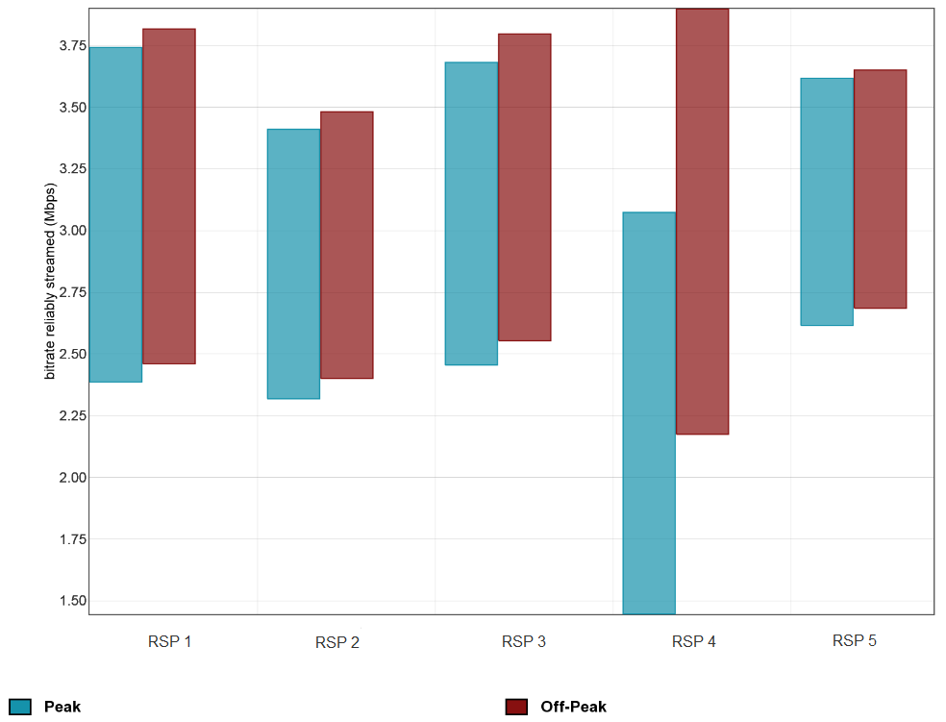
Note: In this section, where a box plot is used, it shows the spread of results amongst the sample; the centre of the box is the mean, whilst the top and bottom of the box signify where 95% of results lay based on the assumption that it is normally distributed, that is, the minimum and maximum values may not represent the actual results collected. Refer to Appendix A for further details about how the data was collated for the Pilot Program. Note also that peak hours are defined as 7-11pm local time.

    - Startup delay by technology and RSP
The data considered in this section demonstrates that video startup delay is lower for higher speed services (e.g. HFC) than lower speed services (e.g. ADSL). This is because the test involves downloading two seconds of video content from a video service’s servers, which means faster services are expected to lead to quicker video start times. The data also demonstrates that the startup delays are relatively minimal for lower bitrate videos (offered by Video Service X), and that consumers are unlikely to be able to observe a difference in performance quality.
Figure 16 shows Video Service X’s video startup delay for ADSL services by RSP and shows that ADSL services have average startup delays ranging between 887ms and 1466ms. The startup delay for HFC services, which are not displayed in Figure 16, indicated that HFC services deliver the lowest startup delays with ranges between 482ms and 891ms. As the bitrate of Video Service X’s videos did not exceed approximately 4Mbps, this caused the startup delays for Video Service X’s videos to be relatively minimal and would likely not be noticeable by a majority of end-users.
Figure 16: Video Service X startup delay (milliseconds) for ADSL services by RSP
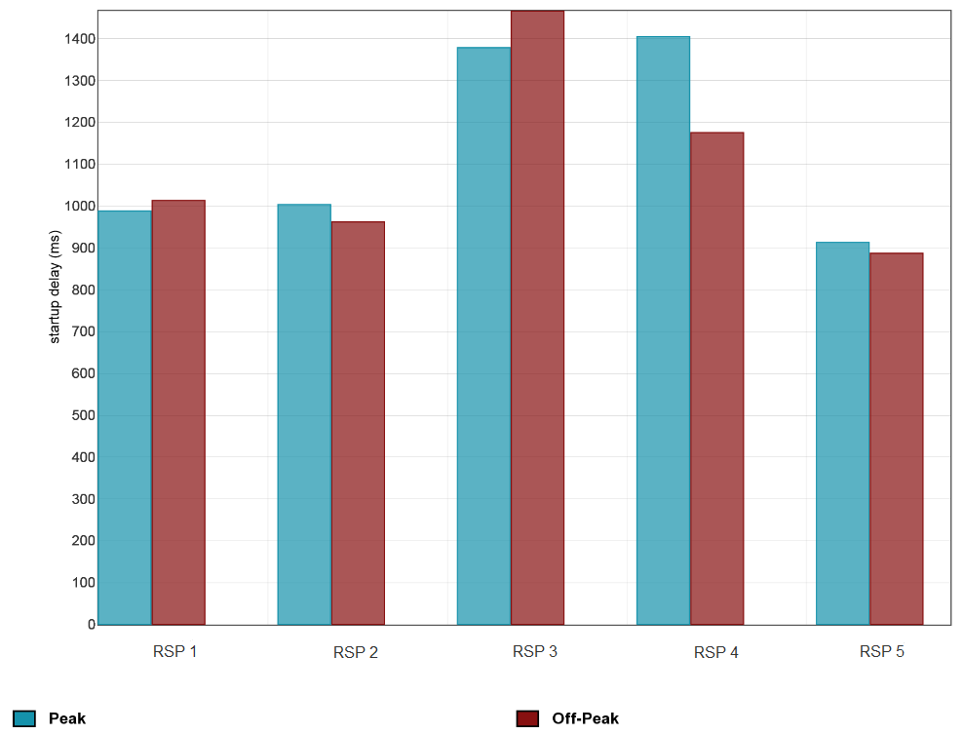
Note: In this section, where a bar chart is used, the top of the box represents the mean. Refer to Appendix A for further details about how the data was collated for the Pilot Program. Note also that peak hours are defined as 7-11pm local time.

    - Conclusions about video streaming results
The above analysis shows various methods of presenting video streaming results that provide information about how RSPs perform in relation to the technologies they offer. Furthermore, comparing performance during peak and off-peak periods provides useful information about how performance generally deteriorates during peak hours. This information would help consumers interested in video streaming select a service appropriate for their needs and budget and to evaluate and validate the performance of their existing services.
The results show that once a user’s speed meets the bitrates required to enable streaming of video, higher access speeds do not necessarily improve the video quality, particularly when the bitrate is the provider’s maximum bitrate (i.e. highest quality video) offered.
While ADSL services typically have lower bitrates reliably streamed than HFC services, the results show that there is little difference between the technologies when the video service is offered at low bitrates. However, the difference between the technologies is likely to be more prominent when the video service is offered at higher bitrates. Video streaming services vary significantly in their bandwidth requirements depending on the video quality required, with higher bitrates required to stream higher quality videos. For example, one video streaming service recommends 25Mbps to stream its highest quality videos while another service recommends 7.5Mbps to stream its highest quality videos.
The Pilot Program results illustrate that video streaming testing can inform meaningful comparisons between access technologies and RSPs, and provide useful differentiation of service performance characteristics for consumers and RSPs.
  - Web browsing
This section discusses the Pilot Program results for website loading time, a metric that contributes to a user’s performance experience and which is relevant to all consumers using the Internet. The results from the Pilot Program for this metric highlight the degree of variation between access technologies and RSPs for website loading time and provide further insight into the factors affecting broadband performance.
For consumers, information on web browsing performance could help them make more informed choices about their service needs and whether it is likely they will receive the service levels they expect from a particular provider. However, consumers may not be aware that their web browsing experience depends on broadband technology, RSP, where the website is hosted and whether changes are made to the website. Consumers who have a choice of different technologies and/or RSPs at their premises will likely benefit from having access to information that shows which technology and/or RSP best suits their needs. For RSPs, information regarding web browsing performance can help them to both verify their performance and enable them to have comparative data that is of interest to consumers on which they can compete.
Information on web browsing performance could help third parties, such as website operators, understand how changes they make to their websites can have a real impact on the end-user experience and factor this into any future planned changes accordingly.
    - What is being tested?
The website loading time measures the average time (in seconds) that all the elements of selected webpages took to load. A lower loading time may indicate better broadband performance experienced by the end-user. The aim of the test is to determine how long it takes to obtain common local and international content.
Ten real websites were tested and included websites hosted locally and abroad. Testing real websites allows for performance factors such as content distribution networks to be taken into account. It is possible for the results of this test to vary according to changes in the websites being visited (i.e. website operators change hosting arrangements or redesign the websites).
A technical description of the web browsing metric and the methodology for collecting this data is available in the Technical Appendix (Appendix A).
    - Local website loading time by technology and RSP
The data considered in this section demonstrates that loading times of Australian websites vary between RSPs and that higher speed services (e.g. HFC) have lower website load times than slower services (e.g. ADSL). The difference in load times between RSPs is likely a result of decisions by RSPs about congestion management during peak periods, whereas the difference between technologies is due to the impact of throughput on website load times. However, the effect of throughput on local website loading times diminishes once speeds reach a certain threshold, such that beyond a certain speed, performance is not improved.
This section shows two graphs; Figure 17 compares load times of Australian websites of ADSL services by RSP during peak and off-peak periods; and Figure 18 demonstrates the correlation between Australian website load times and downstream speed of ADSL and HFC services. The Australian website load times represent the average load times across seven websites with content predominantly or completely hosted in Australia.
Figure 17 shows the load times of Australian websites for ADSL services offered by each RSP and the results demonstrate that most RSPs’ performance did not deteriorate significantly during peak hours other than RSP 4’s ADSL service. The average website load times on RSP 4’s service during peak hours is approximately one second slower than other RSPs’ ADSL services during the same period. While this lag on RSP 4’s ADSL service may not be noticeable to all customers, those customers who usually experience fast load times may notice an observable change. RSP 4’s poor performance in comparison to its competitors suggests that there may be congestion in its network during peak periods.
Figure 17: Average website load times (seconds) of seven Australian websites for ADSL services by RSP
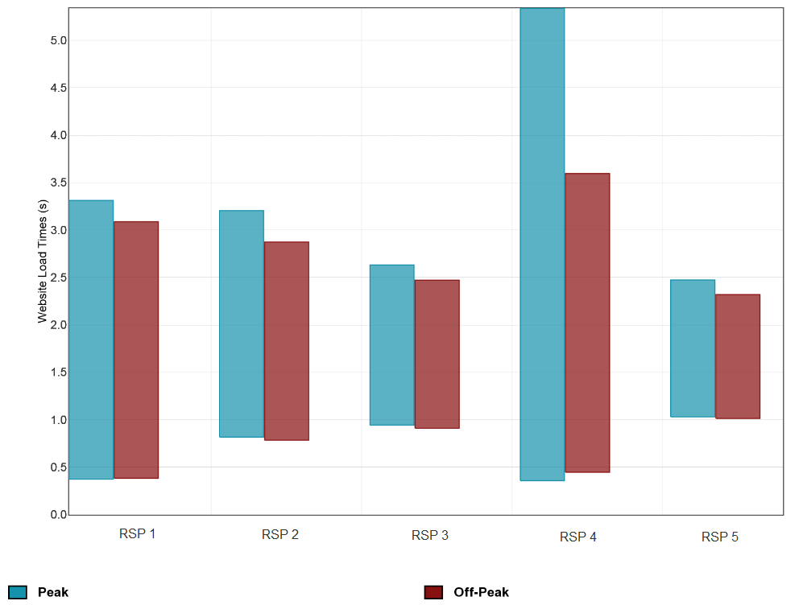
Note: In this section, where a box plot is used, it shows the spread of results amongst the sample; the centre of the box is the mean, whilst the top and bottom of the box signify where 95% of results lay based on the assumption that it is normally distributed, that is, the minimum and maximum values may not represent the actual results collected (i.e. users on ISP G – ADSL did not actually experience zero load times). Refer to Appendix A for further details about how the data was collated for the Pilot Program. Note also that peak hours are defined as 7-11pm local time.

Calculations using the ADSL data in Figure 17 and HFC data not presented in the graph show that ADSL services averaged 1.9 seconds, which is slower than the approximately 1.2 seconds load times of the average of the three HFC services. This difference, although it appears small, is likely to be noticeable by some end-users, particularly those accustomed to faster load times. This example of high speed services loading websites faster highlights the impact of throughput on web browsing times, which is depicted in Figure 18. Figure 18 shows the downstream speed and Australian website load times of ADSL and HFC services over a 24-hour period, aggregated over the duration of the Pilot Program. The graph shows that as downstream speed first increases, there is a steep drop in website loading times, which levels off at higher speeds (i.e. beyond 10-15Mbps). This means that higher access speeds beyond a relevant threshold do not necessarily lead to faster web browsing times. In this regard, the Federal Communications Commission’s Measuring Broadband America report found that the benefits on web browsing performance due to increased speeds diminish beyond approximately 10Mbps and latency becomes the dominant factor in determining web browsing performance beyond this point. While the relevant threshold is not clear in Figure 18 due to the limited sample size in the Pilot Program, more data in an ongoing BPMR program could be used to more clearly show the threshold beyond which web browsing performance improvements diminish.
Figure 18: Correlation between Australian website load times and downstream speed of ADSL and HFC services

Note: This graph shows results over a 24-hour period, aggregated over the duration of the Pilot Program. Refer to Appendix A for further details about how the data was collated for the Pilot Program.

    - International website loading time by technology and RSP
The data considered in this section demonstrates that international websites take longer to load than Australian websites and that higher speed services (e.g. HFC) do not load websites much faster than lower speed services (e.g. ADSL). This is because latency becomes an important factor in web browsing performance when long links to international servers are involved. Loading local websites does not involve long links so latency is not a dominant factor impacting performance but the influence of throughput is much more significant. Therefore, while local website loading time is affected by throughput, international website loading time is predominantly determined by latency.
This section shows one graph comparing the load times of international websites for ADSL services by RSP during peak and off-peak periods. The international website load times represent the average load times across three websites with content predominantly or completely hosted overseas.
Figure 19 shows the load times of international websites for ADSL services offered by each RSP and the results demonstrate that most RSPs’ performance did not deteriorate significantly during peak hours other than RSP 4’s ADSL service. The average website load times on RSP 4’s service during peak hours is approximately 1.5 seconds slower than other RSPs’ ADSL services during the same period. While this lag on RSP 4’s ADSL service may not be noticeable to all customers, those customers who normally experience fast load times may experience an appreciable difference. RSP 4’s poor performance in comparison to its competitors suggests that there may be congestion in its network during peak periods. RSP 4’s ADSL performance here is in line with its performance in loading Australian websites observed in Figure 17 above (RSP 4’s performance in Figure 17).
Calculations using the ADSL data in Figure 19 and HFC data not presented in the graph show that average of the three HFC services loaded websites in approximately 5.3 seconds, which is not much faster than ADSL services which averaged 5.5 seconds. This example indicates that users on higher speed services are unlikely to see observable improvement in performance in international website load times over slower speed services. International web browsing involves long links to the international website’s server so if many objects need to be requested, then many requests need to be sent and each request incurs one round-trip. This is the case irrespective of how high the capacity of the broadband connection is. This means that international web browsing performance is predominantly influenced by latency and not throughput.
Figure 19: Average website load times (seconds) of three international websites for ADSL services by RSP
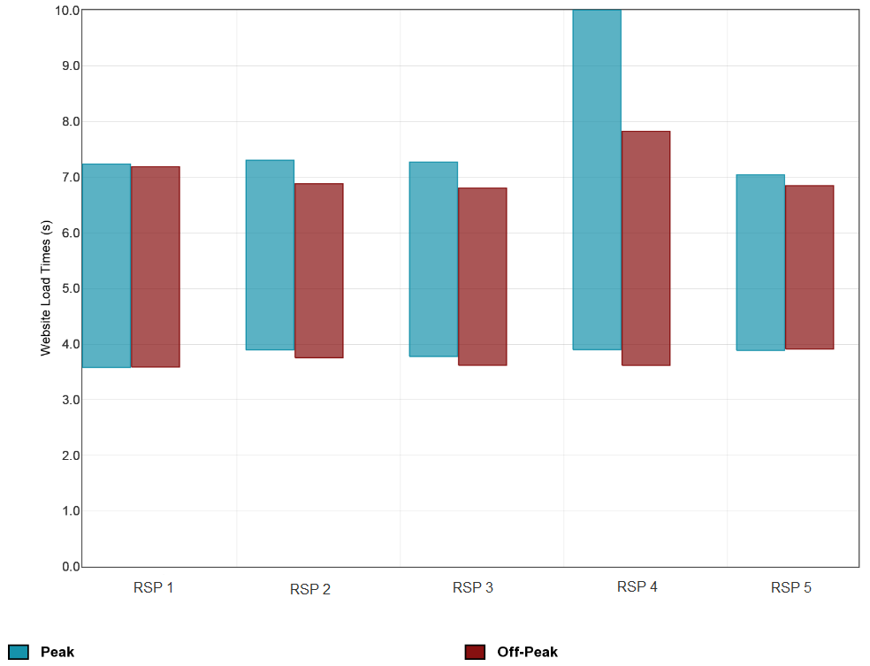
Note: In this section, where a box plot is used, it shows the spread of results amongst the sample; the centre of the box is the mean, whilst the top and bottom of the box signify where 95% of results lay based on the assumption that it is normally distributed, that is, the minimum and maximum values may not represent the actual results collected. Refer to Appendix A for further details about how the data was collated for the Pilot Program. Note also that peak hours are defined as 7-11pm local time.

    - Website-specific observations
The data considered in this section demonstrates that an end-user’s experience of a particular website can be affected by the location of the web servers they are being sent to or changes to the website made by third parties (i.e. not RSPs). This section shows two graphs comparing the load times of Facebook and Yahoo by technology and RSP.
Figure 20 shows the loading times for Facebook for RSPs offering ADSL services and it demonstrates that all RSPs have similar results except for RSP 5’s service; prior to 15 March 2015, RSP 5’s ADSL customers were experiencing almost double the page loading time to users on other RSPs. It is unsurprising that the majority of RSPs have similar loading times as Facebook is hosted locally in Sydney. Further investigation of the results by our Testing Provider indicated that prior to 15 March, RSP 5’s ADSL customers were being sent to the Hong Kong Facebook web servers, instead of Sydney. The correction on 15 March resulted in RSP 5’s customers experiencing faster Facebook load times by approximately one second, which may be noticeable by users given they were previously experiencing load times of around two seconds.
While the example in Figure 20 was unlikely to present a practical problem noticeable by RSP 5’s customers, this example demonstrates that in theory the routing of users’ internet traffic can slow the user experience of particular websites. However, it is important to note that this route selection may or may not be within an RSP’s control. In this regard, a BPMR program would only seek to show whether the web browsing results of particular websites had a real effect on end-user experience of the website and would not determine the underlying cause of the results. However, any ongoing reporting of an RSP’s performance regarding their web browsing results would be accompanied by appropriate contextualisation and caveats to account for the effects of network elements outside the control of RSPs.
Figure 20: Average website load times (seconds) for Facebook for ADSL services by RSP
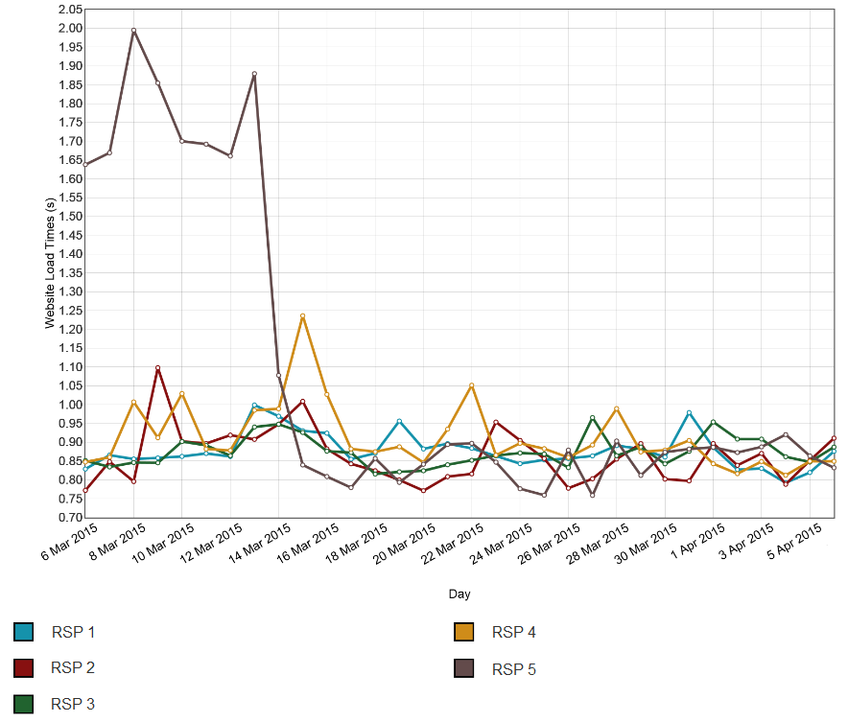
Note: This graph shows results on a daily basis, over a one month period from 6 March – 6 April 2015. Refer to Appendix A for further details about how the data was collated for the Pilot Program.
In contrast to Figure 20, Figure 21 provides an example of where all RSPs had poorer results initially and subsequently experienced similar improvements, which suggests that changes to the website were made by third parties (e.g. Yahoo or a service they rely upon) rather than RSPs. Figure 21 shows the loading times for Yahoo for RSPs offering ADSL services and it demonstrates that prior to 13 March 2015, all RSPs had loading times ranging between six and nine seconds. After this date, the loading times dropped for all RSPs to between four and six seconds. This improvement is likely to be noticeable by end-users, particularly for some users who experienced load times of around eight seconds just before changes were made to Yahoo, which dropped to approximately 5 seconds after the changes. This example demonstrates that a BPMR program could show when changes made to websites are likely to be outside the control of RSPs and whether the results of these changes had a real effect on end-user experience.
Figure 21: Average website load times (seconds) for Yahoo for ADSL services by RSP
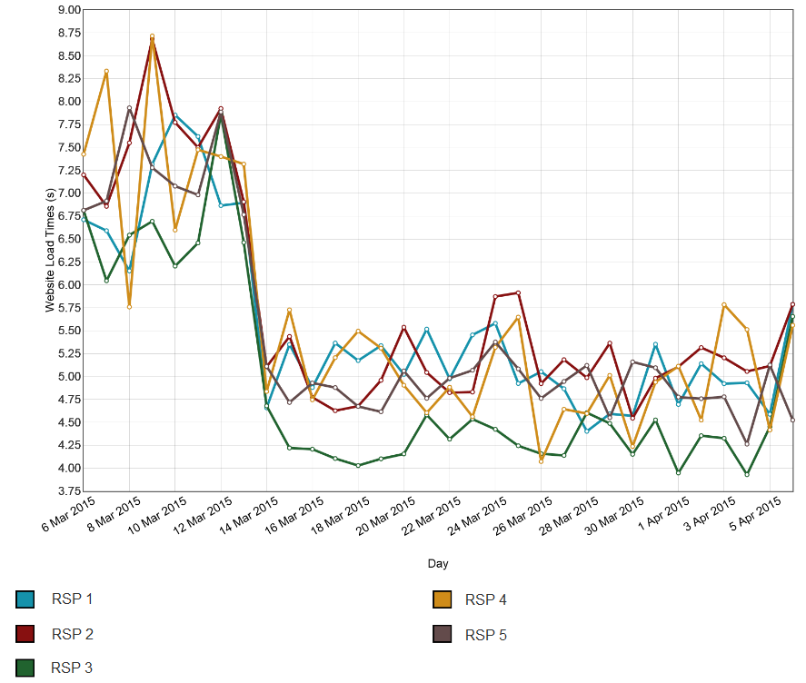
Note: This graph shows results on a daily basis, over a one month period from 6 March – 6 April 2015. Refer to Appendix A for further details about how the data was collated for the Pilot Program.

    - Conclusions about web browsing results
The above analysis shows various methods of presenting web browsing results that provide information about how RSPs perform in relation to the technologies they offer. Further, comparing performance during peak and off-peak periods provides useful information about how performance generally deteriorates during peak hours. This information would help consumers who frequently browse Australian and international websites select a service appropriate for their needs and budget and to evaluate and validate the performance of their existing services.
While higher speed services (e.g. HFC) have lower local website load times than slower services (e.g. ADSL), the results show that there is little difference between the technologies with respect to international web browsing. The results show that while local website loading time is affected by throughput, international website loading time is predominantly determined by latency.
The results also show that end-user experience of particular websites can be affected by the location of the web servers they are being sent to or changes to the website made by third parties. While routing selections and changes to websites may or may not be within an RSP’s control, a BPMR program would only seek to show whether the web browsing results of particular websites had a real effect on end-user experience of the website and would not determine the underlying cause of the results.
The Pilot Program results illustrate that web browsing testing can inform meaningful comparisons between access technologies and RSPs, and provide useful differentiation of service performance characteristics for consumers and RSPs.
  - Packet loss
This section discusses the Pilot Program results for packet loss, a metric that contributes to overall performance and is likely to be relevant for consumers who engage in time sensitive applications (e.g. Voice over IP and online gaming). The results from the Pilot Program confirm that packet loss testing is another useful way to measure and differentiate broadband performance.
    - What is being tested?
Packet loss measures how likely it is that a data packet sent from one point will reach another point. However, packet loss may be managed effectively by network protocols and the relevance of the results need to be considered in the context of the particular end-user application (e.g. emails, VoIP, etc). Packet loss is recorded as a percentage: lower percentages indicate better broadband performance.
Measurements were all conducted between the test server hosted in Melbourne and volunteers’ homes. A technical description of the packet loss metric and the methodology for collecting this data is available in the Technical Appendix (Appendix A).

    - Packet loss by technology and RSP
It is expected that packet loss increases during peak periods as networks are busier and congestion at any one point in a network path can lead to a data packet being dropped. The data considered in this section demonstrates that packet loss varies between RSPs and peak/off-peak hours but there is little difference between technologies (in this case ADSL and HFC). The difference in packet loss between RSPs can be the result of engineering decisions of RSPs, which is reflected in significant variances between peak and off-peak period performance. This section shows one graph comparing packet loss by technology and RSP.
Figure 22 shows the packet loss results for ADSL services split by RSP and it demonstrates that packet loss variation between RSPs is much more significant during peak hours. Packet loss for HFC services, which are not displayed in Figure 22, provided similar results to ADSL services with no noticeable differences in performance between the two technologies. Packet loss during off-peak periods is very low, with no RSPs exceeding 0.32%, whereas packet loss rises significantly during peak periods across most RSPs, the highest being 0.58%. Whilst the increase in packet loss during peak hours may appear significant, it is unlikely to have a real effect on the end-user experience of applications where low packet loss is important for the application to operate at a satisfactory level. Such applications are time sensitive and include applications such as Voice over IP (VoIP) and online gaming. Our Testing Provider has advised that once packet loss increases beyond one or two percent it becomes quite noticeable to users.
Figure 22: Average packet loss (%) for ADSL services by RSP
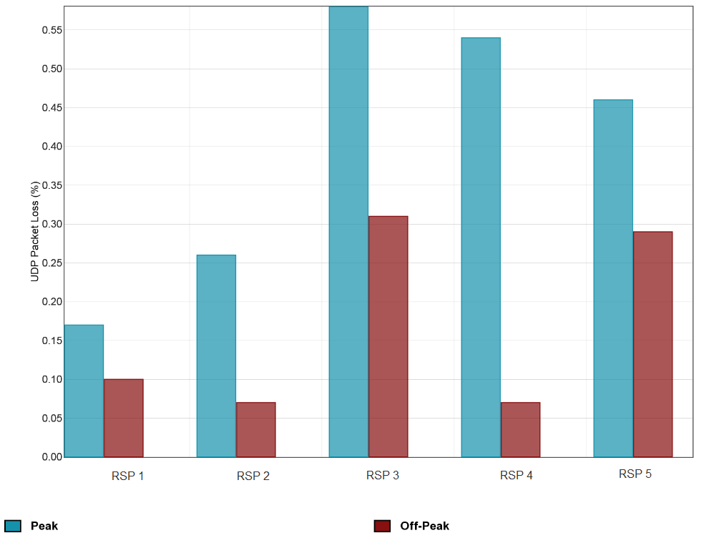
Note: In this section, where a bar chart is used, the top of the box represents the mean. Refer to Appendix A for further details about how the data was collated for the Pilot Program. Note also that peak hours are defined as 7-11pm local time.

    - Conclusions about packet loss results
The above analysis shows how packet loss results can provide information about how RSPs perform in relation to the technologies they offer. Comparing performance during peak and off-peak periods also provides useful information about how performance generally deteriorates during peak hours. This information would help consumers who use time sensitive applications select a service appropriate for their needs and budget and to evaluate and validate the performance of their existing services.
The results show that packet loss increases during peak hours as networks are busier but the low levels of packet loss are unlikely to be noticeable by end-users. However, if packet loss results are higher than one or two percent then users are likely to notice some deterioration in operating applications that require low packet loss.
The Pilot Program results illustrate that packet loss testing can inform meaningful comparisons between RSPs, and provide useful differentiation of service performance characteristics for consumers and RSPs.

  - VoIP emulation (jitter)
This section discusses the Pilot Program results for VoIP emulation (referred to as jitter in this section), a metric that contributes to overall performance and is likely to be relevant for consumers who use real-time applications (e.g. VoIP and online gaming). The results from the Pilot Program for this metric confirm that jitter is another useful way to measure and differentiate broadband performance.
    - What is being tested?
Jitter measures the difference in arrival times of data packets at the destination. This means that jitter measures how consistently a broadband connection can deliver and receive data packets sent with a fixed interval.
The test measures the downstream and upstream jitter of packets during a simulated VoIP call. Downstream jitter measures the jitter experienced at the end-user’s side when the server is sending data and the end-user is receiving it. Upstream jitter measures the jitter experienced at the server side when the end-user is uploading data. Jitter in both directions (downstream and upstream) is particularly important for VoIP because conversations are bi-directional.
The jitter results presented here are of most relevance to an end-user’s experience on an application that use a User Datagram Protocol (UDP) (e.g. some voice and video applications), but may not be as relevant to applications that use a different transmission protocol, or which use techniques to actively manage for jitter. Carrier grade voice applications can manage for jitter by use of Class of Service and buffering.
Jitter is recorded in milliseconds and a lower level of jitter indicates better broadband performance.
A technical description of the jitter metric and the methodology for collecting this data is available in the Technical Appendix (Appendix A).
    - Jitter by technology and RSP
The data considered in this section demonstrates that downstream and upstream jitter varies between RSPs and peak/off-peak hours but upstream jitter varies most significantly between technologies (in this case ADSL and HFC). The difference in jitter between RSPs is likely a result of decisions about congestion management, which is reflected in variances between peak and off-peak period performance. The difference in upstream jitter between ADSL and HFC services may be due to implementation of the different technologies. This section shows two graphs comparing downstream jitter and upstream jitter by technology and RSP.
Figure 23 shows the downstream jitter results of ADSL services split by RSP and it demonstrates only minor variations in jitter between RSPs with more significant variation between peak and off-peak hours. Downstream jitter during off-peak periods is very low, with no RSPs exceeding 0.79ms, but rises during peak periods across all RSPs, the highest being 1.1ms. Figure 24 shows the upstream jitter results of ADSL services split by RSP and it demonstrates only minor variations in jitter between RSPs. Upstream jitter for HFC services, which are not displayed in Figure 24, indicates that HFC services have much higher upstream jitter, ranging from 3 to 8ms in peak periods, than ADSL services. ADSL services appear to have similar upstream jitter results across RSPs with very minor increases during peak hours. In contrast, jitter results for HFC services are at least double that of ADSL services during both peak and off-peak periods, which may be due to implementation of the different technologies..
The HFC data also shows that downstream and upstream jitter for a particular RSP’s HFC service approximately doubles during peak hours compared to off-peak hours. This significant variation between peak and off-peak periods is not observed in other RSPs’ services, which indicates potential congestion in that RSP’s access network.
Whilst the differences in jitter observed in the ADSL and HFC data may appear significant, it is unlikely to have a real effect on the end-user experience of applications where a low level of jitter is important for the application to operate consistently. Such applications are time sensitive and include applications such as VoIP and online gaming. In the case of VoIP, these services usually have a de-jitter buffer, of approximately 25ms, to allow for low levels of jitter without noticeably degrading voice quality. This means that jitter levels below 25ms will not cause audible problems for end-users. In this regard, our Testing Provider has advised that once jitter increases beyond 25ms users are likely to notice an impact on VoIP call quality.
Figure 23: Average downstream jitter (milliseconds) for ADSL services by RSP
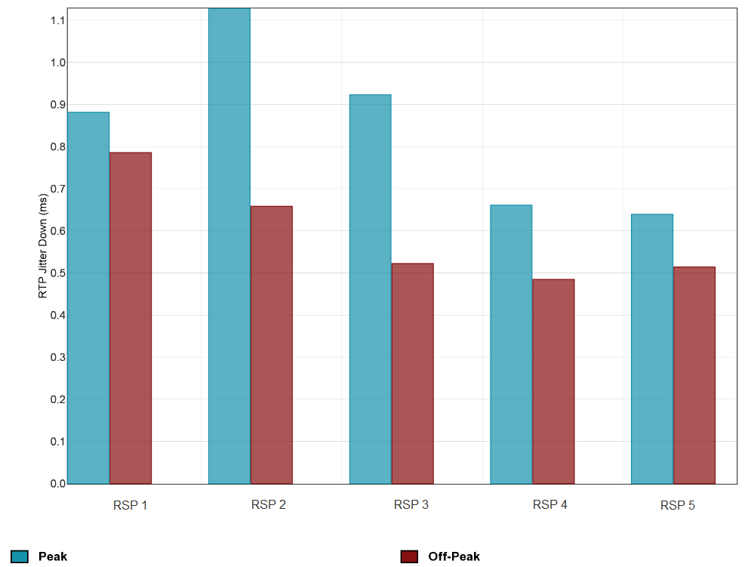
Note: In this section, where a bar chart is used, the top of the box represents the mean. Refer to Appendix A for further details about how the data was collated for the Pilot Program. Note also that peak hours are defined as 7-11pm local time.
Figure 24: Average upstream jitter (milliseconds) for ADSL services by RSP
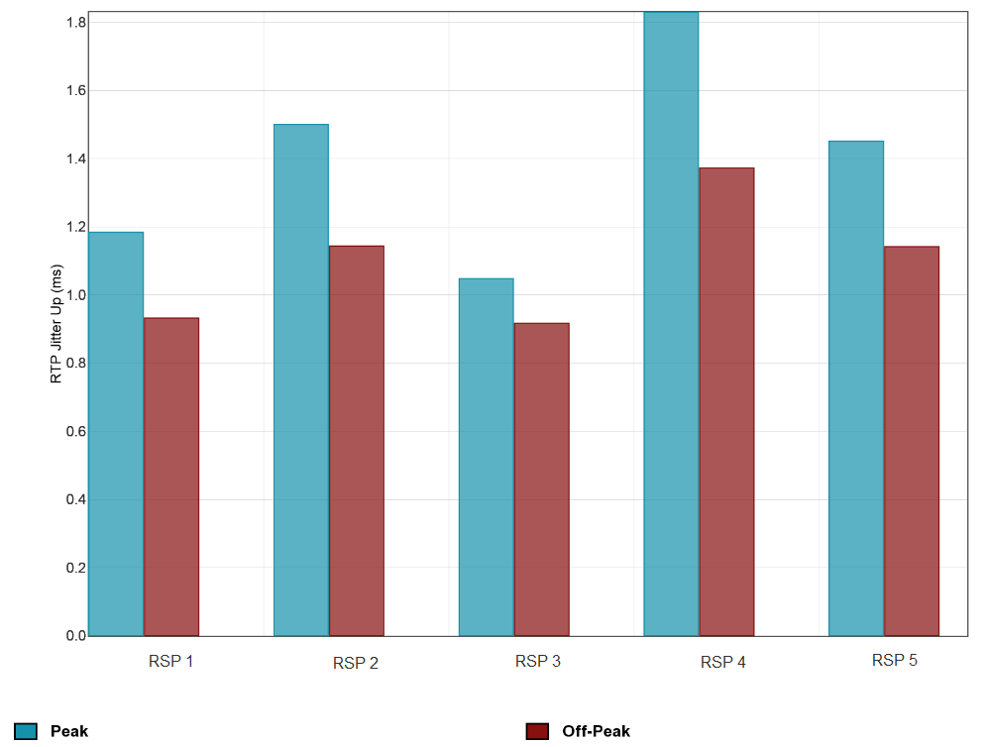
Note: In this section, where a bar chart is used, the top of the box represents the mean. Refer to Appendix A for further details about how the data was collated for the Pilot Program. Note also that peak hours are defined as 7-11pm local time.

    - Conclusions about jitter results
The above analysis shows how jitter results can provide information about how RSPs perform in relation to the technologies they offer. Furthermore, comparing performance during peak and off-peak periods provides useful information about how performance generally deteriorates during peak hours. This information would help consumers who use real-time applications select a service appropriate for their needs and budget and to evaluate and validate the performance of their existing services.
The results show that differences in jitter between RSPs are likely due to congestion in RSPs’ networks during peak hours. In the case of upstream jitter, variations between RSPs are due to inherent differences between ADSL and HFC technologies. However, the low levels of jitter observed in the Pilot Program results are unlikely to be noticeable by end-users. It is only when jitter results are higher than 25ms then users are likely to notice some deterioration (e.g. impact on VoIP call quality) in operating applications that require low jitter.
The Pilot Program results illustrate that jitter testing can inform meaningful comparisons between access technologies and RSPs, and provide useful differentiation of service performance characteristics for consumers and RSPs.
  - DNS response times and failure rate
This section discusses the Pilot Program results for Domain Name Service (DNS) response times and failure rate, metrics that reflect performance that is likely to be relevant for consumers who use web browsing and applications that require connecting to Internet services (e.g. loading videos). The results from the Pilot Program for these metrics demonstrate the kind of information that would likely be available for an ongoing program and this section discusses how this is relevant for the performance experience for consumers. The Pilot Program results confirm that DNS testing will likely be able to inform meaningful comparisons between RSPs, and provide useful differentiation of service performance characteristics.
    - What is being tested?
DNS (Domain Name Service) servers are machines that convert a website address (a hostname), such as ‘www.google.com’ into an IP address. As DNS is one of the most fundamental services used on the Internet, RSPs deploy DNS caches in their networks to ensure quick delivery of DNS replies to end-users’ queries. DNS queries are usually performed over UDP, which is a transport protocol that is very fast but unreliable when it comes to guarantees of delivery.
The DNS response time metric operates by querying selected hostnames and records the time taken to receive the response. The hostnames used in the Pilot Program were the ten websites selected for testing website load times. DNS response times are recorded in milliseconds and a lower time indicates better broadband performance.
The DNS failure rate metric identifies how frequently the DNS resolution process fails. This test records the percentage of DNS requests that have failed and a lower percentage indicates better broadband performance.
A technical description of the DNS response times and failure rate metrics and the methodology for collecting this data is available in the Technical Appendix (Appendix A).
    - DNS response times by technology and RSP
The data considered in this section demonstrates that DNS response times vary between RSPs and peak/off-peak hours but there is no observable difference between technologies (in this case ADSL and HFC). The difference in DNS response times between RSPs is likely a result of whether the hostnames have already been cached by the RSP’s DNS cache. As RSP’s DNS caches are a real, shared service, this is likely the cause of variations in DNS response times between peak and off-peak periods. This section shows one graph comparing DNS response times for ADSL services by RSP.
Figure 25 shows the results for DNS response times for ADSL services split by RSP and it demonstrates significant variation between RSPs during both peak and off-peak hours. The DNS response times for ADSL services range between averages of 23.6ms to 36.8ms. DNS response times for HFC services, which are not displayed in Figure 25, shows ranges of 10.5ms to 36.2ms. The wide spread of results is likely due to a combination of reasons. Firstly, RSPs’ DNS caches are a shared service which would cause some periodic delays when the caches are very busy (i.e. peak hours). The second reason is that a hostname has not been cached by the RSP’s DNS cache so the RSP’s DNS cache had to query the authoritative DNS server first, leading to a delayed reply to the end-user.
Whilst the wide spread of results may appear significant, it is unlikely to have a real effect on the end-user experience of applications where low DNS response times is important for the application to operate at a satisfactory level. Such applications include web browsing and other applications that require connecting to services on the Internet (e.g. loading videos). For example, if queries to DNS servers are delayed (i.e. high DNS response times), users will experience frequent delays when browsing websites. Our Testing Provider has advised that DNS response times in urban locations should be below 50ms while rural areas may be up to 100ms but anything beyond 200ms becomes quite noticeable to users (e.g. visible lag when loading websites).
Figure 25: DNS response times (milliseconds) for ADSL services by RSP
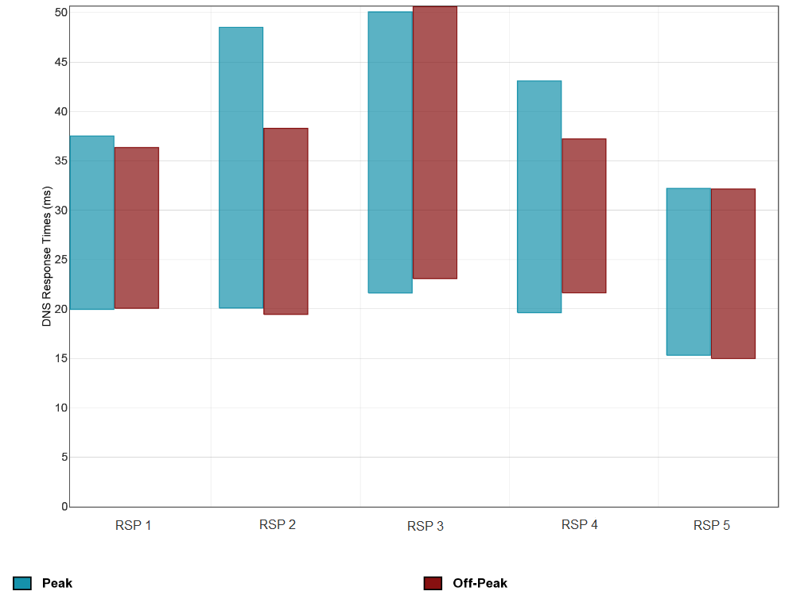
Note: In this section, where a box plot is used, it shows the spread of results amongst the sample; the centre of the box is the mean, whilst the top and bottom of the box signify where 95% of results lay based on the assumption that it is normally distributed, that is, the minimum and maximum values may not represent the actual results collected. Refer to Appendix A for further details about how the data was collated for the Pilot Program. Note also that peak hours are defined as 7-11pm local time.

    - DNS failure rate by technology and RSP
The data considered in this section demonstrates that DNS failure rate varies between RSPs and peak/off-peak hours but there is no observable difference between technologies (in this case ADSL and HFC). The difference in DNS failure rate between RSPs is potentially a result of congestion in the RSP’s DNS caches during peak hours. This section shows one graph comparing DNS failure rate for ADSL services by RSP.
Figure 26 shows the results for DNS failure rate for ADSL services split by RSP and it demonstrates significant variation between RSPs during both peak and off-peak hours. DNS failure rate for HFC services, which are not displayed in Figure 26, provided similar results to ADSL services with no noticeable differences in performance between the two technologies. The most significant difference between peak and off-peak performance relates to RSP 2’s ADSL service which shows an increase from an average of 0.35% during off-peak hours to 2.15% during peak hours. This peak period increase is so significant that it indicates RSP 2’s DNS caches may be congested during peak hours.
Figure 26 also shows that the average DNS failure rate during off-peak periods ranges from 0.15% to 5.56%, and during peak periods the averages are between 0.12% and 5.99%. All modern computers retry DNS requests automatically if they timeout (timeout occurs when no response is received within a few seconds) so even a relatively high rate of DNS failures, of approximately 2% or more, is unlikely to have a noticeable impact on end-users. This means that customers of RSP 3’s ADSL and 5’s ADSL services, which had average failed DNS queries exceeding 4%, are likely to have experienced problems when accessing Internet services. High rates of DNS failures will result in users noticing a lag when loading websites or connecting to services.
Figure 26: DNS failure rate (%) for ADSL services by RSP
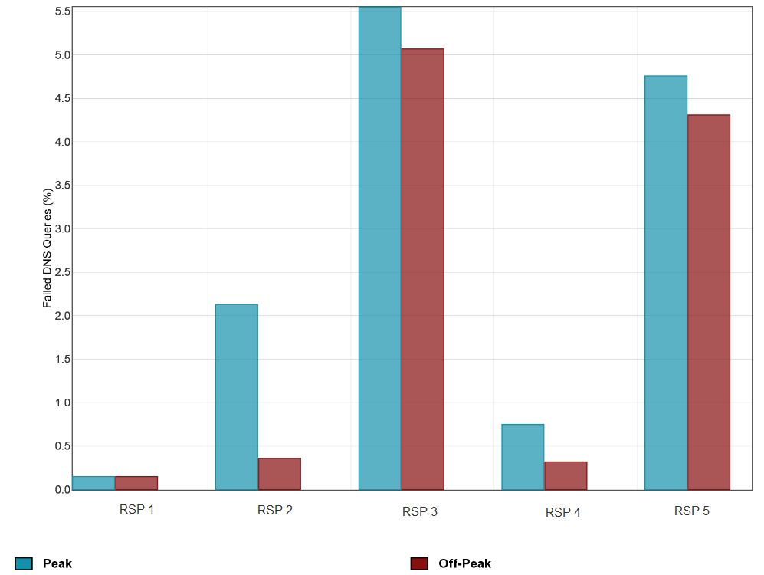
Note: In this section, where a bar chart is used, the top of the box represents the mean. Refer to Appendix A for further details about how the data was collated for the Pilot Program. Note also that peak hours are defined as 7-11pm local time.
    - Conclusions about DNS response times and failure rate results
The above analysis shows how DNS results can provide information about how RSPs perform in relation to the technologies they offer. Comparing performance during peak and off-peak periods also provides useful information about how performance generally deteriorates during peak hours. This information would help consumers who use web browsing or any applications that require connecting to Internet services to select a service appropriate for their needs and budget and to evaluate and validate the performance of their existing services.
The results show that DNS response times and failure rates vary between RSPs and peak/off-peak hours, which are likely due to congestion in RSPs’ DNS caches during peak hours. Whilst the Pilot Program results for DNS response times are unlikely to be noticeable by end-users, the results for DNS failure rates are likely to have a visible impact on some end-users’ experience. The Pilot Program results illustrate that DNS testing can inform meaningful comparisons between access technologies and RSPs, and provide useful differentiation of service performance characteristics for consumers and RSPs.

- Considerations for an ongoing program
This section reflects on the observations arising from the Pilot Program experience and outlines the potential models for implementing any ongoing BPMR program. We consider that the Pilot Program was a successful proof of concept that provided valuable insight into how an ongoing program would operate in practice. The Pilot Program confirmed that a monitoring and reporting program is likely to have significant benefits for consumers, RSPs and third parties. That is, consumers would have better visibility over the performance of their services while RSPs would have access to information about the performance of competitors. In addition the Pilot Program has demonstrated that:
- the principles outlined in the ACCC’s 2014 Position Paper establish a sound basis for an ongoing program
- probe-based, hardware testing works well in the Australian setting
- the Pilot Program provided results that were consistent with expectations regarding the performance of different technologies and experiences in other jurisdictions
- the scheme can be run efficiently
- relevant and useful data can be obtained that can be used to fulfil the objectives of educating and informing consumers, rewarding RSPs for efforts to improve services and informing policy decisions.
Broadband monitoring programs have been established in the United Kingdom (2008), United States of America (2010), New Zealand (2010) and Singapore (2011), with Canada poised to commence reporting on its program in 2016. During the ACCC’s consultation with other regulators who have implemented similar programs internationally, many indicated they believe such programs have indeed brought about benefits to stakeholders and positively changed market behaviour.
Prior to the implementation of any ongoing BPMR program, it is necessary to give consideration to the options that could be adopted in an ongoing program. The approach adopted will ultimately depend on funding, the scope and scale of the testing, and what is the most efficient and effective method of communication of results to all stakeholders. The ACCC recognises that the approach adopted for any ongoing program would also need to ensure that any regulatory burden placed on RSPs would be limited to the extent possible and needs to be balanced against a clear benefit for consumers and competition.
The following section sets out the objectives of an ongoing BPMR program (section 4.1) and the options available for establishing and running an ongoing program and the ACCC’s position regarding each approach (sections 4.2 to 4.7). Sections 4.2 to 4.7 consider:
- Funding for any ongoing BPMR program
- Involvement of RSPs
- Sample selection
- Sample size
- Volunteer panel constitution
- Metrics for testing
- Reporting approach
- Raw data release
  - Objectives of an ongoing program
In the ACCC’s view an ongoing BPMR program would seek to achieve three main objectives:
- improving consumer information: give consumers independent and reliable information on fixed broadband service performance to assist them in their purchasing decisions.
- providing visibility over the performance of fixed broadband access networks: including those operated by NBN Co and retail broadband services offered by RSPs to consumers over those networks
- promoting effective competition: on the basis of service performance between RSPs
    - Improving consumer information
From a consumer information perspective, there is a lack of independent and reliable information on broadband service performance. This is likely to be preventing full consumer engagement in the competitive process and can lead to consumer harm by increasing product search and transactional costs, given that services are typically sold on a minimum term basis with early exit fees.
The potential for consumer harm remains relevant as the NBN rollout progresses, due to the heightened service performance expectations that the NBN brings. In the context of the multi-technology mix being adopted by NBN Co, improvements to the ability of consumers to access information about how their services perform would be beneficial for both consumers and competition.
Importantly, an ongoing program would respond to this potential harm by providing information on the average network performance of RSP products; that is, it would focus primarily on those elements of the network that RSPs can control. In this regard, providing transparency to consumers regarding the average performance of different types of broadband services and different RSP product offerings would better equip consumers to make judgments on whether a particular service is appropriate for their needs and budget.
This would provide clear incentives to RSPs to accurately represent the technical performance capability of the products during the pre-purchase stage and where necessary to take further operational measures to improve the technical performance of their products. It would not be feasible or necessary to provide tailored advice to individual end-users about their likely end-to-end broadband experience with a particular product in order for this consumer benefit to arise.
Similarly, RSPs and access network operators would gain a broad insight through the program into how the investment and operational decisions of all industry participants translates into end-user service quality, which will become increasingly valuable as the industry moves to wholesale-only models for access network operators.
    - Improving visibility over performance of fixed broadband access networks
The rollout of the NBN is a key driver for the consideration of a monitoring and reporting program. With higher potential service performance there is a greater risk of consumer detriment if expectations are created and not met. RSPs have an important role to play both in terms of how they construct and market specific offerings to consumers and in terms of their wholesale capacity provisioning decisions. However, RSPs are dependent on their access provider (whether NBN Co or another network operator) for the underlying network capability and as such we consider it important to provide visibility over any network-based performance issues.
An ongoing BPMR program would achieve the access network monitoring objective by collecting performance-related data from a representative sample of consumers on all major fixed broadband networks. Analysis of results on a suitably aggregated basis (e.g. by access network, region etc.) would provide visibility over performance problems which may be caused by the underlying network rather than the RSP. On the other hand, results which demonstrated that RSPs could provide high quality performance on a particular network would provide confidence in the performance of what will often be monopoly fixed-line access networks.
At the same time, data produced by an ongoing program would enable specific conclusions to be drawn about the performance of individual RSPs. A decision by an RSP to either provision sufficient network capacity to meet end-user demand, or provision more limited capacity to reduce costs, would likely be reflected in test results. It is worth noting that varying performance may not inherently be a problem for some consumers who are willing to make a trade-off between performance and price provided they are adequately informed of performance limitations in the communication of offers.
    - Promoting effective competition
From a competition perspective, robust data on the relative service performance of RSPs from a trustworthy and independent source would better enable RSPs to compete through performance-based differentiation. This is because RSPs would be rewarded through market outcomes where they developed and offered technically superior products that consumers demanded and valued, which would not be the case where consumers were not well placed to make product choices on this basis.
An ongoing program would seek to promote competition by drawing out broadband service performance as an important competitive parameter alongside price, customer service and value added features. This market-based mechanism would have clear potential to avoid the need for standards-based regulation of technical requirements for end-user services.
  - Funding for any ongoing BPMR program
This section outlines the possible funding models for an ongoing BPMR program, which has been informed by a review of international practice. The costs of an ongoing program are also determined by the potential scope and scale of any such program, something which is considered further below. The primary cost components of any ongoing program include:
- Purchase and cost of distributing testing hardware – one per volunteer
- Recruitment and maintenance of volunteer base
- Operation of testing system and production of testing results, including software analysis system and testing servers
- Analysis of testing results, including statistical analysis and preparation of a public report/data
- Coordination of the program.
The international models for funding include:
- Model 1: Fully government funded
- Model 2: Funded by the regulatory agency, which is itself funded by Government and/or industry levies
- Model 3: Regulatory agency/Government co-funded with RSPs
- Model 4: Regulatory agency/Government co-funded with RSPs and third party testing provider (who retains rights to sell data).
The international examples provide a wide range of models that could be adopted for an ongoing program, all of which deliver results in accordance with the objectives of each of the programs. The structure of any model that is ultimately adopted in Australia is likely to require support and cooperation from government and industry stakeholders in order to succeed and as such will require further consideration and consultation following the release of this report.
In the next section, we discuss some of the factors that would contribute to how an ongoing program could be designed and the implications this might have for the scope of an ongoing program.
  - RSPs involvement in program
A review of international approaches to direct involvement by RSPs in performance monitoring programs revealed two primary options. The first approach was to involve RSPs in the programs, an approach which balanced the benefits of involvement (such as effective volunteer recruitment, verified data, and an ability to conduct more comprehensive testing) against the potential risks (i.e. the ability to game the results). The US has adopted a collaborative approach to their program with industry involvement from an early stage. An alternative, historically adopted by the UK, is to operate testing independently of the RSPs, without the identity of volunteers being revealed, so that the process remains completely independent.
Involvement of RSPs can bring a number of benefits. In a number of jurisdictions, the RSPs helped recruit volunteers by sending direct communications to their customers asking them to consider joining the testing. The volunteer panel was selected by a third party provider to ensure it was representative, however, selection was from a considerably larger pool of potential volunteers than is likely to have been obtained without RSP assistance. RSP involvement can also enable testing data to be verified where necessary to ensure the accuracy and meaning of results (for example, a performance issue may be the result of an issue which is not within the control of the RSP) and the plan details provided by the volunteer.
The Pilot Program demonstrated that volunteers often do not have an accurate knowledge of the technology underlying their broadband service or the details of their plans. In addition, in some jurisdictions where RSPs were involved in the testing, the amount of data used for testing was carved out of the volunteer’s data plan. This allowed the impact on consumers to be minimised and more testing to take place where otherwise such testing would negatively impact on the consumer’s monthly data allowance. The Pilot Program demonstrated that certain types of testing on high speed connections could use up to 16GB of data per month (e.g. on a 100Mbps connection).
In jurisdictions where RSPs are involved in the monitoring program these arrangements are usually supported by a binding code of conduct or agreement not to interfere in the independence of the testing process. This is to ensure, for example, that volunteers being tested are not given preferential treatment. Some programs also build in a small number of non-identified cross-checking samples, to further verify the results.
  - Sample selection
    - Sample size
It is a question of statistical analysis as to the number of data points needed to establish a reliable statistical sample for each sub-segment of the data. For example, how many data points are needed to establish an accurate reflection of network performance nationally or by state/region according to RSP and/or technology? SamKnows has created a set of guidelines and best practices for sample plan design, in particular the requirements for minimum sample sizes. SamKnows has recommended that a statistically significant sample would require a minimum of approximately 45 measurement probes per sub-segment. However, consultation with other regulators revealed that a number of them have sought to increase this number up to 100 in practice, where possible. In the Australian context, the finalisation of the number of data probes per sub-segment is likely to be something that would benefit from further consultation with RSPs and relevant stakeholders, depending on the scale and scope of the testing.
    - Constitution of the volunteer panel
The constitution of the volunteer panel determines the scope and scale of any broadband performance monitoring and reporting program.
Two options are considered below:
- Restricting the volunteer panel to consumers on high speed networks
- Volunteer panel that is representative of the national broadband market including NBN and legacy services.
    - Option 1: Restricting the volunteer panel to consumers on high speed networks
As the NBN rollout progresses and consumers are progressively transitioned from legacy services to the NBN, it may be more cost efficient and targeted for a BPMR program to only monitor the performance of NBN services and those third party networks that will be operating post-migration. An advantage of this option is that it offers a more targeted method of volunteer recruitment than the second option which is broader as it requires recruitment from a much larger pool of broadband users. However, a disadvantage of this approach is that it would limit the benefits of a BPMR program to consumers on superfast networks and post-legacy consumers rather than to Australian consumers more broadly. This would mean consumers who are still on legacy services while the NBN is being rolled out would not have access to information that would be helpful in assessing their broadband services.
This option has the benefit of being more forward-looking as over time all connections will become high speed. However, it would also mean foregoing a broader comparison of technologies during the current transition phase where legacy and NBN services co-exist. If this option was adopted, the test results would focus on the performance of a specified portion of the current broadband market, a portion that would increase with the passage of time, rather than the overall performance of broadband services in Australia.
    - Option 2: Volunteer panel that is representative of current national broadband market, including NBN and legacy services
This option requires recruiting volunteers across Australia to ensure the selected sample is representative of the Australian fixed broadband market. Recruiting a representative sample on a national basis would ensure that the benefits of a BPMR program would be experienced by all participants in the fixed broadband market. However, a disadvantage of this option is that it would require a more complex and lengthy recruitment process than option 1 above because the overall sample would need to be representative across defined geographic segments, service types (legacy and NBN services), RSPs and speed tiers. In addition, the legacy services being tested would likely be migrated to NBN services in the next five years, such that within this five year period the value of the costs of selection and provision of hardware and services to these parties would likely be time-limited.
While this option is the most comprehensive and costly option for panel selection, this is the approach undertaken in similar programs in other international jurisdictions.

Issues with testing ADSL and VDSL services
Speed on ADSL services varies by the length and quality of the telephone line between an end-user’s premises and the telephone exchange (and as mentioned above may also be affected by factors outside of an RSP’s control, such as customer premises wiring). If an ongoing program included testing of ADSL services, an issue that would need to be settled is how to test ADSL services given performance diminishes the further away a party is from the exchange. The approach adopted by Ofcom is to exclude all ADSL services where the straight-line distance between a volunteer’s home and the exchange is more than 5km. Ofcom noted that its approach limited the “impact of outliers when weighting and normalising data to straight-line distance distributions”. An alternative approach to consider is to apply a statistical weighting to all ADSL services which accounts for how far a premises is from the exchange.
The approach adopted for ADSL services would also apply to FTTN services as speeds on VDSL services will also vary depending on the distance between an end-user’s premises and the node. While speeds on FTTB may also vary depending on the length of in-building wiring, it is unlikely that any performance variation would be so significant to warrant distance weighting to be applied to FTTB results, however, this would need to be the subject of consideration in any ongoing program.
    - Conclusion
Both options have merit, with a focus on superfast networks offering a more future-proof approach to testing, as all connections will eventually become high speed. However, there is capacity to test legacy services and a program which tested all networks in the Australian broadband market would offer more comprehensive information for all consumers. The option that is ultimately adopted has implications for the scope and cost of any ongoing BPMR program.
  - Metrics for testing performance
There are a number of metrics that are tested in most jurisdictions with broadband performance monitoring programs, which helped inform the basis of the testing methodology outlined in the Position Paper and adopted in the Pilot Program. As discussed in section 3 of this paper, reporting on these metrics can provide important information to consumers, RSPs and third parties about network performance that can benefit consumers and competition.
A baseline program would likely test the following metrics: download speed, upload speed, web browsing time, latency and packet loss. Each of these metrics are tested in the UK, US, Singapore, New Zealand and Canada. In addition, the following metrics, which are generally not data intensive to test, were tested in the Pilot Program and a similarly expansive testing regime is used in the UK and US: jitter, DNS response times, DNS failure rate, Voice over IP and average daily disconnections. An advantage of this approach is that it results in more comprehensive testing which promotes rigorous broadband performance monitoring. Testing for international latency would also be relevant for Australian consumers who access a large amount of information from overseas.
A primary question for consideration is the testing of video, in particular the best way to test video streaming services. Ofcom is currently changing its methodology to include testing of video streaming and the FCC has also conducted some video testing. Given the increasing amount of traffic to online streaming sites, it could be beneficial to test video streaming in the program, in order to monitor the video streaming market and test the performance of specific services on various networks and technologies.
A disadvantage of this option is that it would be data intensive, which in turn could lead to increased testing costs, both in terms of the infrastructure and service costs for testing. In addition, it may be difficult to select which streaming services should be tested in order to ensure these services are not advantaged by selection (e.g. that RSPs do not seek to improve the performance on services selected for testing, which could disadvantage services that are not selected). Further, consumers may use video streaming performance as a proxy for an RSP’s overall performance, which may result in selecting an RSP that does not perform as well in other metrics relevant to the consumer (e.g. RSP A did well in one provider’s video streaming testing but poor across other relevant metrics). Testing a select number of video streaming providers may also disadvantage smaller competitors, such as Presto or Stan, and could result in an incomplete overview of the video streaming market in Australia. An ongoing program would need to consider the best way to test video streaming. Options may include anonymising the video providers, rotating the video providers or spreading the testing across many providers at once.
    - Conclusion
The metrics that were selected for the Pilot Program are a very good starting point, and compare well with other international programs. Selecting the final metrics that will be tested will have implications for the scope and cost of any ongoing program and would be a relevant factor when considering funding.
  - Reporting approach
As noted in the Executive Summary, this report on the Pilot Program has been written with policy-makers and industry as the key intended audience and currently replicates the form of information that is contained in the reports of some of the other international regulators testing broadband performance. This in turn reflects the type of data, in terms of depth and detail, which is required by RSPs and other third parties (such as industry groups, academics and policy-makers). However, in order to meet the objectives of improving access to information for consumers, any such reporting in an ongoing program would ideally be supplemented by information that is targeted and accessible to consumers and which facilitates the broadest distribution of this information to consumers.
There are a variety of ways in which the ACCC could analyse and report on the data from an ongoing BPMR program. Our preliminary view, which is supported by the experience of a number of international regulators, is that a comprehensive report analysing the data should be produced and that it should consider one month of collected data.
Focussing on one month of data allows for currency (given that some months are required to validate and process the data and to perform and document analysis of the data). Analysing one month of data also provides some flexibility to exclude any periods where, for example, an RSP faced unforeseen network problems caused by an external event. In addition, an annual report allows for network and retail market changes to manifest over a longer period of time, enabling more meaningful analysis and commentary.
The annual reporting approach has been used by the Federal Communications Commission (FCC) in the US since they began measuring broadband performance. As part of Ofcom and the FCC’s ongoing broadband performance monitoring programs, reports are released twice and once a year respectively which are typically around 70-80 pages. Ofcom’s report identifies residential UK broadband speeds, the performance of individual RSP packages, analysis of the research, and the methodologies used. Ofcom has advised it is moving to an annual reporting approach. Similarly the FCC’s report outlines the major findings from the testing, comparisons to the previous testing period, actual versus advertised speeds, data consumption and volunteer migration in the US. The FCC also publishes an accompanying technical appendix which outlines the methodology of the testing and the tests that are undertaken.
There are several advantages to publishing a report with detailed commentary and analysis of the data. Firstly, it would enable the ACCC to provide comprehensive information to the public about the aims, methodologies and results of the project, future considerations and changes to the project, the state of the broadband market and the effect the monitoring program is having on competition. This would promote transparency and accountability for the project and the ACCC. As independent regulators, the FCC and Ofcom have highlighted the need for transparency when producing their reports and it is important for the ACCC to similarly have regard to transparency obligations. Secondly, under a report model, the ACCC would be able to provide the public with both a short and long-term view of broadband performance in Australia. This would help the ACCC monitor the success of the program and identify improvements that could be made. Thirdly, this approach allows for a more complete set of broadband data to be obtained and examined. Some regulators noted that they were testing across the country as a whole, in order to obtain a complete picture of broadband performance across geographic areas and RSP packages. A report format would similarly allow the ACCC to consider broadband performance across Australia as a whole.
Producing a comprehensive report would require committed levels of funding, staff and time, however, it would also help ensure that any investment in a BPMR program was being adequately recouped.
In addition to a comprehensive and detailed report, information should be available that is consumer friendly and accessible for non-experts. As noted above in section 2.3, in reporting on the results of any ongoing program, the ACCC would seek to provide information to consumers that is practical and easy-to-use. An ongoing program would be able to provide results from the network testing server to the modem (i.e. it would be able to avoid most in-home interference and isolate factors affecting performance in the home). However, consumer information could provide further detail about the factors that may be affecting broadband performance, including those that are not within an RSP’s control. Consumers would be aided by being provided with clear information about what type of broadband services suit their needs, for example, what type of applications require what type of speeds and at what point certain speeds may be less relevant to their needs.
In addition, as discussed below in relation to access to raw data, the ACCC is open to third-parties also using the information from an ongoing program to improve consumer access to information regarding the broadband performance indicators that are of most relevance to them. For example, RSPs could provide their customers with more detailed advice as to which of their services would best suit their customer’s needs based on the data available through any ongoing program, using the data to verify claims they make to consumers about the quality of their services.
    - Conclusion
The ACCC’s preferred approach is to adopt semi-regular reporting of results to ensure that information about broadband performance is current and accessible for consumers, RSPs and third parties. This could be done by releasing a report six-monthly or annually and/or by releasing raw data or summary information on a monthly basis.
  - Raw data
An ongoing program would generate large amounts of data that could be analysed and reported on as well as released separately as raw data. It would be the ACCC’s preference to consider releasing raw data as part of any ongoing program where the data is of a high quality and drawn from a statistically reliable sample. Two potential options for releasing the raw data are considered below: 1) release raw data directly to the public; 2) allow a third party testing provider to sell raw data to interested parties to assist with funding an ongoing program.
    - Option 1: Release raw data directly to the public
The first option is to release raw data collected in the testing to the public through the ACCC website. Ofcom and the FCC both release raw data in the form of an excel spreadsheet alongside their reports. The ACCC could similarly provide an excel spreadsheet with the raw data collected during each testing period. This spreadsheet could include a qualification statement noting that the data is raw and therefore has not been subject to the same quality checks as the final data released by the ACCC on its website or report. An advantage of releasing raw data is that it would promote transparency and provide consumers with more information about the testing and results. The ACCC could also publish a guide about how to interpret the raw data and there is the potential to release raw data early to industry for validation and to give fair warning of the results. The ACCC would also be open to considering third parties producing more regular reports or providing information to consumers based on any data from an ongoing program, including information that is aimed at providing consumers with comparisons between RSPs.
Alternatively, the ACCC could withhold the raw data. An advantage of not releasing raw data is that it focuses the general public upon the regulator’s analysis of the results. This allows the regulator to direct consumers’ attention towards the most relevant and significant findings from the testing. A disadvantage of this approach is that it may appear to be inconsistent with the ACCC’s role as an independent and transparent regulator. Providing the raw data to the public may also encourage interest in the program and its methodology and data collection process. This could result in improvements being suggested for the efficacy and efficiency of the program in the future and foster a broader appeal among researchers and policy-makers.
    - Option 2: Allow a third party testing provider to sell the raw data to interested parties
The second option involves allowing a third party testing provider to sell the raw data to interested parties. An advantage of this approach is that it would allow some of the ongoing revenue requirements of the program to be recouped over time. A disadvantage is that some parties may be able to afford access to the information over others, thereby limiting the potential benefits of distributing this information more broadly.
    - Conclusion
In general the ACCC’s preferred approach is to retain ownership of the raw data and to provide it to the public free of charge and to place a constraint on commercialisation of the raw data. However, this may ultimately be a question of funding and would require further consideration of the costs and benefits associated with selling raw data.
- Enquiries and further information
Enquiries should be sent to broadbandperformance@accc.gov.au.

For the purposes of this report, ‘speed’ refers to the ‘data rate’ capacity of a user’s broadband connection. Although from a technical engineering perspective, ‘speed’ is not a term that is entirely interchangeable with ‘data rate’, it has been adopted in this report because it is a term that is both commonly used by consumers and it is how ‘data rates’ are generally referred to in other international testing regimes.
Latency is a measure of how long it takes a data packet to travel between two points. From a technical engineering perspective, latency is described as the ‘data transit time’ and is defined as the time interval between a stimulation and a response: see section 1 of the Technical Appendix for a full definition of each metric.
Packet loss measures how likely it is that a data packet sent from one point will reach another point: see section 1 of the Technical Appendix for a full definition of each metric.
VoIP emulation (jitter) measures the difference in arrival times of data packets at the destination: see section 1 of the Technical Appendix for a full definition of each metric.
The DNS response time metric operates by querying selected hostnames and records the time taken to receive the response: see section 1 of the Technical Appendix for a full definition of each metric.
Submissions are available on the ACCC’s website at: www.accc.gov.au/regulated-infrastructure/communications/monitoring-reporting/broadband-performance-monitoring-reporting-program.
The open letter is available on the ACCC’s website at http://www.accc.gov.au/system/files/ACCC%20open%20letter%20-%2029%20October%202013.pdf.
See section 3 of the Technical Appendix which sets out the testing methodology in detail, and where it has been adopted for the Pilot Program.
Hardware testing cannot identify all customer specific performance issues, for example, performance issues that may be the result of problems in the configuration of in-house wiring for an ADSL service, as in-house wiring can have an impact on data rates. As discussed in section 4.3 below, this type of issue may be one of the advantages of facilitating RSP verification of the results.
Involvement of RSPs in the verification of data in an ongoing program is discussed in section 4.3 below.
For example, Virgin Media uses the Ofcom broadband performance results on its website to evidence the speeds Virgin Media is providing in comparison to its competitors. Virgin Media’s website is available at: http://store.virginmedia.com/discover/broadband/ultrafast.html.
The report prepared by Which? is available at: http://www.staticwhich.co.uk/documents/pdf/broadband-advertising-not-up-to-speed-406472.pdf .
Information provided by SamKnows.
There may be different speed packages/products sold by an RSP within a technology. Accounting for this would be addressed in the methodology in any ongoing program to ensure the differences do not skew the results, e.g. if an RSP had more customers on lower speed tiers, this would be would be taken into account to ensure no RSP is disadvantaged by the results.
These factors would be taken into account when reporting on ADSL performance in any ongoing program to ensure comparisons are made on a like-for-like basis and that RSPs are not disadvantaged by the way results are reported.
As noted earlier in this Report, the ADSL results reflect the average across a variety of line lengths and quality. Furthermore, RSPs may seek to balance stability against the bitrate available to customers and therefore speeds can sometimes be lowered for more stability.
Information provided by SamKnows.
From a technical engineering perspective, latency is described as the ‘data transit time’ and is defined as the time interval between a stimulation and a response.
Articles discussing the pressure video streaming traffic is putting on RSP networks are available at: http://www.cnet.com/au/news/netflix-now-accounts-for-25-percent-of-iinet-traffic/ and http://www.smh.com.au/digital-life/digital-life-news/the-real-reason-iinet-customers-are-facing-internet-speed-slowdowns-after-netflixs-arrival-20150408-1mgvas.html.
Examples of the different levels of video quality offered by two video streaming providers are available at: https://help.netflix.com/en/node/306 and https://help.stan.com.au/hc/en-us/articles/203080460-What-is-the-minimum-Internet-speed-I-need-to-run-Stan-.
Federal Communications Commission, 2014 Measuring Broadband America Fixed Broadband Report, p. 17. See: https://www.fcc.gov/reports/measuring-broadband-america-2014.
E.g. the use of Time Division Multiplexing (TDM) in DOCSIS cable technologies.
SamKnows, Sample Size Methodology: Statistical information relating to broadband download speeds, June 2015. See: https://www.samknows.com/broadband/uploads/methodology/SamKnows_Sample_Size_Whitepaper_20150610.pdf
Ofcom, UK fixed-line broadband performance, November 2014 report, pp.18 and 63. See: http://stakeholders.ofcom.org.uk/binaries/research/broadband-research/november2014/Fixed_bb_speeds_November_2014.pdf.
Ofcom, UK fixed-line broadband performance, November 2014 report, p. 8. See: http://stakeholders.ofcom.org.uk/binaries/research/broadband-research/november2014/Fixed_bb_speeds_November_2014.pdf .
Robert Kenny and Tom Broughton, Domestic bandwidth requirements in Australia: A forecast for the period 2013-2023, Communication Chambers, 26 May 2014, pp.11-13.
The FCC’s report is available at: https://www.fcc.gov/reports/measuring-broadband-america-2014.
Ofcom, UK fixed-line broadband performance, November 2014 report, p. 8. See: http://stakeholders.ofcom.org.uk/binaries/research/broadband-research/november2014/Fixed_bb_speeds_November_2014.pdf.
FCC, 2014 Measuring Broadband America Report, Technical Appendix. See: http://data.fcc.gov/download/measuring-broadband-america/2014/Technical-Appendix-fixed-2014.pdf.
Ofcom’s raw data is available at: http://stakeholders.ofcom.org.uk/market-data-research/other/telecoms-research/broadband-speeds/broadband-speeds-november2014/; FCC’s raw data is available at: https://www.fcc.gov/measuring-broadband-america/2014/raw-data-fixed-2013.
A similar approach is adopted by the FCC who provides qualifying statements to accompany the release of the raw data. See: https://www.fcc.gov/measuring-broadband-america/2015/raw-data-2014#node-80197.

