Driving prosperity through effective competition

Rod Sims
Chairman of the Australian Competition and Consumer Commission

The Mexico Forum 2013
JANUARY 7-10, 2013
MEXICO CITY

 | The Mexico Forum 2013  Mexico City  Driving prosperity through effective competition  Rod Sims, Chairman, Australian Competition and Consumer Commission (ACCC)

Ladies and Gentleman, it is an honour to be invited to address you today as Mexico prepares to embark on a competition reform programme designed to improve the living standards of millions of Mexican families.
As the Chairman of the Australian Competition and Consumer Commission I have enjoyed and benefitted from my meetings with Eduardo Perez Motta. Eduardo has clearly conveyed to me his passion for driving prosperity for Mexico through competition, and I was honoured to accept his invitation to speak to you today.
In 2004, following a review of the economic performance of 13 countries, the McKinsey Global Institute wrote “productivity varies widely around the world and explains virtually all the differences in GDP per capita”.
I have been involved in both public policy, and then commercial company operations and strategy, for around 40 years. That experience has shown me that competition and private ownership drive productivity and so prosperity.
Perhaps it is the advantage of age that I can simply assert such propositions and rely on grey hair authority.
But as proof I offer any sporting team. It will only strive and improve when faced with competition; without competition its performance will be poor.
As another proof I can point to a recent paper by a former colleague and lead author of Australia’s National Competition Policy (NCP) Report, Prof. Fred Hilmer. Fred argues that productivity depends on both incentives (essentially through competition) and enablers. Enablers are such things as investment in infrastructure, education, skills, R & D, and technology. Fred says “...enablers make it possible for firms and individuals to lift productivity. However, just because firms and individuals can improve productivity does not mean they will....” For this they need incentives, particularly provided through competition.
Pro competition reforms have another important advantage. Particularly when they deal with powerful monopolies, they are probably the only way simultaneously to boost growth and address income inequality.
A successful market economy, therefore, needs two things in particular. First, it needs the incentives for innovation and dynamism that only competition can bring, preferably extended to as many sectors as possible. Second, it needs the clear boundaries for commercial behaviour provided by effective competition law, widely applied.
Adam Smith in the Wealth of Nations over 200 years ago taught us that the profit motive works for the public good when there is both competition, and strong and clear boundaries within which the profit motive can work.
Put another way, deregulation never means no regulation; that is nonsense. When sectors are deregulated there is all the more need for strong, economy wide and effective competition regulation.
This is why you see the apparent paradox of competition regulators being the strongest advocates for competition being extended to as many sectors as possible. Competition and competition regulation are natural complements.
The Pacto por Mexico clearly recognises this and also suggests a two pronged approach:
- Extending competition to more sectors of the Mexican economy such as telecommunications, transport, financial services and energy; and simultaneously
- Strengthening and widening the reach of competition regulation.

I understand that Mexico has, among other things, looked to Australia’s National Competition Policy reform programme when shaping the agenda set out in the Pacto por Mexico signed on December 2, 2012.

Delivering prosperity through broad based microeconomic and competition reform is a topic I am passionate about, as I have seen first hand the benefits in many counties, but particularly Australia.

In the 1960s, 1970s and early 1980s Australia was an insular, highly regulated economy, with many public sector monopolies, contributing to low productivity and growth and poor comparative economic performance.

From the 1980s and 1990s Australia’s economy was transformed by a broad reform agenda, particularly Australia’s National Competition Policy, into an open, dynamic, flexible and high productivity economy.
These were changes I am proud to have been closely associated with.

Today I want to provide you an insider’s view of these reforms. My discussion will cover:

- The changes that were made, and the role of the National Competition Policy in particular.
- The benefits from these reforms in terms of productivity, growth, incomes and Australia’s overall economic standing.
- Why and how these reforms were achieved.
- The lessons learnt, some of which I hope will be useful to you in the months and years ahead.

- The changes that were made, and the role of the National Competition Policy in particular.
Around 1900 Australia had the highest level of labour productivity in the world, which reflected a relative abundance of natural resources and a small population. After 1900 Australia’s productivity performance deteriorated as governments progressively traded our high starting position for “national development”, involving high protective trade barriers and the development of economic infrastructure through government monopoly ownership.
By 1950 Australia’s GDP per hour had slipped to 81% of the level of the productivity leader, the USA, but we still ranked 4th among the group of 22 developed or high income countries.
By 1983 Australia had slipped to 14th, as shown in Exhibit 1.
Exhibit 1
AUSTRALIA’S RELATIVE DECLINE
Per capita GDP (PPP) ranking in OECD
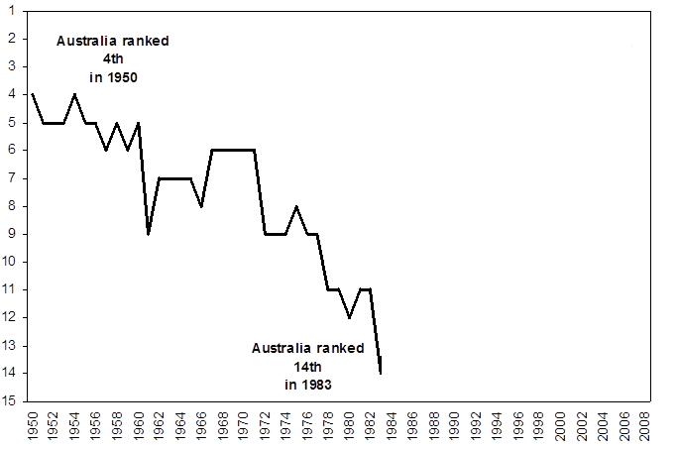
Source: see footnote 6

The policy settings that lead to this relative decline involved affording preferment to certain industries via quotas, high tariffs and subsidies; prescriptive approaches to the regulation of product and factor markets; inflexible work practices; government-owned infrastructure monopolies that saw high cost utility services; and heavily regulated export sectors in agriculture and mining.
By the 1980s Australia’s productivity performance relative to other nations was poor, as shown in Exhibit 2.
Exhibit 2
TOTAL FACTOR PRODUCTIVITY GROWTH, 1980 - 1990
%, average annual rate, OECD countries
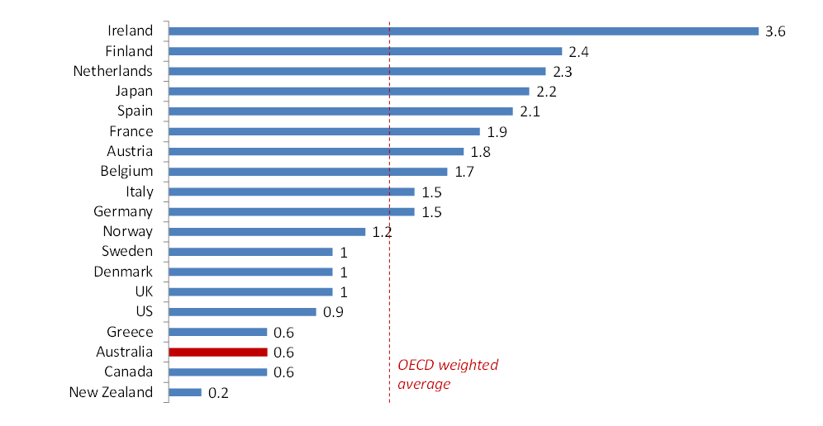
Source: OECD Data, referred to in Giuseppe Nicoletti and Stefano Scarpetta, “Regulation, Productivity and Growth:” OECD evidence”, Economic Policy Vol. 18 No. 36 (abril 2003), pp. 9-72.

Increasingly, the world was globalising and Australia was not keeping up.
Instead of competing domestically and internationally a growing number of Australian businesses put their efforts into lobbying government for support to cover their cost disadvantages.
The realisation of the need for change came slowly. It was helped, of course, by a growing international realisation by economists and others that governments generally had overestimated their capacity to replace the effective workings of the market.
In the early 1980s there was gradual change in trade reform as tariff quotas were phased out and some very high tariff levels were lowered.
The largest early changes were in the financial sector. In 1981 interest rate controls were removed and some bank lending restrictions were withdrawn. In 1983 the Australian dollar was floated, and then new bank licences were issued.
In the mid 1980s there were important tax reforms which lowered marginal tax rates and broadened the tax base.
It was, however, from the late 1980s that the wide ranging microeconomic reforms began.
In 1988 the Government announced that by 1992 tariffs above 15% (and there were many very high tariffs) were to be reduced to 15%; and in 1991 it announced that all tariffs would be reduced to 5% by 1996.
From the late 1980s and early 1990s there were some early reforms in telecommunications, electricity, water, road and rail.
In 1991 the Australian Commonwealth, State and Territory governments reached agreement on the need for a national competition policy and later commissioned an independent Committee of Inquiry into a National Competition Policy for Australia (which reported in August 1993)
As the NCP Report itself said, the need for such a policy was driven by three factors:
- The need for Australia to become an integrated single market able to compete internationally, rather than an economy limited by State and Territory boundaries.
- Recent micro-economic reforms had shown that the Trade Practices Act (which preceded the current Competition and Consumer Act) was too limited in its application, with coverage depending on ownership or corporate form, and
- It was seen that the early reforms begun since the late 1980s were being progressed on a sector-by-sector basis without the benefit of a broader framework covering both economic principles and political governance.
Overall, there was a recognition that if Australia’s economy was not competitive domestically it could not compete internationally. Harvard economist and ex McKinsey & Co strategist Michael Porter’s work helped define thinking about country competitiveness.
The Committee of Inquiry was chaired by Prof. Fred Hilmer. Fred was the Dean of the Australian Graduate School of Management, at the University of New South Wales (where he is now President and Vice Chancellor). He had, however, previously headed the Australian practice of McKinsey & Co, and so was well versed in Australian business strategy.
I first met him in 1982 when he sought to have me join McKinseys but I decided then to stay with public policy. He had, in the late 1980s, co-authored a landmark report on the problems with Australia’s industrial relations system, so we thought he was ideally suited to the task of chairing the inquiry, and so it turned out.
The NCP Report said that “Australia Competition Policy is sometimes seen as solely comprising the....Trade Practices Act...(however) the relevant field of policy interest is much wider..... The Committee has considered competition policy in terms of six specific elements....”. These are listed in Exhibit 3.
Exhibit 3
MAJOR NATIONAL COMPETITION POLICY ELEMENTS
Policy Element | Example
- Limiting anti-competitive conduct of firms | Competition conduct rules of Part IV of the Trade Practices Act
- Reforming regulations which unjustifiably restrict competition | Deregulation of domestic aviation and egg marketing
- Reforming the structure of public monopolies to facilitate competition | Proposed restructuring of energy utilities in several States
- Providing third-party access to certain facilities that are essential for competition | Access arrangements for the telecommunications network
- Restraining monopoly pricing behaviour | Prices surveillance by Price Surveillance Authority (later becoming part of the ACCC)
- Fostering “competitive neutrality” between government & private business when they compete | Requirements for government businesses to make tax-equivalent payments

First, it recommended some changes to the Trade Practices Act, but more importantly recommended it apply universally to all business activity in Australia. This largely involved extending the Act to cover unincorporated enterprises and government business enterprises.
Second, it recommended a comprehensive review and subsequent reform of all Federal, State and Territory legislation that regulated markets or restricted competition. If the public benefit of any legislation did not outweigh the competition detriment, the policy should be overturned, with the onus of proof on those wanting to maintain the competitive determent in the existing legislation.
Third, it recommended the structural reform of public monopolies, including separating out those parts that could viably operate in competitive markets, and breaking these potentially competitive activities into a number of smaller, independent business units before selling them.
Fourth, it recommended introducing a third party access regime to promote competition in markets that needed access to infrastructure which had the potential to create bottlenecks, such as electricity and communication wires, pipelines, railways and ports.
Fifth, it recommended independent pricing oversight to limit monopoly pricing or behaviour of any remaining public monopolies.
Finally, it recommended fostering “competitive neutrality” between government and private businesses when they compete. For example, the cost of debt should reflect business risk, and government businesses should operate in the same regulatory environment as competitors, pay tax, and be expected to earn a commercial rate of return.
The reforms that followed were fundamental.
As shown in Exhibit 4, many sectors were utterly transformed by the reform process. The telecommunications, rail and electricity sectors, for example, became unrecognisable, and Australia introduced world leading rural water reforms (although not without considerable effort, and they are still not yet complete).
Exhibit 4
EXAMPLE OF INFRASTRUCTURE CHANGES
FROM | TO
LATE 1980S | LATE 1990S (USUALLY)
Telecommunications  - Government owned Telecom fully vertically integrated, essentially no competition, self regulates | - Pro-competition access regime plus auction of new licences create many fixed line and mobile competitors to a privately owned Telstra
Electricity  - Each State owns a vertically integrated monopoly that faces no competition; grid essentially not connected across State borders | - Many electricity generation companies/retailers compete nationally across an interconnected east coast grid; monopoly networks as stand-alone businesses
Gas  - Trading only within State borders, many barriers to trade | - Interstate free gas trade; third party access regime to gas pipelines.
Rail Freight  - Each State has own rail freight monopoly, which is vertically integrated, and is loss making; freight trains often unload at State borders, no single accountability for freight travelling interstate | - Two privately owned competitors operating nationally formed out of previous State entities, with separate rail track company still government owned
Road Freight  - Different rules means trucks often cannot cross State borders; pay low and differing road user charges | - Very close to having national road freight rules and user charging, making for a national road freight market.
Aviation  - Separate publically owned domestic and international airlines, the latter strongly protected from competition | - Qantas privately owned and flying domestically and internationally in an “open skies” environment
Rural Water  - Non tradable virtually free water entitlements create static water usage, particularly to some very low value activities; water property rights in essence vest with land | - World leading water trading regime that separates water entitlements from land title and allows temporary and permanent trading within and between irrigation areas.
Urban Water  - Non cost reflective pricing; in some cases no usage based changes | - Largely cost reflective pricing; many cross subsides removed

The reforms that followed, however, ran far deeper than these headline changes to the main infrastructure sectors.
Around 1800 individual pieces of restrictive legislation were identified and listed for scrutiny. Approximately 85% of this legislation was reviewed and where appropriate reformed, and so change flowed widely across the economy. Exhibit 5 provides ten examples of the many changes achieved in various States of Australia.
Exhibit 5
EXAMPLES OF OTHER REFORMS
- Considerable deregulation of retail trading hours so stores can essentially open when they choose | - Reduced restrictions on health professionals  eg: introduced a nurse practitioner classification with authority to seek some diagnostic and pathology testing; removed restrictions on ownership of medical practices
- Reduced controls on liquor licensing that previously provided protection to the hotel industry, or required patrons who drink to also consume a meal | - Free up grain marketing  eg: end an export marketing monopoly for barley, and other grains, and a State domestic marketing monopoly for rice
- Reduced business licensing ‘red tape’  eg: NSW repealed 72 business licence categories | - End marketing restrictions on eggs and poultry  eg: end centralised compulsory price fixing, contract approval and supply restrictions
- Streamlined development assessment process eg: for major infrastructure and other projects of significance | - Remove dairy controls  eg: remove wholesale and retail price controls and supply management
- Reduced restrictions on the legal profession  eg: allow legal firms to advertise, incorporate and to form multi-disciplinary partnerships; remove legal profession’s monopoly on conveyancing | - Modernise a range of fishery management controls  eg: phase out non transferable licences, introduce full cost recovery, introduce greater flexibility

All of the above was nothing short of a competition revolution. These changes were forecast to lead to significant and wide economic gains for Australia, and they did.
- The benefits from these reforms in terms of productivity, growth, incomes and Australia’s overall economic standing.
An important reason the reforms came about were the gains forecast in 1995 by the then Industry Commission. These were substantial, and are shown in Exhibit 6, which is a slide used by Fred Hilmer in a speech he gave in 1995 to the Business Council of Australia, an organisation presenting Australia’s top 100 companies.
Exhibit 6
FORECAST GROWTH AND REVENUE BENEFITS FROM NCP CHANGES
1995 $
GROWTH
Real GDP | 5.5% | $23 billion pa
Real consumption | $9 billion pa | $1,500 per household
Real wages | 3% increase
Employment | 30,000 more jobs
REVENUE
Commonwealth | $5.9 billion
States, Territories, local government  State | $3.0 billion
Source: Industry Commission Report, 10 March 1995

These estimates of gains were said by the Industry Commission to be “outer envelope”, or the maximum effects. They assumed that the reforms are fully implemented and that the economy had fully adjusted to the reforms.
Looking back, there is no reason that I see to question these sizeable numbers.
I would, however, approach any assessment of the actual gains from the reforms from three angles, as follows:
- The “after the event” assessment of growth and income gains
- Specific sector gains
- The possibly less scientific overall and “feel good” effects

2.1. The “after the event” assessment of growth and income gains
In 2005 the Productivity Commission calculated that some selected NCP reforms had boosted Australia’s GDP by 2.5% above levels that would have otherwise prevailed. The modelling was selective in that it only covered the sectors shown in Exhibit 7, which also shows each sector’s contribution to this result.
Exhibit 7
CONTRIBUTION TO GDP GROWTH
Percentage points
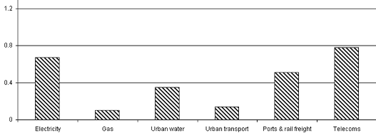 | Total 2.5%
Source – Australian Productivity Commission

In 2011 money this represents an enduring benefit of US$33 billion.
While the sectors shown in Exhibit 7 were the main sectors affected by the NCP reforms, there were effects across all of the economy, as shown in Exhibit 5, and the 2005 calculations excluded the all important dynamic efficiency gains. The modelling also did not pick up the impact from reforms undertaken after 2000 or the impact of earlier reforms not realised until after 2000.
Indeed, the Productivity Commission stated that the implication of these omissions is that “the total boost to GDP from the reforms will ultimately be considerably larger than the (2.5%) estimate which emerged (from its) modelling.”
One argument made against the reforms was a concern that they would advantage the wealthy and disadvantage the poor. Some argued that those Australians on low income, or that Australians living in rural or regional areas outside the cities, would be worse off.
The Productivity Commission, therefore, also incorporated a distributional component into its modelling. This showed that the benefits from the reforms flowed broadly among Australians. Real incomes rose across all income brackets, as shown in Exhibit 8, although the average income gain was not equal.
Exhibit 8
INCREASE IN REAL INCOMES FROM NCP REFORMS
% change, 1989-90 to 1999-00
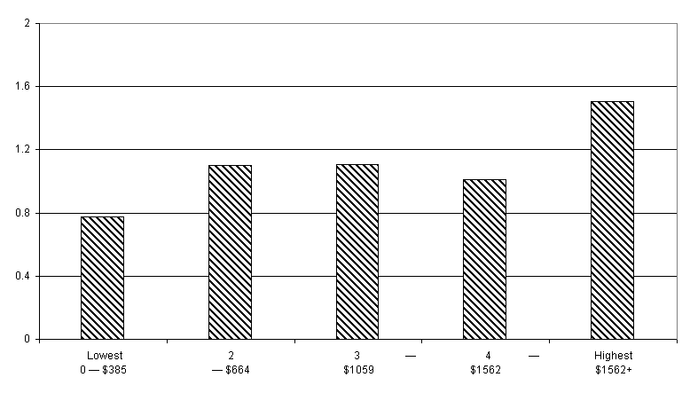
Household Income

2.2. Some specific sectoral gains
While it is not possible to isolate the impacts of the NCP reforms from many other factors, it is telling that in a number of areas targeted by the NCP reforms there were significant price reductions, as follows:
- In the electricity sector, average real prices Australia-wide fell by 19 per cent between the early 1990s and 2004.
- There were substantial reductions in rail freight rates in the second half of the 1990s, ranging from 8 per cent for wheat up to 42 per cent for some coal traffic.
- Between 1996 and 2003, average telecommunications charges fell by 29 per cent for business and 17 per cent for households.
- After deregulation in 2000 the average retail price of milk fell by 5% in real terms despite the imposition of an 11 cents a litre industry assistance levy to assist dairy farmers in the transition.
It must be acknowledged, and it is not surprising, that there was a net employment reduction across all infrastructure sectors of 31,000 between 1990 and 2003, as shown in Exhibit 9. This Exhibit also shows the effect of privatisation.
Exhibit 9
Employment changes in infrastructure industries a, 1990 to 2003
‘000 employees
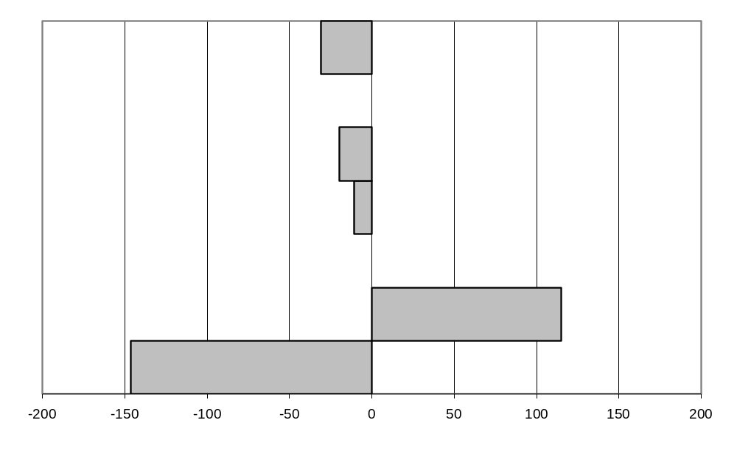
a Comprises electricity, gas, water, road transport (including passenger services), rail, telecommunications, and postal and courier services.
Data source: ABS (Survey of Employee Earnings, Benefits & Trade Union Membership, Cat. no. 6310.0, unpublished data).

It should be noted, however, that the declines occurred in the first half of 1990s, and were then followed by increases. Indeed, after declining by 50,000 jobs between 1990 and 1995, total employment in the infrastructure sectors increased by 19,000 in the subsequent eight year period.
There were other effects which could be seen as negative, but which were in fact intended. For example, urban water prices increased, in some cases significantly, as it was recognised that artificially low water prices encourage excessive consumption of a scare resource, and blunt investment signals.
2.3. The overall and “feel good” effects
When looking at aggregate numbers it is hard to determine cause and effect. Nonetheless, a number of studies have largely attributed what follows to the NCP reforms and the other pro competition changes such as the tariff reductions.
By 2005 the NCP reforms had contributed significantly to a productivity surge that has underpinned 13 years (now 21 years) of continuous economic growth. Australia’s productivity performance went from being one of the worst in the OECD to one of the top performers, as shown in Exhibit 10.
Exhibit 10
Total Factor Productivity growth, 1990-2000 vs. 1980-1990

Percentage Points, difference between average annual growth

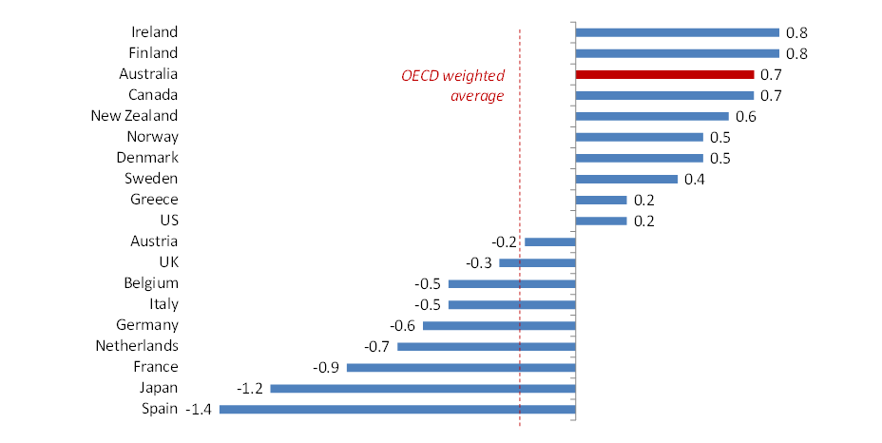
Source: OECD Data, referred to in Giuseppe Nicoletti and Stefano Scarpetta, “Regulation, Productivity and Growth: OECD evidence”, Economic Policy Vol. 18 No. 36 (april 2003), pp. 9-72.

This relative productivity performance also translated into a strong relative growth performance, as show vividly in Exhibit 11.
Exhibit 11
Real GDP growth, Australia vs OECD

Percentage Points, difference between average annual growth

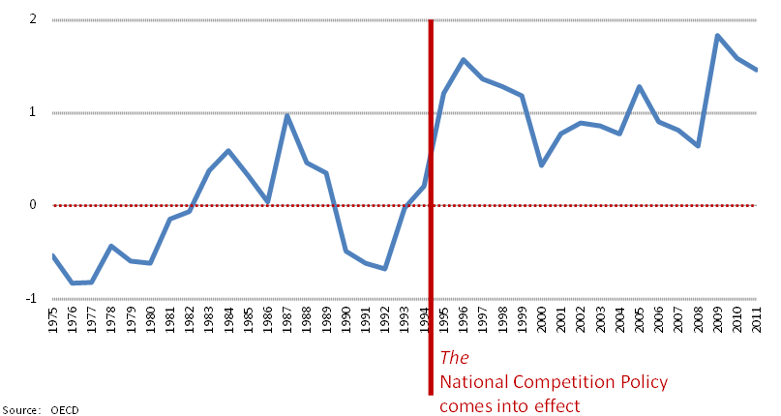
It is also worth noting that the rate of increase in per capita incomes in the second half of the 1990s was as high in Australia as at any time in the 20th Century, and that unemployment was at its lowest level in three decades. While, as previously stated, cause and effect is difficult to determine, the tangible benefits and then the overall dynamism generated by the reforms must take significant credit.
Indeed, there was a clear “feel good” effect. As Exhibit 12 shows, by the late 1990s Australia had regained its per capita GDP rating and in 2008 it still ranked 5th.
Exhibit 12
AUSTRALIA’S RELATIVE DECLINE AND RESURGENCE
Per capita GDP (PPP) ranking in OECD
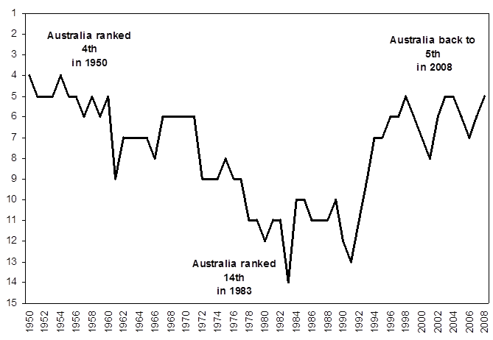

I think it is possible to argue that such a relative positioning puts a collective “spring” in a nation’s step. Much as Australia gained a feeling of general pride from a successful staging of, and performance in, the 2000 Olympics, I think it is fair to say it also gained a collective feeling of pride from the successful NCP reforms.

- Why and how the reforms were achieved
This is not the place to delve into Australian history. Also, the questions of why and how the reforms were achieved can elicit only a subjective response, and many will be specific to Australia.
That said, there may be some value to this audience if I provide some perspectives. Part of what follows may either strike a chord, or yield an insight of value, as you chart the way forward here in Mexico.
This section divides into two. First, some views on why the NCP reforms occurred; then views on how the reforms were actually achieved.
Consistent with the above, these sections contain short, discrete observations, which I have kept to five under each heading.
  - Why the NCP reforms occurred
Under this heading the following seem the most relevant observations.
First, prior to the NCP reforms Australia had experienced a long debate over tariff reform. Indeed, the debate over whether or not to use tariffs to protect our manufacturing industry dates back to Australia’s beginnings as a nation in 1901.
By the 1970s and 1980s, however, Australia lived behind a high tariff wall, and the costs and benefits of this were increasingly debated. The Tariff Board was founded in 1921; in 1973 it became the Industries Assistance Commission; then the Industry Commission; and from 1998 the Productivity Commission. The name changes are telling.
Originally established to set the required tariffs, these bodies increasingly questioned the wider costs to Australia of industry protection. These fierce debates exposed the trade-off between large and visible benefits to one industry and its employees, and the widely distributed and so smaller costs to all other industries, and so the Australian community generally.
The debate was eventually settled in favour of essentially removing tariffs, with the first major step taken in 1988, as already mentioned.
This success laid a key foundation stone; the public understood that there were large costs to society of preferential treatment for particular industries. An important economic evaluation framework, albeit vague to some and at a high level, was accepted by the majority of the electorate.
Second, the Australian economy was performing poorly, and this was seen to be getting steadily worse. In 1986 and 1988 the Australian Treasurer and then the Prime Minister bravely made powerful statements that posed challenges that had to be addressed.
Facing what was then Australia’s worst current account deficit on record, the Australian Treasurer said on radio “We must let Australians know truthfully, honestly, earnestly, just what sort of an international hole Australia is in... The only thing to do is to slow the growth down to a canter, and once that happens...unemployment starts to rise...”
The trade-off was clear. Avoid a current account problem by slowing growth to reduce imports; or reform the economy and have Australia grow its way out of the problem. In 1986 the Australian Treasurer posed a powerful and clear choice for Australia.
In 1988, in a deliberate agenda setting speech, the Australian Prime Minister said that Australia’s economy was more fragmented than Europes. This struck a chord; it was an indictment that Australia, as a single nation, had more fragmented rules covering, for example, its energy market and land transport sectors, than did Europe with all its separate countries.
This statement also required action; the Prime Minister created a challenge his Government had to address. This challenge was a driving force for the NCP Review, as mentioned in Section 1.
Third, after the floating of Australian’s exchange rate and then the effective removal of the tariff wall, Australian industries were exposed to international competition, and had to adapt and become more efficient.
These industries complained, increasingly loudly, that they could not get access to competitively priced inputs. Australian governments came under pressure for the prices of electricity, gas, transport and communications to be reduced. The responsible entities were at that stage owned and regulated by governments.
A wide constituency was built for reform, from business, the media, and some in parts of the social sector and unions. Their industries were being held back, or they wanted the benefits that higher government revenues would bring.
Fourth, and as shown in Exhibit 6, the public had the gains quantified by the respected Industry Commission. A $23 billion per annum boost to national output, $1,500 extra for each household, more jobs and higher government revenues. Why would we not pursue these gains?
Fifth, and of course fundamental, there was strong political leadership. The Prime Minister, the Treasurer and 4-5 key Ministers in the 1983-1996 Labor Government drove the early reforms, and were assisted by some strong, pro reform Premiers (heads of State Governments) from non-Labor parties. Also the then Leader of the Opposition bravely supported many of the Labor Government’s reforms. In a number of areas he carried forward the reforms and he benefited from them generally as Prime Minister himself from 1996-2007. This cross-party consensus for reform also made it difficult for those wanting to oppose reform.
  - How the reforms were achieved
Again, five main points may be relevant to this audience.
First, the formation of the Council of Australian Governments (COAG) in 1992 brought together Australia’s Prime Minister and all State and Territory leaders to drive wide ranging reform. It was this group that, in 1995, and following receipt of the NCP Report, committed to three pivotal agreements that set NCP policy objectives and direction, saw the reach of competition law widened, and reached agreement to implement key reforms and on a future reform process.
It was COAG that gave the NCP process authority and priority.
Second, and closely following the first point, while the main work was usually undertaken by industry experts, central agency people were closely involved. This reflected the interest of the leaders of governments in the progress of the reforms, and the desire to ensure progress did not slip as the “old guard” and vested interests (often with the most industry knowledge) fought to keep key parts of the status quo.
Third, COAG created a new institution, the National Competition Council (NCC), as an independent body to assess the progress of all governments on implementing their agreed reforms. Its assessment processes were transparent and its findings were made public.
In this way governments were held to account if they did not meet their specific reform commitments. In addition, in relation to the reviews of the 1800 pieces of legislation, the NCC assessed the quality of these reviews and challenged review recommendations that were not supported with evidence. When governments opted not to change legislation that restricted competition, the NCC publicly assessed the justification given.
Fourth, to encourage reform, the Federal Government established a system of payments to States known as National Competition Payments. These payments recognised the benefits to federal government revenues to be gained from the reforms, and sought to share them with State Governments that had to make the changes to bring these benefits about.
It was the NCC that recommended to the Federal Treasurer whether the State Governments had “earned” their payments; whether they had sufficiently undertaken the agreed reforms, and appropriately assessed other legislation that restricted competition.
These National Competition Payments had three benefits; first, the State Governments had an incentive to change as they wanted the payments; second, they suffered political opprobrium if some payments were seen to be withheld; and third, they could use the payments as an excuse for change.
On this last point State Government Ministers often said, in effect, “we do not want to make this change, but we will lose the payments which can provide needed services if we do not”. That is, State Ministers often found the need to achieve the payments an easier public excuse for change than making the logical case, which sometimes involved complex concepts.
Fifth, the Hilmer NCP Report considered what type of regulatory institutions should administer the reforms. The options were to combine the technical and economic regulation in sector specific regulators; or to organise technical regulation as a stand-alone function, and include economic regulation within the competition agency.
As the NCP Report says...”The Committee began its task with a sceptical bias against the need to establish separate regulators for individual industries. Apart from the risk of “capture” by the regulated industry, approaches of this kind fragment the application of competition policy and cause issues of consistency between industries. There are also forgone opportunities to develop and apply the insights gained in one industry to analogous issues in other industries, a fragmentation of regulatory and analytical skills, and typically greater administrative costs”.
Following the recommendations of the NCP Report, the Australian Competition and Consumer Commission (ACCC) was established with economy-wide responsibility for economic regulation in addition to competition law and consumer protection. Thus the ACCC is responsible for industry specific economic regulation in telecommunications, it incorporates the Australian Energy Regulator, it administers the general infrastructure access regime set out in Part IIIA of the Competition and Consumer Act, and it has important regulatory and/or monitoring roles in the rural water trading regime, airports, land transport and ports.
The advantages of having general competition law and industry specific regulation combined in the one organisation have been important to sustaining emerging competition in new sectors. For example, in telecommunications the initial reliance on general competition law and the negotiate/arbitrate approach to access to the previous monopolist’s copper wire has, with a pro competition approach, given way to more direct access declaration and price setting powers for the ACCC, which has driven a more competitive telecommunications market in Australia.
Rather than simply regulate the previous telecommunications monopoly, a pro competition approach was taken.

- Some of the lessons we have learnt which may be useful to you
With hindsight, the need for reform can seem so apparent the outcomes so beneficial, that you could be forgiven for thinking the reforms received universal support when they were being undertaken. Indeed, one of the few things both sides of Australian politics agree on now is that Australia’s microeconomic reforms of the 1980s and 1990s formed a key foundation for what in Australia has been 21 years of uninterrupted growth.
Of course, these reforms did not receive universal support at the time. Reform is a long, hard process; the winners are many and usually quiet, the losers are few and extremely vocal.
As someone close to many of these reforms I can say we made mistakes, and from mistakes you learn, as with all things in life.
Looking back, I think there are perhaps 10 lessons I would share. Some may be obvious, others not. I will list them all, both to be comprehensive, and in the hope one or two may be useful to you.
First, prepare the ground well before proceeding with reform. Unfortunately in Australia and elsewhere today we often hear that reform is too difficult. Some politicians float reforms, and drop them when there is initial resistance.
Reform will fail, however, if it lands on ill prepared ground. Before precise reforms are announced, or before reform seeds are dispersed, there needs to be well prepared ground; explaining why reform is needed, and what it will achieve.
Section three above provided many examples of how the ground was prepared; much prior work on the costs to society of high tariffs and on the benefits of reform to specific industries and the economy as a whole. This required a focus on economic linkages and flow on effects; and continuing repetition.
Here I want to share an anecdote, which I hope with a small amount of diligent groundwork and soil tilling, won’t be lost in translation. Australia has a common native parrot called a galah, which in captivity is known to be able to ‘talk’ by mimicking overheard conversation. Not coincidently, ‘galah’ has also become Australian idiom for someone who is a bit of a fool or loud mouth. At one point during Australia’s long micro-economic reform process the then Prime Minister responded to a media question about the alleged slow pace of reform saying that “I guarantee if you walk into any pet shop in Australia, the resident galah will be talking about microeconomic policy.”
The Prime Minister may not have been happy about it, but this neatly sums up where debate in Australia landed during the reform process. The issue was principally not whether micro-economic reform should occur; this became accepted as a given. Despite some of the negative consequences of reform, the public debate was around whether the reforms were occurring quickly enough.
This can only arise where there has been sufficient groundwork to foster support for the reforms.
Second, pursue reform on a broad front. There are many benefits from this; the losers do not feel they are the only ones, and they may win from other changes.
Moreover, specific reforms are easier to defend if they are seen as part of an integrated agenda with wide community benefit.
Third, formulate a well structured agenda that is not cluttered. The reforms must be seen as meaningful and able to bring the promised large benefits, and they need to be prioritised to deliver some early wins that provide broader confidence that the agenda can be delivered.
There may seem to be a contradiction to moving on a broad front and not cluttering the agenda, but there is not. While moving on a broad front is essential there are only so many people with the required skills to achieve successful reforms, and only so much high level political focus.
This leads to the next lesson.
Fourth, reform requires high level political drive and constant attention, with appropriate support structures. Governments are like companies; everyone notices what interests the CEO.
Likewise, successful reform requires the constant attention of the (Mexican) President or the (Australian) Prime Minister. This constant attention also needs strong support structures, such as the COAG mentioned earlier, and strong roles for central agency officials to work with and guide the industry experts.
In Australia there is a highway named after an early European explorer, the Eyre Highway, which stretches across a massive flat almost treeless landscape known as the Nullarbor Plain. This road contains the longest straight section of tarred road in Australia at almost 150km. You have an unobstructed view of the road all the way to the horizon. The dry desert ensures the road’s surrounds are clear from trees or other obstacles which may obscure a hidden danger. The weather is almost always clear. Tragically, many people lose concentration and have serious accidents on the highway.
The moral is clear. It is not enough to set strong goals and to have a clear vision.
The reform road is long and requires constant attention.
Fifth, set a considered, not a frenetic pace. There is no better way to express this point than to quote Fred Hilmer himself from a speech he gave in 1995.
“...it is critical that as the package is implemented there be no ‘deregulation disasters.’ Microeconomic reform in general suffered from the experience of the first few years of banking deregulation (in the early to mid 1980s)...There is a lesson here for competition policy. Blackouts, service operating problems in utilities, sharp and surprising rate hikes to certain classes of consumers....if these type of events occur the whole cause of competition policy reform will seriously damaged. It is more important that progress is inevitable, clear and deliberate than that arbitrary deadlines are met in ways that end up undermining reform”
It remains only to add that an existing reform agenda needs to be seen to be progressing well before new items are added.
Sixth, provide financial assistance and/or incentives to achieve reform. This was an important feature of the Australian reforms. Assistance was provided to industries facing significantly lower tariffs and other changes (eg the dairy industry), and National Competition Payments were made to the State Governments in exchange for undertaking the required reforms.
Usually, the costs of such assistance or incentives are short-lived, while the benefits last much longer. The support also recognises that some bear the brunt of reform (which, of course, is the flip side of their gains from past distortions), yet the whole community benefits.
Seventh, get industry structures right. This is crucial. Sometimes in Australia we got this right, sometimes we got it wrong with high long term costs.
When restructuring monopolies there are two key elements, one vertical, the other horizontal.
At the vertical level, separate out the potentially competitive segments from those that are natural monopolies. Electricity is a clear example; generation and retail can be competitive businesses, while the poles and wires are a natural monopoly. It is important to separate them so that the competitive segment does not use its monopoly to remove or limit competition.
Other examples are separating the operation of trains and ownership of track, and separating ownership of natural monopoly telecommunications infrastructure from retail functions.
At the horizontal level, it is important to break up the competitive segments to create sufficient competition. For example, in the State of Victoria the old electricity generation monopoly was broken up into many separate operating units despite considerable opposition at the time. The subsequent reform experience has seen a fiercely competitive electricity generation sector.
Eighth, it follows that there is seldom if ever any merit to the “national champions” argument. We still hear this argument in Australia.
The argument is that a country needs strong, large, domestically owned companies for its economy to thrive. This is only true if those companies achieve this status by out-competing their local opposition. If governments grant them this status they will simply become bloated and lazy, and overcharge their customers.
Creating “national champions” is the opposite to promoting competition, and has the reverse effects.
Ninth, ownership matters but privatise for competition and efficiency, not for maximum sale proceeds. It follows that government need to be very careful when privatising not to follow too closely the advice of investment bankers.
In my personal view, government owned commercial enterprises are inherently inefficient, at least in an Australian context. If governments want to maintain ownership there must, therefore, be strong non commercial objectives being pursued to overcome the costs of continuing the inefficiency that comes from public ownership.
It essentially follows that the reason for privatisation is to improve efficiency, not to maximise the sale proceeds. This distinction is crucial. If maximum sale proceeds is the objective, then monopolies will be sold as such, and not disaggregated, or they will be poorly regulated so that they can increase prices to the continuing cost of the community.
Tenth, deregulation does not mean no regulation. Strong competitive market economies thrive on low levels of government regulation, but they need some.
Often the pendulum will swing too far. In a frenzy of deregulation all regulation can be removed. In Australia we hear monopoly businesses arguing to be freed up to maximise innovation and competition. But they are often natural monopolies, competition is not possible and they have no pressure to innovate.
While there are always costs to regulation, there are usually much larger costs from unfettered monopolies and the use of market power.
In addition, we are all aware that the profit motive works to society’s benefit only if there is a respected and completely independent competition regulator preventing abuses of dominance and anti competitive agreements and mergers.
Concluding remarks
If you can forgive me stretching my earlier road metaphor a little further, it is in my view fitting to see competition as a journey, not a destination. There is no direct end point; markets shift and evolve, and so do the challenges facing governments and regulators.
Australia took the approach of implementing a specific set of reforms over a ten year period, which provides a useful 2005 case study on what was achieved, but we cannot declare “job done”. We needed to, and in part did, have new reform processes underway, but reform fatigue is ever present.
Australia faces continuing challenges in encouraging effective competition and sensible economic regulation in areas including telecommunications, transport, education and health care. We are also grappling with the many new dimensions of the changing online landscape. We have numerous concentrated sectors, and continue to identify cartels and many other anti-competitive practices which damage Australia’s economy.
There is much for my organisation, the ACCC, to do in terms of enforcing our existing laws, and in being an outspoken advocate of increased competition and improved regulation.
All nations, including Australia, must constantly be looking for new areas to open up to competition. And you must regulate for effective competition. It is crucial to protect the process of competition, not particular competitors, a discipline which must be upheld even in times of economic turmoil such as the Global Financial Crisis.
But I have no doubt that you recognise this and understand the challenges ahead. I read the Message to the Nation of your President, Enrique Peña Nieto, on 1 December last year. While I apologise for my English translation of his speech, I understand he said that:
“In the life of a country, six years is a short period, but 2191 days are enough for laying the foundations for what now must be our goal: to make Mexico a prosperous country, with new opportunities and greater welfare for all.”
Such reforms and the benefits of those reforms will not occur overnight, but these foundations will be fundamental.
Get it right and the benefits will flow. And as I said at the beginning, competition reform is really the only way simultaneously to boost economic growth and address income inequality.
From my own experience I can attest that it is immensely gratifying to initiate a process which lifts the standard of living of millions of people in your own country.
Thank you for your time today, and I wish you all, and Mexico, the very best for the future.

Prior to his current role Rod Sims was Chairman of the Independent Pricing and Regulatory Commission in NSW, a Councillor with the National Competition Council, Chairman of InfraCo Asia (an infrastructure development company based in Singapore), a Director of Ingeus (one of Europe’s largest welfare-to-work outsourcing companies), and a commercial strategy adviser to a number of Australia’s top companies. He gave up all these positions on being appointed Chairman of the ACCC. Earlier in his career (from the mid 1980s to mid 1990s, relevant to today’s discussion) he was in charge of microeconomic policy, and then Deputy Secretary, in the Department of Prime Minister and Cabinet; Deputy Secretary in the Department of Transport and Communications; and (from 1988-90) Principal Economic Adviser to Australia’s Prime Minister.
William W Lewis, “The power of Productivity”, The McKinsey Quarterly, 2004, No2. This reference was provided to me by Fred Hilmer; see his speech to the Sydney Institute, 31 August 2010, “What’s wrong with microeconomic reform today”; or his speech to the ACCC Regulatory Conference, “Learnings from Successful Competition Policy and Productivity”, available on the ACCC website.
Referred to in footnote 2
P.6
These three paragraphs are essentially taken from the work of Dean Parham, “Microeconomic reforms and the revival in Australia’s growth in productivity and living standards”, Conference of Economists, Adelaide, 2002, page 3
See Paul Gretton, “National economic reform in a federal system – the case of Australian national competition policy and related reforms”, paper to the conference on federation and reform in Asia, New Delhi, December, 2010, page 6.
See National Competition Policy, Report by Independent Committee of Inquiry, August 1993, pXVII-XVIII
Pages XVI-XVII
Productivity Commission, Review of National Competition Policy Reforms, Inquiry Report No33, February 2005.
See Gretton, 2010, footnote 6; and Parham 2002, footnote 5.
PXXXV
Prof. Fred Hilmer, “The National Competition Policy: Grasping the Nettle”, in “Making Hilmer Happen”, Business Council of Australia Bulletin, 1995, p 11

