ACCC Review of the Water Charge Rules—Overview of the Draft Advice
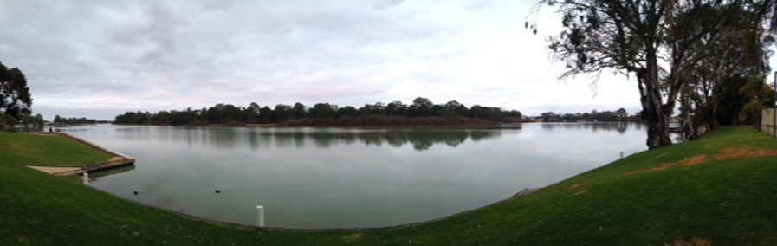
A view of the Murray River in Renmark, SA
Source: ACCC Staff
The ACCC’s Draft Advice is targeted at promoting efficient and sustainable use of water infrastructure, facilitating effective water markets and improving transparency of charging arrangements, while addressing the need to reduce the burden on the sector.
This document is intended to assist stakeholders in understanding the ACCC’s Draft Advice and proposed water charge rules. It contains four sections:
About the water charge rules review
Water charging arrangements in the Murray-Darling Basin
A brief explanation of the amendments to the water charge rules that the ACCC is proposing
Consultation process and timeline (including how to make a submission).

About the water charge rules review
In December 2014, the Minister requested the ACCC to review the three sets of water charge rules.
- The Water Charge (Infrastructure) Rules 2010 (WCIR)—set requirements relating to the charges payable to infrastructure operators for infrastructure services
- The Water Charge (Termination Fees) Rules 2009 (WCTFR)—regulate the maximum amount of termination fee payable to an operator when a customer terminates access to water service infrastructure
- The Water Charge (Planning and Management Information) Rules 2010 (WCPMIR)—place information requirements on persons determining charges for planning and management activities.
The water charge rules were made under section 92 of the Water Act 2007 (the Act). The rules have now been in place for around five years after being introduced at a time of significant reform within the Murray-Darling Basin. Since the introduction of the rules, charging practices and water markets in the Murray-Darling Basin have continued to evolve and develop. As such, it is timely to review the rules to ensure they remain appropriate and fit for purpose.
The ACCC’s analysis and findings from reviewing the water charge rules to date are set out in the Draft Advice. The proposed water charge rules show what the rules would look like if all of the ACCC’s draft rule advice is accepted. You should consider these documents when providing feedback to the ACCC.

Water charging arrangements in the Murray-Darling Basin
Water charging arrangements in the Murray-Darling Basin vary between and within states. Further, the terminology used varies considerably across the Basin.
This section provides background information on the participants, types of tradeable water rights and regulated water charges in the rural water sector, explained in the terms that are used in the Draft Advice.
These generic terms may differ from terms used in specific circumstances—for example, ‘water access entitlement’ as defined by the Water Act is called ‘water share’ in Victoria, ‘water access licence’ in New South Wales, ‘water access entitlement’ in South Australia and ‘water allocation’ in Queensland. An expanded discussion on the water charging arrangements is in Chapter 2 of the Draft Advice.

Participants in the rural water supply chain
Government departments and water authorities undertake planning and management activities to plan for and manage water resources. These activities include:
- managing water access entitlements
- managing trade registers
- making water allocation decisions
- water monitoring
- environmental works to minimise the negative impacts of consumptive use.
Infrastructure operators own or operate infrastructure to provide a service (e.g. storage, delivery or drainage of water) to another person. These services are known as an infrastructure services. Water service infrastructure can include dams, weirs, channels, pipes and associated equipment.
Infrastructure operators can have a range of different customers. These include irrigators, environmental water holders, commercial operations and other infrastructure operators like urban water supply networks. Infrastructure operators can also be water users themselves; for example, an operator may hold its own separate water right which it uses to cover distribution losses.
Water users Irrigators make up the overwhelming majority of water users in the Murray-Darling Basin. Irrigators can be located either on-river or off-river. On-river irrigators are called ‘private diverters’ and take their water directly from the river. Off-river irrigators are irrigation infrastructure operator (IIO) customers and rely on the IIO’s channels and / or pipes to have water delivered to their property. Other water users include:
- environmental water holders
- rural stock and domestic users
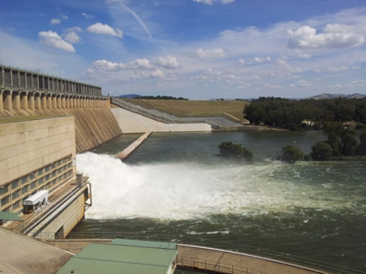
- manufacturing and processing operations
- commercial plantations (e.g. forestry)
- mining operations
- operators of urban water supply networks.
Just like irrigators, these other water users require infrastructure services for the storage and delivery of water access rights that they hold. Typically, they will incur the same types of charges as irrigators where they use the same infrastructure services.
Hume Dam, NSW
Source: ACCC staff

Types of services in the rural water supply chain
The infrastructure services provided by infrastructure operators can be categorised as ‘on river’ or ‘off-river’.
On-river infrastructure services include harvesting and storing water through infrastructure such as dams, lakes, weirs and reservoirs and delivering water, primarily through natural watercourses, to a point of extraction on a natural watercourse. On-river infrastructure services are sometimes referred to as ‘bulk water services’. Consequently, infrastructure operators that provide ‘on-river services’ are sometimes referred to as ‘bulk water suppliers’. The charges imposed by on-river infrastructure operators are sometimes referred to as ‘bulk water charges’.
Off-river infrastructure services include delivery of water from an extraction point of a natural watercourse through a network consisting of channels and/or pipes (which can be gravity-fed or pressurised) to a water users’ extraction point. Infrastructure operators that provide ‘off-river services’ are often referred to as ‘irrigation infrastructure operators’. An irrigation infrastructure operator delivers water for the primary purpose of irrigation and its water service infrastructure is its ‘irrigation network’.

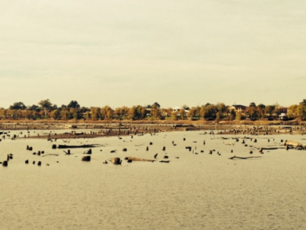
Tradeable water rights
Water users holding a tradeable water right have a right to access or use water in the Murray-Darling Basin. Basin States and operators use different terms to refer to tradeable water rights. The Draft Advice and proposed amended rules use the same terms as the Water Act.
The following types of rights can be traded between different water users and locations in water markets throughout the Murray-Darling Basin:
- water access right Lake Mulwala, Yarrawonga, Vic
- irrigation right Source: ACCC staff
- water delivery right.
A water access right is a statutory right to hold or take water, which includes:
- water access entitlement—a perpetual or ongoing entitlement to exclusive access to a share of a water resource. Trade of a water access entitlement is sometimes referred to as a ‘permanent trade’. It is also possible to lease a water access entitlement.
- water allocation—a specific volume of water allocated to a water access entitlement in a given water accounting period. Trade of a water allocation is sometimes referred to as a ‘temporary trade’.
Irrigators are able to sell or lease some or all of their water access entitlement or water allocation, without seeking the irrigation infrastructure operator’s approval. Water access entitlements can also be used as a form of security in obtaining finance and to gain access to carryover of water allocations.
An irrigation right is a right that a person holds against an irrigation infrastructure operator to receive water (which is not a water access right or a water delivery right). An irrigator is able to trade all or a part of their irrigation right but requires the irrigation infrastructure operator’s approval to do so. An irrigation right can be transformed into a statutory water access entitlement held in the customer’s own name. This process is known as ‘transformation’ and is regulated under the Water Market Rules 2009.
A water delivery right is a right to have water delivered by an infrastructure operator. It is a contractual or statutory right which entitles the holder to access services for the delivery of water through an operator’s infrastructure. Usually, water delivery rights are held in relation to an operator’s infrastructure (e.g. pipes and channels) and are used for the delivery of water to an irrigator’s property or to another designated location – for example to a wetland in the case of an environmental water user.. A customer can modify their water delivery right in two ways:
- terminate their access right and pay a termination fee or
- trade their water delivery right to other irrigators located in the area serviced by their infrastructure operator.
Water delivery rights could also be specified for on-river delivery services.

Regulated water charges
The water charge rules apply to three broad types of regulated water charges (as defined under section 91 of the Water Act 2007):
- water planning and management charges;
- infrastructure charges; and
- termination fees.
Information on these charges, including longer-term trends and tariff structures, is available in the ACCC’s water monitoring reports.
Planning and management charges are imposed by or on behalf of government to recover some or all of the costs associated with planning and management activities. These charges may be levied on infrastructure operators or on water users directly.
Planning and management charges are regulated by the Water Charge (Planning and Management Information) Rules 2010.
Proposed changes to planning and management charge rules are discussed in Chapter 6 of the Draft Advice.
Infrastructure charges recover the cost of infrastructure operators providing infrastructure services to customers. They are not charges for physical water or water access rights. However, infrastructure operators often use the volume of a tradeable water right held or used by a customer as a proxy for that customer’s use of infrastructure services and therefore their liability for infrastructure charges.
Infrastructure operators that provide on-river infrastructure services impose infrastructure charges to recover the costs associated with:
- water harvesting and storage; and
- water transportation and delivery.
Infrastructure charges for on-river infrastructure services are usually levied on the volume of water access right held and / or used by a customer.
Infrastructure operators that provide off-river services impose infrastructure charges to recover the costs associated with:
- the day-to-day operation of their infrastructure;
- maintaining / renewing their infrastructure;
- meeting overheads.
Infrastructure charges for off-river infrastructure services are typically levied on the volume of water delivery right held by and / or water delivered to a customer.
Infrastructure operators may also incur planning and management charges or infrastructure charges. The cost of these charges is passed on to the infrastructure operator’s customers.
Infrastructure charges are currently regulated by the Water Charge (Infrastructure) Rules 2010.
Proposed changes to infrastructure charge rules are discussed in Chapter 5 of the Draft Advice.
Termination fees are charges payable to an infrastructure operator by customers when they terminate or surrender all or part of their right of access to the infrastructure operator’s water service infrastructure.
Termination fees are capped and are only payable in some circumstances.
Termination fees are regulated by the Water Charge (Termination Fees) Rules 2009.
Proposed changes to termination fee rules are discussed in chapter 6 of the Draft Advice.
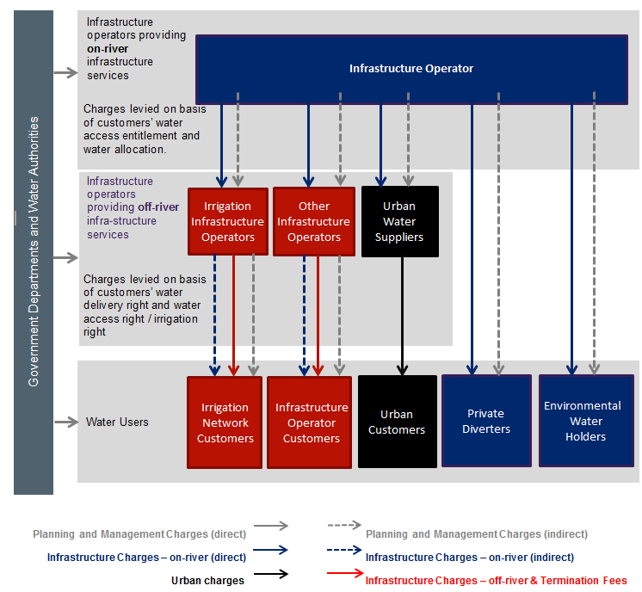
Figure 1 — Overview of regulated water charge arrangements including the rural water supply chain participants.

Summary of proposed amendments
The Draft Advice contains numbered ‘draft rule advice’ and ‘recommendations’.
Draft rule advice: the ACCC’s proposed amendments to the water charge rules to address the issues identified (where rule amendments are considered the preferred course of action).
Recommendation: the ACCC’s view on some other course of action that should be taken in order to address the issues identified.
The proposed water charge rules and the amending instrument (i.e. the instrument that will change the current rules to the proposed water charge rules) are available from the ACCC’s website at www.accc.gov.au/water-charge-rules-review/draft-advice.
The proposed amendments set out in the Draft Advice seek to achieve a number of outcomes. A summary of each outcome, and the relevant rule advice, is provided below.
Outcome | Current Rules | Proposed Water Charge Rules | Rule advice
Streamlining the rules and ensuring a consistent approach | Complex tiered structure based on operators' size, ownership and activities | Streamlined structure: no tiers, price determination under the water charge rules (WCR) only in limited circumstances | 5-A, 5-G, 5-M, 6-A
 | Requirements spread over three sets of rules | Rules combined into one instrument; right of private action extended to the WCR as a whole | 4-A to 4-C
Improving pricing transparency and customer engagement | Schedule of Charges requirements set at high level, leading to a lack of clarity in many cases | Schedule of Charges requirements specific to provide clarity & apply to both infrastructure operators and other entities who determine planning & management charges | 5-E, 5-F, 5-I, 5-K, 7-B
 |  | Schedule of charges timing and publication requirements improved | 5-H, 5-J, 5-K, 6-D
 | No transparency on how charges are passed through | Pass-through charge rule ensures transparency and non-discrimination | 5-Y, 5-Z
 | Operators not required to explain termination fee calculations | All operators required to explain how termination fees are calculated | 6-F
 | Prescriptive network planning and consultation requirements for some operators only | All operators now required to provide a statement on how customers can be involved and make inquiries in charging decisions  Network planning and consultation requirements (Part 5) repealed | 5-F  5-L
Ensuring charge approvals and determinations where necessary | Rules require the approval or determination of infrastructure charges previously regulated by States | Rules recognise limited incentives to seek monopoly rents, ongoing regulation of infrastructure operators’ other charges by states, and focus on pricing outcomes across customers:  Costs of large non-member owned operators continue to be scrutinised by State regulators  Amended application of price approvals under the WCR (Part 6) | 5-M
 |  | Improvements to mechanics of how price determinations operate under Part 6 the WCR | 5-N to 5-R
 | No effective deterrent for operators to make many distortionary types of distributions | ‘Safe harbour’ forms of distributions made clear; other distributions that discriminate between customers unfairly trigger regulatory scrutiny of charges  Application of rules governing operator distributions (Part 7) include ability for ACCC to exempt application of Part 7 | 5-S to 5-V
Preventing discriminatory charging | Limited protection against discriminatory infrastructure charges for transformed customers in member-owned operators  Operators are free to impose higher charges on non-preferred customers for the same infrastructure service | Enhanced non-discrimination rules prohibiting discrimination based on:  - holdings or use of tradeable water rights (includes existing provision)  - participation in water markets  - purpose for which water is used  - association between water access rights and location-related rights  - area of land held or irrigated | 5-B to 5-D
Interaction with broader regulatory framework | Pricing approvals overlay similar provisions in State law | Pricing approvals/determination under WCR reserved for where States can’t or don’t regulate key monopoly infrastructure operators | 5-M
 | Accreditation of State regulators has not led to consistency in charging outcomes across Basin States | Winding back of accreditation arrangements that will no longer be necessary | 5-W
 | WPM cost activity reporting duplicates existing NWI commitments | Limit water charge rules to disclosure of planning & management charges, not activity costs | 7-A
 | Interaction between water charge rules and CCA Part IIIA unclear | Exemption from non-discrimination rules for charges pursuant to Part IIIA of the CCA (e.g. an accredited state access regime) | 5-X
Facilitating efficient water markets | Operators free to levy infrastructure charges upon trade by customers | Restrictions on levying infrastructure charges in relation to trade | 5-D
 | Incentive to limit water delivery right trade as an alternative to termination | Incentives for operators to allow water delivery right (WDR) trade – maximum termination fees lower if operator does not allow WDR trade | 6-E
 | Termination fees calculation doesn't account for avoidable fixed costs or customer contributions | Modified approach to termination fees calculation to takes into account avoidable fixed costs. Only some non-volumetric charges included in termination fee calculation | 6-B, 6-C

Out-of-scope issues
Submissions to the ACCC’s Issues Paper and public forums raised a range of issues that were not within the terms of reference for the water charge rules review. The ACCC has made a number of recommendations in relation to some of these out of scope issues in Chapter 8. Broadly, these recommendations relate to improving stakeholders’ understanding of unbundled water rights, greater market transparency especially for trade prices, and improving irrigators’ access to dispute resolution mechanisms.

Consultation process and timeline
The Draft Advice and proposed water charge rules have been developed based on extensive stakeholder consultation, including written submissions to the ACCC’s Issues Paper, public forums and targeted stakeholder meetings throughout the Murray-Darling Basin during July–August 2015. Where relevant the ACCC has also taken into account the views put forward in the 2014 review of the Water Act.
Summaries of stakeholder feedback are provided in each section of the Draft Advice. The ACCC has also drawn on information it has gathered over five years of monitoring regulated water charges and compliance with the water charge rules and water market rules.
The Draft Advice also notes a range of concerns expressed by stakeholders during consultation on issues outside the scope of the water charge rules. These include concerns about the transparency of water markets, unbundling of water rights, the effect of the Basin Plan and water quality concerns. Where appropriate, the ACCC has made recommendations (but no rule advice) in relation to these matters. The ACCC will be consulting on its Draft Advice and the proposed water charge rules throughout November, December and January. The ACCC encourages all interested parties to make a written submission on the proposed water charge rules and the rationale for changes to the matters set out in the Draft Advice. The ACCC will also be meeting directly with interested parties throughout this time.
Submissions are due by Friday 4 March 2016. The ACCC will use this feedback to refine its advice and the proposed rule amendments before handing its Final Advice to the Minister in May 2016.

How to make a submission
- Chapters 4 to 8 of the Draft Advice contain numbered ‘draft rule advices’ and ‘recommendations’ for other actions. Where submissions address one or more of these specific rule advices and recommendations, your submission should note the relevant number(s).
- Wherever possible, you should support your submission with evidence and data.
- The ACCC is required to consider the costs and benefits of the various policy proposals being considered in its advice to the Minister. You can assist the ACCC to ensure that its assessment is well-informed by providing information in your submission, where appropriate, on the costs and benefits to you or your business of existing rule requirements and on the anticipated costs and benefits of specific new policy proposals. The ACCC’s assessment of changes in regulatory costs is in chapter 9 of the Draft Advice.
- Submissions need to be provided to the ACCC no later than Friday 4 March 2016. Please ensure your submission clearly indicates your name and the date of your submission.
Submissions should be sent to:
Email: waterchargerules@accc.gov.au or
Mailing address:
Review of the water charge rules
Australian Competition and Consumer Commission
GPO Box 520
Melbourne Vic 3001
- To foster an informed and consultative process, all submissions will be considered as public submissions and published on the ACCC’s website.
- We prefer emailed submissions, but posted submissions are also accepted. We encourage submissions to be sent either in Microsoft Word or in PDF (i.e. please send us actual Word or PDF documents rather than scanned copies in which the text cannot be searched).
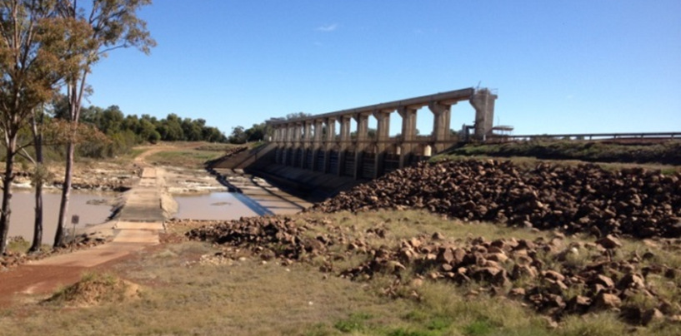
Weir at St George, Qld
Source: ACCC staff

The full terms of reference for the review are included in Appendix A of the Draft Advice.
Charges in respect of urban water supply activities beyond the point at which water has been removed from a Basin water resource are not covered by the water charge rules. However, regulated water charges incurred by an urban water supplier (and imposed by another infrastructure operator) may nevertheless be subject to the water charge rules.
Some infrastructure operators that provide an off-river infrastructure service for the delivery of water will also provide a service for the (off-river) storage of water or drainage of water.
Irrigation infrastructure operators typically provide off-river infrastructure services, however this is not always the case.
The definition of ‘water access right’ in the Act also includes stock and domestic rights, riparian rights and any other right to the take or use of water prescribed by the regulations.
Treatment of confidential information: If you claim that your submission contains confidential information, the ACCC will publish a version of your submission which excludes the confidential information. If you wish to submit commercial-in-confidence material to the ACCC, you should submit both a public and a commercial-in-confidence version of their submission. The commercial-in-confidence version should highlight the confidential material in yellow. The public version of the submission should clearly identify the commercial-in-confidence material by replacing the confidential material with an appropriate symbol or ‘c-i-c’. The ACCC expects that claims for commercial-in-confidence status of information by parties will be limited in order to allow the widest possible participation in the public inquiry. You can access the ACCC-AER’s general policy on the collection, use and disclosure of information on the ACCC’s website - see: https://www.accc.gov.au/publications/accc-aer-information-policy-collection-and-disclosure-of-information.

