Public interest disclosure procedures

Acknowledgement of country
The ACCC acknowledges the traditional owners and custodians of Country throughout Australia and recognises their continuing connection to the land, sea and community. We pay our respects to them and their cultures; and to their Elders past, present and future.
Australian Competition and Consumer Commission
Land of the Ngunnawal people
23 Marcus Clarke Street, Canberra, Australian Capital Territory, 2601
© Commonwealth of Australia 2023
This work is copyright. In addition to any use permitted under the Copyright Act 1968, all material contained within this work is provided under a Creative Commons Attribution 4.0 Australia licence, with the exception of:
- the Commonwealth Coat of Arms
- the ACCC and AER logos
- any illustration, diagram, photograph or graphic over which the Australian Competition and Consumer Commission does not hold copyright, but which may be part of or contained within this publication.
The details of the relevant licence conditions are available on the Creative Commons website, as is the full legal code for the CC BY 3.0 AU licence.
Requests and inquiries concerning reproduction and rights should be addressed to the
Director, Content and Digital Services, ACCC, GPO Box 3131, Canberra ACT 2601.
Important notice
The information in this publication is for general guidance only. It does not constitute legal or other professional advice, and should not be relied on as a statement of the law in any jurisdiction. Because it is intended only as a general guide, it may contain generalisations. You should obtain professional advice if you have any specific concern.
The ACCC has made every reasonable effort to provide current and accurate information, but it does not make any guarantees regarding the accuracy, currency or completeness of that information.
Parties who wish to re-publish or otherwise use the information in this publication must check this information for currency and accuracy prior to publication. This should be done prior to each publication edition, as ACCC guidance and relevant transitional legislation frequently change. Any queries parties have should be addressed to the
Director, Content and Digital Services, ACCC, GPO Box 3131, Canberra ACT 2601.
ACCC
www.accc.gov.au

Contents
1. Purpose 4
2. Overview of the PID Act 4
What is a public interest disclosure? 4
What is disclosable conduct? 4
Making an internal public interest disclosure 6
Protection for disclosers, witnesses and potential disclosers 7
Risk assessment for reprisal conduct 8
Support for disclosers, witnesses, potential disclosers and persons the subject of PIDs 9
Confidentiality 9
Immunity from liability 10
3. Procedures to be followed when a PID is received 11
Procedures to be followed by supervisors, managers and authorised officers upon receipt of a disclosure concerning disclosable conduct 11
Interaction with the National Anti-Corruption Commission and the requirement to refer corrupt conduct 12
Obligation to advise a discloser or potential discloser about the PID Act 13
Authorised officer must decide whether to allocate a disclosure 14
Allocation of an internal disclosure to the relevant agency 15
Dealing with anonymous disclosures 15
Deciding whether to investigate 16
Investigation procedures 17
Conducting interviews 18
Reporting of a corruption issue during investigation 18
Investigation report requirements 19
Record keeping 20
Further information 20
Attachment A: Key steps for Authorised Officers for internal disclosures 21

Public interest disclosure procedures for the ACCC/AER
I, Scott Gregson, Chief Executive Officer and delegate of the Principal Officer of the Australian Competition and Consumer Commission (ACCC) and the Australian Energy Regulator (AER) establish these Procedures under subsection 59(3) of the Public Interest Disclosure Act 2013 (the PID Act).
These Procedures commence upon execution and revoke and replace any previous procedures established for the ACCC and the AER under section 59 of the PID Act.

Signed: | [signed]
Name: | Scott Gregson
Title: | Chief Executive Officer
Dated: | 18 January 2024

- Purpose
The purpose of the PID Act is to promote the integrity and accountability of the Commonwealth public sector by providing a legislative scheme for the making and investigation of allegations of serious wrongdoing. The PID Act facilitates the making of disclosures, ensures that disclosures are properly considered and investigated and establishes protections for disclosers from reprisal action.
These Procedures set out how the ACCC/AER facilitates and deals with public interest disclosures (PIDs) that relate to the ACCC/AER. These Procedures support the ACCC’s commitment to:
- the highest standards of ethical and accountable conduct
- encouraging the reporting and investigation of public interest disclosures and
- supporting and protecting persons who make public interest disclosures.
- Overview of the PID Act

What is a public interest disclosure?
A disclosure will be a PID for the purposes of the PID Act if:
- it is made by a current or former public official or someone who is deemed to be a public official
- the information comprised in the disclosure tends to show, or the discloser believes on reasonable grounds that the information tends to show, disclosable conduct and
- the information is disclosed to an appropriate person (generally, their supervisor or an authorised internal recipient).

What is disclosable conduct?
The definition of disclosable conduct is set out in section 29 of the PID Act. In summary, disclosable conduct is conduct by an agency or by a public official that:
- contravenes a law of the Commonwealth, a State or a Territory
- occurs in a foreign country and contravenes a law in force in that country that applies to the agency or public official and that corresponds to a law in force in the Australian Capital Territory
- perverts or attempts to pervert, the course of justice or involves corruption of any other kind
- constitutes maladministration including conduct that is:
- based on improper motives
- unreasonable, unjust or oppressive or
- negligent
- is an abuse of public trust
- is fabrication, falsification, or deception in relation to scientific research, or misconduct in relation to scientific work
- results in the wastage of public money or public property or of the money or property of an authority covered by the PID Act
- unreasonably results in a danger to the health and safety of a person or unreasonably results in or increases the risk of a danger to the health and safety of a person
- results in a danger to the environment or results in or increases the risk of a danger to the environment
- is prescribed by rules made pursuant to the PID Act, or
- is engaged in by a public official that:
- involves abuse of the public official’s position, or
- could, if proved, give reasonable grounds for disciplinary action resulting in termination of the public official’s engagement or appointment.
Disclosable conduct does not include:
- disagreements with government policy or proposed policy, expenditure or proposed expenditure and/or action or proposed action by a minister, the Speaker of the House of Representatives or the President of the Senate
- judicial conduct (unless of an administrative nature and unrelated to matters before the court or tribunal)
- conduct of members of Parliament or persons employed under the Members of Parliament (Staff) Act 1984 (Cth)
- conduct of an intelligence agency (or conduct of a public official who belongs to an intelligence agency) if engaged in the proper performance of its functions or exercise of its powers or
- personal work-related conduct (see table below) unless:
- that conduct constitutes taking reprisal action against another person
- is of such a significant nature that it would undermine public confidence in an agency or
- has other significant implications for an agency.
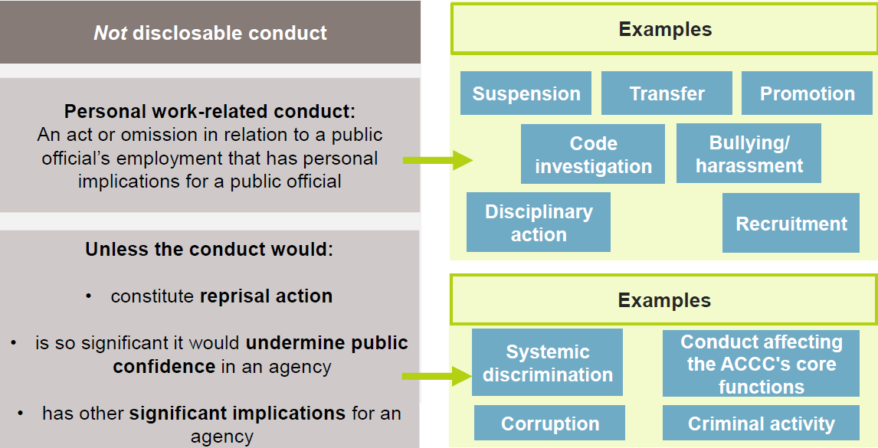

Making an internal public interest disclosure
The PID Act establishes five kinds of public interest disclosure:
- internal disclosures (disclosed within an agency)
- external disclosures (disclosed outside Government)
- emergency disclosures
- legal practitioner disclosures and
- National Anti-Corruption Commission disclosures.
These Procedures have been prepared in respect of the Agency’s handling of internal public interest disclosures.
All public officials and former public officials are entitled to make a disclosure under the PID Act. At the ACCC/AER, public officials include:
- ACCC employees
- statutory officeholders such as Commission members and AER Board members and
- contracted service providers and their employees who provide, or who have provided, services to the ACCC/AER.
A public interest disclosure may be made anonymously and/or a public interest disclosure may be made orally or in writing.
Where a public official makes a PID, they do not have to state or intend that they are doing so under the PID Act.
Where a public official is considering making a disclosure, they can contact one of the ACCC’s authorised officers to obtain information about making a public interest disclosure under the PID Act.
Public officials at the ACCC/AER may make a disclosure of disclosable conduct to their supervisor or manager, to an authorised officer, or in certain circumstances, to the Commonwealth Ombudsman.
The identities and contact details of the ACCC’s authorised officers are available on the intranet or by emailing PID@accc.gov.au.

To the extent possible, the information comprised in a disclosure should be factual and provide supporting evidence including identifying witnesses to the alleged disclosable conduct.
A person who knowingly makes a false or misleading disclosure will not have any protections under the PID Act that would otherwise apply.
A person who has made a disclosure under the PID Act should not discuss the details of their disclosure with anyone who does not have a need to know about it.
A supervisor, manager or Authorised Officer who receives a disclosure of disclosable conduct from a public official should deal with the disclosure in accordance with the PID Act, any standard in force under section 74 of the PID Act (currently the Public Interest Disclosure Standard 2013 or ‘PID Standard’) and these procedures.

Protection for disclosers, witnesses and potential disclosers
The PID Act provides protections against reprisal conduct by establishing an offence (that carries a penalty of 2 years imprisonment) in respect of such conduct.
Reprisal occurs when someone causes by an act or omission, detriment to another person because they believe or suspect that person or anyone else may have made or intends to make a PID. Detriment includes:
- disadvantage to a person, including dismissal, injury in their employment, discrimination between them and other employees or alteration of their position to their disadvantage
- a physical or psychological injury
- intimidation, harassment or victimisation
- loss or damage to property
- disadvantage to a person’s career (for example, denying them a reference or a promotion without appropriate reasons).
It is a criminal offence to take or threaten to take a reprisal action against anyone in relation to a PID and the penalty is up to 2 years imprisonment.
An officer who commits a reprisal action may also be subject to disciplinary procedures for example for breaching the Australian Public Service Code of Conduct as set out in section 13 of the Public Service Act 1999.

Risk assessment for reprisal conduct
Notwithstanding that the PID Act provides protection against reprisal conduct, a reprisal risk assessment should be conducted for each PID. That risk assessment should be reviewed as required through the course of any PID investigation.
In most circumstances, a relevant Authorised Officer will conduct the risk assessment. There may be circumstances, however, where a manager or supervisor is more appropriately placed to conduct a risk assessment (for example, where a disclosure is made initially to a manager or supervisor and the discloser wishes to otherwise remain anonymous).
A properly conducted reprisal risk assessment will, having regard to the particular circumstances of a PID:
- identify potential reprisal action (and the consequences of that action) that might be taken against a discloser, a witness or potential discloser
- assess the likelihood of reprisal action taking place
- set out and implement strategies to contain and prevent identified reprisal risks from manifesting and
- implement a process to monitor and review the implementation and efficacy of those strategies.
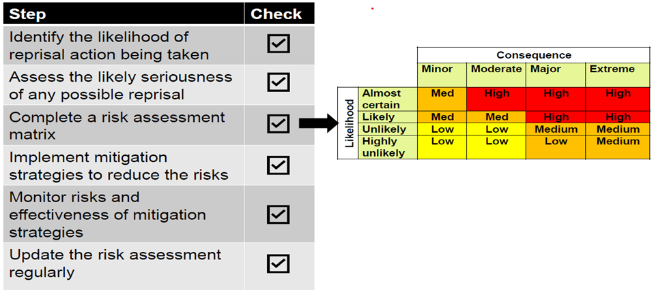

Support for disclosers, witnesses, potential disclosers and persons the subject of PIDs
The ACCC will provide support to those who make, and are otherwise involved in, PIDs. That support will be tailored to the individual circumstances, and may include:
- with consent, appointing a person to assist, support and otherwise regularly check on the wellbeing of that a discloser, potential discloser or witness
- ensuring that disclosers, witnesses and potential disclosers are aware of the availability of the ACCC’s Employee Assistance Program as well as the support that can be provided by ACCC Peer Support Advisers.
The ACCC will also take steps to support an employee who is the subject of a PID. That support will include ensuring that the employee is aware of:
- their rights and obligations and the ACCC’s investigation procedures
- the wellbeing supports available.

Confidentiality
All reasonable steps will be taken to protect the identity of a public official who has made a PID.
Only individuals directly involved in dealing with the PID may be advised of the details of the PID. These individuals must not disclose the identity of the discloser or any information which is likely to reveal the identity of the discloser without the consent of the discloser.
It is an offence for a public official to disclose or use information that is likely to enable the identification of a person as a person who has made a PID other than in accordance with the PID Act.
Identifying information about a discloser will not be disclosed to a court or tribunal except where necessary to give effect to the PID Act.
The investigation of the disclosure should be conducted in as confidential a manner as is possible. In particular, the identity of both the discloser and the person alleged to have engaged in the disclosable conduct should not be revealed except where this is reasonably necessary for the effective investigation of the disclosure (including because of the need to afford procedural fairness).

Immunity from liability
Subject to certain exceptions (including where a discloser or witness knowingly makes a false or misleading statement), a person who makes a PID, or who provides evidence as a witness in relation to a PID, will not be subject to any civil, criminal or administrative liability (including disciplinary action) for making the PID or providing evidence as a witness in relation to a PID. A discloser or witness also has absolute privilege in proceedings for defamation in respect of a PID.
Additionally and subject to certain exceptions, no contractual or other remedy may be enforced and no contractual or other right may be exercised, against a discloser or witness on the basis of their involvement in a PID. A contract to which a discloser or witness is a party cannot be terminated because of a PID.

- Procedures to be followed when a PID is received

Procedures to be followed by supervisors, managers and authorised officers upon receipt of a disclosure concerning disclosable conduct
A supervisor, manager or authorised officer who receives a disclosure of disclosable conduct from a public official should deal with the disclosure in accordance with the PID Act, the PID Standard and these procedures. A flow chart setting out key steps and actions for authorised officers in relation to the receipt of internal disclosures is set out in Attachment A to these Procedures.
Where a public official in the agency discloses information to their supervisor or manager (and that supervisor or manager is not an authorised officer) and that supervisor or manager has reasonable grounds to believe that the information concerns, or could concern, disclosable conduct, the supervisor or manager must:
- inform the discloser that the disclosure could be treated as an internal disclosure under the PID Act
- explain to the discloser the procedures under the PID Act which require:
- the supervisor or manager to give the disclosure to an authorised officer
- the authorised officer to decide whether to allocate the disclosure to a principal officer in the agency or elsewhere and
- if the disclosure is allocated, the principal officer must investigate it.
- inform the discloser about the circumstances (if any) where the disclosure must be referred to another agency or person under another law of the Commonwealth
- inform the discloser of the civil and criminal protections under the PID Act (set out in 2.30 to 2.31 above)
- seek the discloser's consent to provide the authorised officer with the discloser’s identity and
- as soon as practicable, give the information to an authorised officer in the agency (if the discloser declines for their identity to be passed on, the supervisor or manager will need to provide the authorised officer with as much information as possible, without revealing the discloser’s identity).
Where a disclosure has been made to a supervisor or manager, that supervisor or manager must make a written record of the fact of the disclosure and if the disclosure is not in writing, they must make a written record of the substance of the disclosure and of the time and date of the disclosure. Where practicable, the supervisor or manager should ask the discloser to sign the record of the disclosure.
When a supervisor or manager gives information to an authorised officer in accordance with 3.2, they must also give the authorised officer their written assessment of any risks that reprisal action might be taken against the person who disclosed the information to the supervisor or manager.
Where a supervisor or manager as given information to an authorised officer in accordance with 3.2, they must inform the discloser that they have given the information to an authorised officer and advise the discloser of the name and contact details of that authorised officer.
Upon receiving an internal disclosure (either directly or by way of a supervisor or manager), an authorised officer must make a decision about whether to allocate the disclosure. They must also decide whether the disclosure concerns corrupt conduct that is required to be referred to the NACC. The authorised officer also has certain obligations in relation to advising the discloser and potential disclosers.

Interaction with the National Anti-Corruption Commission and the requirement to refer corrupt conduct
The National Anti-Corruption Commission Act 2022 (NACC Act) established the National Anti-Corruption Commission (the NACC).
The NACC Act and the PID Act provide mechanisms for public officials to report wrongdoing as well as protections for those who do so and have been designed to operate together.
The NACC Act applies in respect of corrupt conduct and provides that a person engages in corrupt conduct if they:
- are a public official and they breach public trust, abuse their office as a public official, or misuse information they have gained in their capacity as a public official or
- do something that could cause a public official to behave dishonestly or in a biased way when they carry out their official duties.
At all stages of dealing with and handling a disclosure, ACCC officials who are exercising powers or functions under Division 1 or 2 of Part 3 of the PID Act (‘PID officers’ including the Principal Officer and Authorised Officers) must be aware of the obligations imposed by section 35 of the NACC Act.
Section 35 of the NACC Act provides that PID officers must refer a corruption issue (being an issue of whether a person has engaged, is engaging or will engage, in corrupt conduct) to the National Anti-Corruption Commissioner (the NACC Commissioner) as soon as reasonably practicable upon becoming aware of a corruption issue that:
- concerns the conduct of a person who is or was a employee of the ACCC while that person is, or was, an employee and
- the PID officer suspects could involve corrupt conduct that is serious or systemic.
A PID officer is not required to refer a corruption issue if they believe on reasonable grounds that the NACC is already aware of the issue.
If a PID officer becomes aware of such a corruption issue as a consequence of a PID being made, they must, as soon as reasonably practicable, notify the discloser of the referral of the issue to the NACC Commissioner in accordance with section 35 of the NACC Act.
Where a referral is made to the NACC Commissioner, the ACCC should continue to deal with and progress a relevant internal disclosure unless and until a stop action direction has been issued to the ACCC Chair by the NACC Commissioner in accordance with subsection 43(1) of the NACC Act.

Obligation to advise a discloser or potential discloser about the PID Act
In circumstances where:
- an individual discloses or is proposing to disclose, information to an authorised officer which the authorised officer has reasonable grounds to believe may be disclosable conduct and
- the authorised officer has reasonable grounds to believe that the person may be unaware of the consequences of making the disclosure
- the authorised officer must:
- inform that individual that the disclosure could be treated as an internal disclosure under the PID Act,
- explain what the PID Act requires for a disclosure to be an internal disclosure,
- inform the person about the circumstances (if any) in which a public interest disclosure must be referred to an agency, or other person or body, under another law of the Commonwealth,
- explain the protections provided by the PID Act to persons who make disclosures under the PID Act, and
- advise the person of any orders or directions that may affect disclosure of the information.

Authorised officer must decide whether to allocate a disclosure
Where a public official or a person who has been a public official, makes a disclosure of disclosable conduct directly to an authorised officer, the authorised officer should:
- make a written record of the fact of the disclosure and, if the disclosure is not in writing, they must make a written record of the substance of the disclosure and of the time and date of the disclosure
- where practicable, request that the discloser sign the written record of the disclosure and
- use their best endeavours to decide on the allocation of the disclosure within 14 days after the disclosure is given to or made to the authorised officer.
An authorised officer who receives a disclosure must allocate the disclosure to the principal officer (or the principal officer’s delegate) unless the authorised officer:
- is satisfied on reasonable grounds that there is no reasonable basis on which the disclosure could be considered to be an internal disclosure or
- considers that the conduct would be more appropriately investigated under another law or power.
Where an authorised officer receives a disclosure, the authorised officer may obtain information and may make such inquiries as they think fit, for the purposes of deciding the appropriate allocation of the disclosure.
Where an authorised officer decides not to allocate a disclosure they must:
- where the discloser’s contact details are known to the authorised officer, provide the discloser with written notice of that decision, the reasons for that decision and the actions (if any) the authorised officer has taken or proposes to take to have the disclosure investigated under another law
- make a record of how the notice was transmitted to the discloser and if not, the reason why the notice was not provided and
- give written notice to the Commonwealth Ombudsman of the decision not to allocate, the reasons for that decision and what actions the authorised officer has taken or proposes to take.
Where an authorised officer has the contact details of a discloser they must, as soon as practicable after receiving the disclosure and before allocating the disclosure, ask the discloser whether the discloser:
- consents to the authorised officer giving the discloser’s name and contact details to the principal officer
- wishes the disclosure to be investigated, noting that once lodged, a PID cannot be withdrawn and the discloser’s wishes will not be determinative as to whether the PID is investigated.
The authorised officer must make a written record of the discloser’s responses (if any) to those questions.
Where a discloser does not respond to those questions within 7 days, the discloser is taken to:
- have consented to the disclosure of their name and contact details to the principal officer and
- wish the disclosure to be investigated.

Allocation of an internal disclosure to the relevant agency
An internal disclosure should generally be allocated to the agency or agencies to which the disclosed conduct relates.
Where an authorised officer is considering allocating an internal disclosure to an agency other than the authorised officer’s own agency, an authorised officer must obtain the consent of an authorised officer in the external agency before allocating the internal disclosure.
Where an authorised officer allocates a disclosure, they must:
- provide the principal officer of the agency to whom the disclosure is allocated with written notice that they have done so and
- provide the Commonwealth Ombudsman with written notice of the allocation (or the IGIS if the disclosure is allocated to an intelligence agency or to the Australian Criminal Intelligence Commission or the Australian Federal Police in relation to those agency’s intelligence functions).

Dealing with anonymous disclosures
The PID Act expressly provides that a disclosure may be made anonymously. Accordingly, an authorised officer may be satisfied based on the information disclosed that the discloser is a public official, despite their anonymity.
If an authorised officer is not satisfied that an anonymous discloser is a public official, the authorised officer can consider exercising their power under section 70 of the PID Act to determine that a person who has disclosed information to them is a public official. If the authorised officer cannot contact the discloser, no determination can be made because the authorised officer must be able to give written notice of the determination to the individual.
Relevant considerations in the exercise of this power on the part of an authorised officer will include whether it is in the public interest, in the agency’s interest and in the discloser’s interest to have a disclosure dealt with as an internal disclosure under the PID Act.
Where the discloser requests the authorised officer to make this determination, the authorised officer must make a decision on this request and must inform the discloser accordingly. If the authorised officer’s decision is to decline the request to make a determination under section 70 of the PID Act, they must also give the discloser reasons for their decision.
A copy of the written notice of the determination should also be given to the principal officer.

Deciding whether to investigate
Where an authorised officer allocates an internal disclosure to an agency and the principal officer has been given the contact details of the discloser, the principal officer must give the discloser an initial written notification of the principal officer’s powers to, within 14 days after the disclosure was allocated to the agency decide not to investigate the disclosure, or not to investigate further, or to investigate under a separate investigative power.
The principal officer should consider whether to exercise their discretion not to investigate the disclosure under the PID Act. The principal officer may decide not to investigate (or may decide to discontinue an investigation already begun) if:
- the discloser is not a current or former public official (and a determination has not been made under section 70 of the PID Act)
- the information disclosed does not to any extent concern serious disclosable conduct
- the disclosure is frivolous or vexatious
- the disclosure is substantially the same as a disclosure that has been investigated under the PID Act and a decision was previously made under the PID Act not to investigate, or the earlier disclosure is or has been investigated
- the conduct disclosed, or substantially the same conduct, is being investigated under another law or power, and the principal officer is satisfied, on reasonable grounds, that it would be inappropriate to conduct an investigation under the PID Act at the same time
- the conduct disclosed, or substantially the same conduct, has been investigated under another law or power, and the principal officer is satisfied, on reasonable grounds, that there are no further matters concerning the conduct that warrant investigation
- the principal officer is satisfied on reasonable grounds, that the conduct disclosed would be more appropriately investigated under another law or power
- both:
- the principal officer of the agency has been informed by the discloser, an authorised officer of the agency, or a principal officer or authorised officer of another agency that the discloser does not wish the investigation of the disclosure to be pursued and
- the first-mentioned principal officer is satisfied, on reasonable grounds, that there are no matters concerning the disclosure that warrant investigation, or
- it is impracticable to investigate the disclosure:
- because the discloser has not revealed their name and contact detail or
- because the discloser has refused or has failed or is unable to give the investigator the information they requested or
- because of the age of the information.
In circumstances where the principal officer decides not to investigate a disclosure, or not to investigate a disclosure further, the principal officer must, as soon as reasonably practicable, provide written notice of that decision to:
- the discloser, including by providing the reasons for that decision as well as detailing any action taken, or action the principal officer proposes to take, to refer the conduct disclosed elsewhere for investigation under another law or power
- the Commonwealth Ombudsman, including by providing the reasons for that decision.

Investigation procedures
Where the principal officer has decided to commence an investigation into an internal disclosure, they may conduct the investigation as they think fit.
The principal officer may for the purposes of the investigation, obtain information from such persons, and make such inquiries as they think fit.
In arriving at an investigation finding, the principal officer must ensure that a decision whether evidence is sufficient to prove a fact is made on the balance of probabilities. A finding of fact must be based on logically probative evidence.
Where, a principal officer proposes to make a finding of fact or express and opinion that is adverse to the discloser or a public official who is the subject of a disclosure, the principal officer must (subject to certain exceptions) give that person a copy of the evidence that is relevant to the proposed finding or opinion and must give the person a reasonable opportunity to comment on it.
The principal officer has 90 days from the date the disclosure was allocated (from an authorised officer or from an external agency), or from the day on which the principal officer becomes aware that a stop action direction under the NACC Act preventing the investigation no longer applies, in which to complete the investigation.
It is possible to seek one or more extensions of time from the Commonwealth Ombudsman. An investigation that is not completed within time does not become invalid.

Conducting interviews
Subject to any obligations that require otherwise, the principal officer must ensure that if a person is interviewed as part of the investigation of an internal disclosure, that person is informed of:
- the identity and function of each person conducting the interview
- the process of conducting an investigation
- the authority of the principal officer under the PID Act to conduct an investigation
- the protections provided to the person under the PID Act and
- the person’s duty:
- if they’re a public official, to use their best endeavours to assist the principal officer in the conduct of an investigation under the PID Act
- not to take or threaten to take reprisal action against the discloser and
- subject to the PID Act, not to disclose the identity of the person who made the disclosure.
If the principal officer is considering recording an interview, the principal officer must ensure than any recording is made with the interviewee’s knowledge.
Where the principal officer conducts an interview as part of an investigation, at the end of the interview, the interviewee must be given an opportunity to make a final statement or comment or express a position. The principal officer must include any final statement, comment or position in the record of the interview.

Reporting of a corruption issue during investigation
If at any time during the course of an investigation, a principal officer or an investigator assisting the principal officer, becomes aware of conduct:
- of a person who is, or was, an employee of the agency while that person is, or was, an employee and
- that is suspected to be serious or systemic corrupt conduct
they must refer the corruption issue to the NACC Commissioner.
The principal officer must notify the discloser that the principal officer has referred the disclosure to the NACC Commissioner, as soon as reasonably practicable, after the referral.
The principal officer is not required to refer a corruption issue to the NACC Commissioner if they believe on reasonable grounds that the NACC is already aware of the issue or the NACC Commissioner makes a determination that referral is not required because of the kind of corruption issue involved or the circumstances in which it arises.
The referral of a corruption issue does not prevent an agency from continuing to take any action in relation to the disclosable conduct unless the NACC Commissioner gives a direction to stop taking action.

Investigation report requirements
In preparing a report of an investigation under the PID Act the principal officer must comply with the PID Act, the PID Standard and these procedures.
A report of an investigation under the PID Act must set out:
- the matters considered in the course of the investigation
- the duration of the investigation
- the investigations findings (if any)
- the action (if any) that has been, is being or is recommended to be taken
- any claims made about, and any evidence of, detrimental action taken against the discloser or any other person, that relates to the matters considered in the course of the investigation, and the agency’s response to those claims and that evidence
and, where relevant, a report must:
- identify whether there have been one or more instances of disclosable conduct
- identify any regulations, rules, administrative requirements or similar matters to which the disclosable conduct (if any) relates
- explain the steps taken to gather evidence
- set out a summary of the evidence and
- set out any recommendations made based on that evidence.
The principal officer must within a reasonable time of preparing a report of an investigation under the PID Act, give a copy of the report to the discloser and the Commonwealth Ombudsman.
The principal officer may delete from the copy of the report given to the discloser any material:
- that is likely to enable the identification of the discloser or another person or
- the inclusion of which would result in the copy being a document:
- that is exempt for the purposes of Part IV of the Freedom of Information Act 1982
- having, or being required to have, a national security or other protective security classification or
- containing intelligence information.
The Principal Officer (or delegate) may delete from a copy of the report given to the Commonwealth Ombudsman any material that is likely to enable the identification of the discloser or another person, or the inclusion of which would contravene a designated publication restriction.

Record keeping
Where an authorised officer or principal officer is required to keep a record under these procedures, access to such records must be restricted to those persons who require access to perform some function under the PID Act or for the purposes of another law of the Commonwealth (for example, under the Work Health and Safety Act 2011 or the Public Service Act 1999).
Any email messages sent by authorised officers or principal officers that contain identifying information must be clearly marked ‘to be read by named addresses only’.

Further information
Further information about the PID scheme is available from the following sources:
- Public Interest Disclosure Act 2013
- Public Interest Disclosure Standard 2013
- Public interest disclosure (whistleblowing) on the intranet.
- By contacting the ACCC’s authorised officers including by emailing pid@accc.gov.au
- www.ombudsman.gov.au/complaints/public-interest-disclosure-whistleblowing
- https://www.ombudsman.gov.au/complaints/public-interest-disclosure-whistleblowing/tools-and-resources
- by contacting the PID team at the Office of the Commonwealth Ombudsman by emailing pid@ombudsman.gov.au or calling 1300 362 072
- Public interest disclosure (whistleblowing) on the intranet.

Attachment A: Key steps for Authorised Officers for internal disclosures
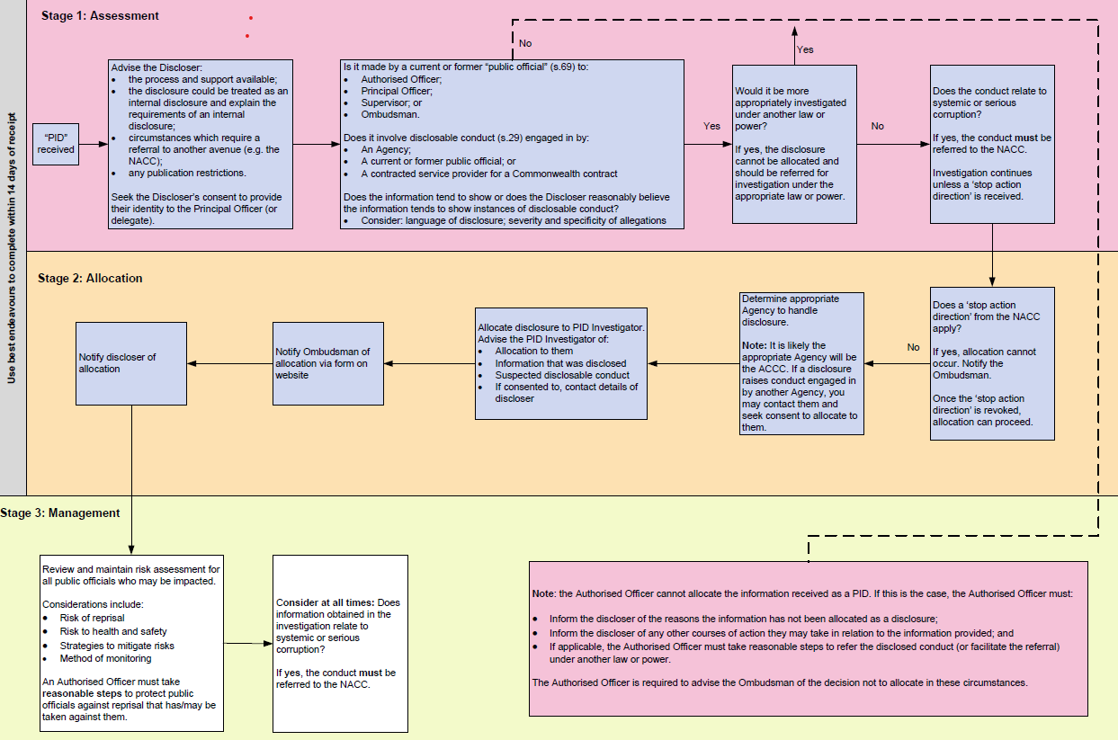

A ‘public official’ is defined by section 69 of the PID Act and includes a current or former Australian Public Service employee, a Parliamentary Service employee, a member of the Defence Force, a director of Commonwealth companies, a statutory office holder and an employee of a Commonwealth contracted service provider.
An ‘authorised officer’ is defined by section 36 of the PID Act and is the principal officer of the agency (being the ACCC Chairperson) as well as any other public official belonging to the agency who is appointed by the principal officer in writing.
Unless otherwise indicated, a reference to a principal officer includes a delegate of a principal officer.
Subsection 28(2) of the PID Act.
Subsection 70(1) of the PID Act.
Section 48 of the PID Act.
A designated publication restriction is defined in section 8 of the PID Act.

