Report to the Minister pursuant to s 60J of the Competition and Consumer Act 2010
Information about the ACCC’s operations during the December 2014 quarter relating to the carbon tax price reduction obligation
January 2015

Table of Contents
Executive Summary 3
Electricity 3
Natural gas 4
Synthetic greenhouse gases 4
Landfill 5
Other industries 5
Compliance & Enforcement 7
The ACCC’s reporting 8
Monitoring 9
Monitoring: Industry assessments 11
Electricity 11
Wholesale market 11
Electricity retailers 13
Assessment of price changes 13
Average price changes 13
Average price changes attributable to the carbon tax repeal 15
Average price changes for residential tariffs 16
Changes to discounts 18
Commercial & Industrial customers 18
Electricity on-sellers or private electricity networks 18
Natural gas 19
Average price changes between July and October 2014 attributable to the carbon tax repeal 20
Average price changes between March and October 2014 22
Synthetic Greenhouse Gases 23
Bulk SGGs 23
Stockpiling 24
Reflection of the levy in prices 25
Actrol Parts Pty Ltd 25
Indirect costs and structural changes 26
SGG prices following the repeal 26
SGG equipment 27
Landfill facility operation 27
Removal of carbon tax cost components from landfill facility gate fees 27
Money collected for future carbon tax liabilities that will no longer eventuate 28
Local councils that are not liable entities 30
IPART rate peg determination in NSW 30
Paper, glass and plastic 31
Carbon inclusive electricity contracts 31
Abatement technology investment 31
Food – dairy and ingredients 32
Explosives 32
Construction 32
Outstanding issues around the carbon tax repeal 33
Liquid fuels 33
Transport 34
Transport operators 34
Freight forwarders 34
Domestic passenger air transport services 35
Compliance 36
Enforcement 38
Annexure 1: electricity and natural gas entities for price monitoring 39
Annexure 2: Glossary 40

Executive Summary
During 2014, the Australian Competition and Consumer Commission (ACCC) provided quarterly reports to the Government on its monitoring of the impact of the carbon tax scheme in a range of industries, and after 17 July 2014, the impact of the carbon tax repeal in these industries.
This report provides information about the monitoring, compliance and enforcement activities of the ACCC during the December 2014 quarter in relation to the carbon tax price reduction obligation and builds on the October 2014 report to the Treasurer, noting observations on price movements in monitored industries.
The ACCC continues to seek and analyse information to ensure that prices offered for regulated goods pass on all of the carbon tax cost savings. Analysis of these cost savings will be made in the April 2015 quarterly report. The ACCC has observed changes in residential electricity and gas prices across all states and territories attributable to the removal of the carbon tax, contributing to overall price decreases or overall price increases less than they otherwise would have been. This is broadly consistent with independent observations of the Australian Energy Market Commission, the ‘Tax on Tax off’ report released by the St Vincent de Paul Society and CPI figures of the Australian Bureau of Statistics.
The ACCC’s compliance activities remain a focus. Contact from the ACCC has prompted a small number of entities in the landfill and synthetic greenhouse gas (SGG) equipment sectors to respond to the carbon tax repeal in a more timely manner. The ACCC has also commenced work to promote awareness amongst electricity on-sellers – typically caravan parks, large residential or commercial building complexes, and shopping centre landlords – of their obligations to pass on all savings from the carbon tax repeal, now that they should see savings from their electricity retailers.
Complaints continue to be low, and are significantly less than the number received in the September 2014 quarter and the number received in the same period on the introduction of the tax. Assessment of the statements by airlines regarding the impact of the carbon tax repeal continues.

Electricity
In the wholesale electricity sector, generators have adjusted their offer behaviour to factor in the removal of the carbon tax.
In the retail electricity sector, there have been average price decreases for residential standing offers attributable to the carbon tax repeal in all states and territories from July- August to October 2014, as seen in the following table.
Electricity – average percentage price change for residential standing offers from July-August 2014 to October 2014 attributable to the removal of the carbon tax
State | ACT | NSW | NT | QLD | SA | VIC | WA | TAS
Average percentage price change | -10.6% | -6.9% | -5.1% | -8.3% | -4.5% | -7.7% | -8.1% | n/a
For information on net price movements from March-April to October 2014, see pages 16-18.

Natural gas
In the natural gas sector, there have been average price decreases attributable to the carbon tax repeal in all states and territories from the July-August to October 2014 as seen in the following table.
Natural gas – average percentage price change for residential standing offers from July-August 2014 to October 2014 attributable to the removal of the carbon tax
State | ACT | NSW | NT | QLD | SA | VIC | WA | TAS
Average percentage price change | -5.7% | -5.8% | -6.5% | -4.9% | -5.2% | -6.2% | -4.1% | -4.6%
For information on net price movements from March-April to October 2014, see pages 22-23.

Synthetic greenhouse gases
The ACCC considers that there was limited competition at the import level for SGGs, which enabled importers to sustain prices at levels that reflected the inclusion of an equivalent carbon price levy component even though importers had stockpiled SGGs prior to the introduction of the carbon tax.
Post repeal, SGG refrigerant imports are now available without a carbon levy. According to SGG importers, in some cases they are now cheaper than prior to the carbon tax. Due to the removal of the carbon tax and intellectual property protections, the ACCC considers the wider availability of these cheaper imports will ensure that lower pricing flows through all levels of the supply chain.
The ACCC will seek further information about post repeal prices for SGGs downstream in the supply chain and monitor for complaints.
On 30 April 2014, the ACCC instituted proceedings against Actrol Parts Pty Ltd (Actrol), a wholesaler of refrigerant gas, alleging that Actrol made false or misleading representations and engaged in misleading or deceptive conduct by representing that price increases effective 1 July 2012 were due to the introduction of the carbon tax scheme. The ACCC expects judgment in this matter to be handed down in early 2015.
Suppliers of equipment containing SGGs are also subject to the carbon price reduction obligation. The ACCC is assessing a small number of complaints regarding SGG equipment and will monitor for further complaints and seek further explanation from SGG equipment suppliers as required.

Landfill
For landfill operators that are liable entities and had carbon tax components in their landfill gate fees, these components have now been removed, which resulted in either gate fee decreases, or increases that were not as high as they otherwise would have been. However, with respect to one landfill operator, the ACCC is not satisfied that it has passed on all cost savings arising from the carbon tax repeal. Most landfill operators have refunded or are in the process of refunding carbon tax components collected during the refund period, while others will put these funds towards abatement measures.
A consultation paper was released on 22 December 2014 by the Department of the Environment proposing voluntary mechanisms for landfill operators to manage the funds received during the carbon tax period for anticipated future carbon tax liabilities, which will not eventuate now that the carbon tax has been repealed. The ACCC is supportive of the proposals. The funds received by landfill operators are reported to be approximately $200 million.

Other industries
Paper, glass and plastic manufacturers have removed carbon tax costs from prices except where entities have stock on hand purchased prior to the repeal that legitimately contains a carbon tax cost component.
Most dairy and ingredient manufacturers have removed the carbon tax cost component from prices. The one remaining entity will remove the carbon tax cost as part of a contract negotiation in February 2015.
Most construction material manufacturers have stated that the carbon tax cost component has been removed and customers have been provided with refunds for the carbon tax component charged between 1 July 2014 and the date of removal of the component. In relation to the prices of bricks and related products which rose at the introduction of the carbon tax, the ACCC has been engaging with some brick manufacturing entities to better understand whether their prices included any carbon tax component. It is not yet clear to the ACCC that recent price adjustments by some entities have adequately reflected the pass through of any cost savings from the carbon tax repeal. The ACCC is continuing to engage with these entities to verify whether there are cost savings, and if so, that these cost savings are passed through to customers.
The ACCC is satisfied that carbon tax costs have been removed from entities’ prices in the explosives, liquid fuels and transport industries.
The ACCC has observed significant efforts by various entities to ensure they are passing through carbon tax cost savings. For example:
- Parkes Shire Council announced that it received a credit due to the repeal from one of its energy suppliers and would be using those funds in future projects improving energy efficiency which will result in future savings to its local community.
- The Queensland Government reduced the price of public transport fares by 5 per cent due to the carbon tax repeal on 3 November 2014. Transport Minister Scott Emerson has announced that the fare reduction will save public transport users between $80 and $300 per year, and that fares would not increase in 2015.

Compliance & Enforcement
The ACCC continues to engage with entities to ensure they understand their obligations and are fully compliant with the carbon tax price reduction obligation. This includes seeking clarification from some entities that the information provided in carbon tax removal substantiation statements and carbon tax removal substantiation notice responses is accurate and complete.
The ACCC is generally pleased with the high levels of compliance with the carbon tax price reduction legislation and consequently, has not undertaken any enforcement activities in the December 2014 quarter.
The ACCC continues to monitor relevant industries following the repeal of the carbon tax in July 2014. This report focuses on price movements. Future reports will summarise the ACCC’s findings regarding further assurance of carbon tax cost savings being passed through following the carbon tax repeal.

The ACCC’s reporting
Pursuant to section 60J of the CCA, the ACCC must give the Minister a report about its operations under Part V of the CCA – the carbon tax price reduction obligation. This is the first report pursuant to section 60J of the CCA as the December 2014 quarter is the first full quarter since the carbon tax price reduction obligation came into effect.
For information about the ACCC’s operations during the September 2014 quarter, please see the October 2014 report to the Treasurer.

Monitoring
The ACCC’s monitoring activities for the December 2014 quarter have focused on:
- seeking confirmation from entities of the pass through of carbon tax cost savings,
- monitoring price movements to determine the impact of the carbon tax repeal on prices,
- obtaining clarification of information provided in carbon tax removal substantiation notices and carbon tax removal substantiation statements (for further detail, see the October 2014 report to the Treasurer), and
- seeking a range of additional information to that provided in the carbon tax removal substantiation notice responses.
Previous reports to the Treasurer have adopted a tiered approach, with Tier 1 comprising regulated industries – electricity, natural gas and SGGs – and Tier 2 and Tier 3 comprising liable entities and additional entities in industries categorised according to the significance of the impact of the carbon tax and apparent complexities surrounding the pass through of any carbon tax cost savings post-repeal.
As the ACCC obtains further information to assure itself of the pass through of carbon tax cost savings, the focus of our monitoring activities shifts. As such, the ACCC has moved away from a tiered approach to reporting. Industry assessments for this report fall into two categories:
- industries which the ACCC continues to monitor in order to substantiate entities’ responses to the carbon tax repeal and clarify outstanding issues, and
- industries the ACCC will cease monitoring as there are no concerns regarding the pass through of carbon tax cost savings.
This report focuses on the impact of the carbon tax repeal in four key industries:
- electricity (wholesale and retail),
- natural gas,
- SGG, and
- landfill.
The carbon tax price reduction obligation applies to suppliers of electricity, natural gas, SGGs and SGG equipment. These industries continue to be the focus of the ACCC’s monitoring role. The landfill industry remains a key industry for monitoring whilst the Department of the Environment continues discussions with the Australian Landfill Owners Association (ALOA) regarding the treatment of any windfall gains. A framework has been released by the Department of the Environment for consideration (see discussion of the Framework on page 29).
The additional industries addressed in this report are:
- local councils that are not liable entities,
- manufacturing:
- paper, glass and plastic,
- food – dairy and ingredients,
- explosives, and
- construction materials,
- liquid fuels,
- transport, and
- domestic passenger air transport services.
Where possible, this report will sign off on monitoring these industries. In all circumstances, the ACCC will continue to monitor for complaints.
The assessments in this report comment on prices as seen to date. Further analysis of carbon tax cost savings and price movements will be provided in the next report to the Minister in April 2015.
The April 2015 quarterly report will provide an update on the remaining industries under assessment and to the extent possible, conclude the ACCC’s assessment of the impact of the carbon tax repeal. The July 2015 quarterly report will summarise the key findings of the ACCC’s monitoring activities.

Monitoring: Industry assessments

Electricity

Wholesale market
The ACCC has reviewed all carbon tax removal substantiation notice responses and further information received from generators.
Generally, generators indicated they had adjusted their offer behaviour to factor in the carbon tax repeal. Generators also indicated that removing carbon from their calculation of short run marginal costs of generation has resulted in lower offer prices for generation to the Australian Energy Market Operator (AEMO). However, generators commented that there are a range of factors that influence their offer strategy and the carbon tax repeal is only one of these.
The AER has undertaken analysis to assess generators’ offer behaviour. Graphs 1 to 3 below compare generation supply curves in Queensland, Victoria and NSW, the states with the highest proportion of coal-fired generation, in the period leading up to the repeal of the carbon tax and the period following carbon tax repeal.
Graph 1: Generation supply curve – Queensland 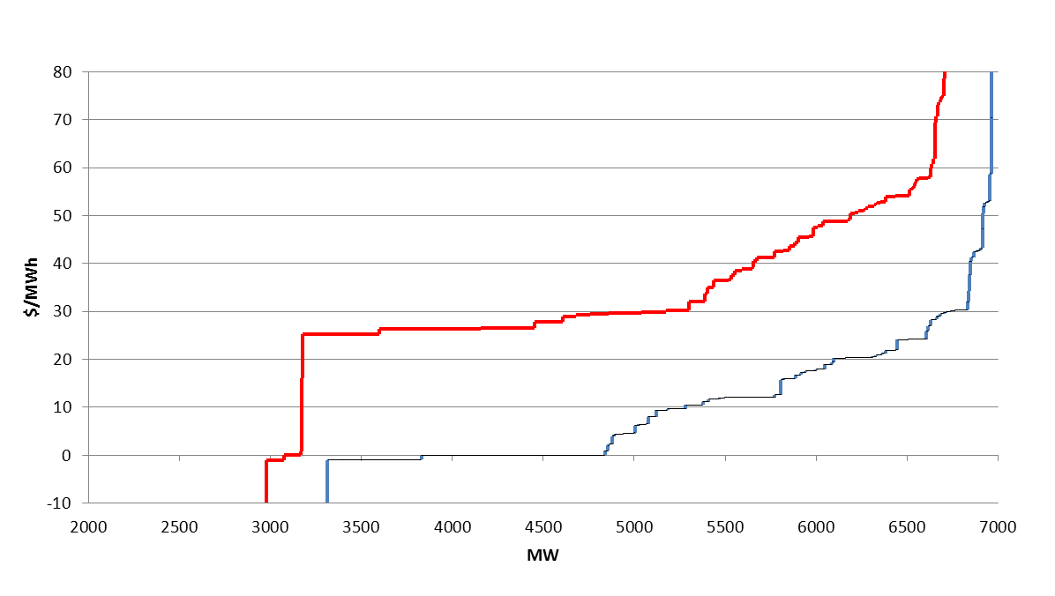
1 March to 17 July 2014 18 July to 24 November 2014

Graph 2: Generation supply curve – Victoria
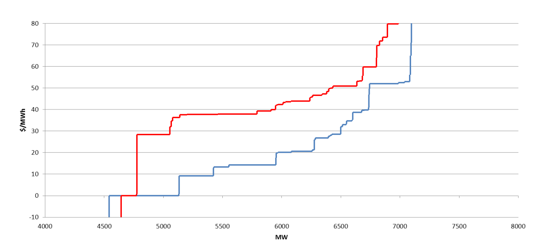
1 March to 17 July 2014 18 July to 24 November 2014

Graph 3: Generation supply curve – NSW
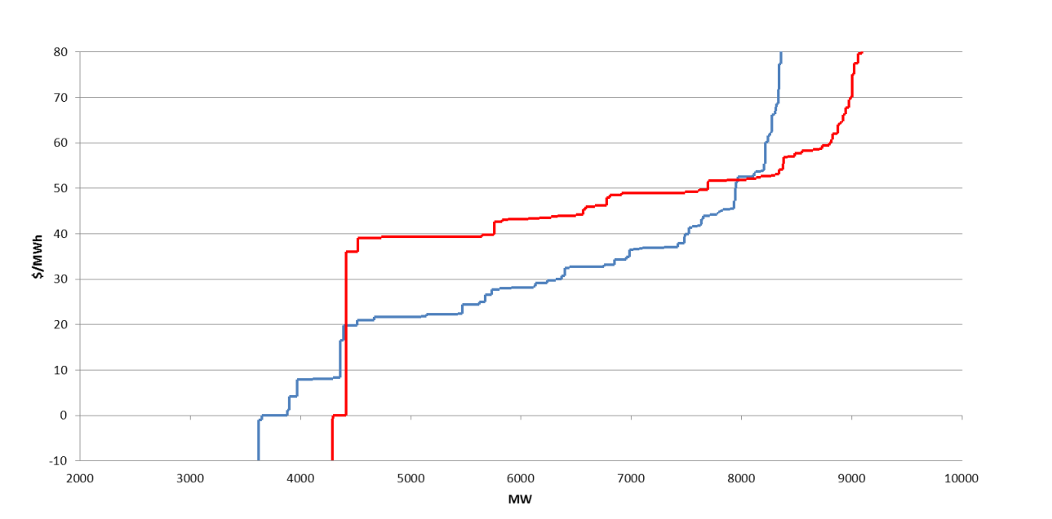
1 March to 17 July 2014 18 July to 24 November 2014

In each state, there is an overall outward shift in supply, meaning that generators were making more capacity available at lower prices following repeal of the carbon tax than they were previously. In NSW there was also an overall reduction in available capacity. This was mainly due to increased technical limitations on generating units and the closure of power stations.
While at any time there have been a range of market conditions influencing this offer behaviour, these outcomes are consistent with claims that generators have adjusted their offer behaviour to factor in the removal of the carbon tax.
These market outcomes indicate that cost savings from the repeal of the carbon tax have been passed through by electricity generators.

Electricity retailers
In the October 2014 report to the Treasurer, the ACCC indicated that two retailers had not confirmed timetables to implement price changes to remove carbon tax cost components from their electricity prices. Sanctuary Energy has now confirmed that it is in the process of implementing a price change and that this will be completed for all customers by 1 February 2015, and backdated to 1 July 2014. Commander Power & Gas has also confirmed that it implemented a price change on 10 November 2014, which was backdated to 1 July 2014.
The ACCC is continuing to assess responses to carbon tax removal substantiation notices and further information obtained from electricity retailers. The ACCC will provide its full assessment as to whether all carbon tax cost savings have been passed on in its next report to the Minister for the March 2015 quarter.

Assessment of price changes
As part of its price monitoring activities, the ACCC has collected pricing information as at March-April, July-August and October 2014 from electricity retailers, including for standing offers and most common offers. Offers classified as most common were identified by electricity retailers as the offers that are most commonly taken up by customers as at March 2014. A list of retailers included in the ACCC’s price monitoring is at Annexure 1.
The ACCC has used the pricing information supplied by retailers to calculate annual electricity bills based on an energy consumption level of 6500 kWh. The ACCC has used these annual bills to calculate price changes between quarters. The average price change figures in the following graphs are simple averages and have not been weighted according to the relative size of each retailer. The ACCC is in the process of considering individual retailer’s price movements in light of the information they provided in response to the substantiation notices. The results of this analysis will be provided in the next report to the Minister.

Average price changes
The following graphs show average price movements for electricity offers to residential customers by state from March-April to July-August 2014 and July-August to October 2014. The average price change in each jurisdiction will not necessarily match an individual consumer’s annual electricity bill change.

Graph 4: Average price change for residential standing offers based on ACCC calculations of annual bills
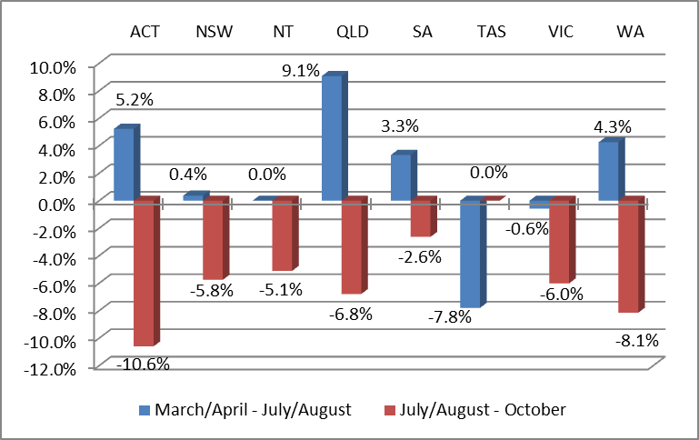

Graph 5: Average price change for most common residential offers based on ACCC calculations of annual bills
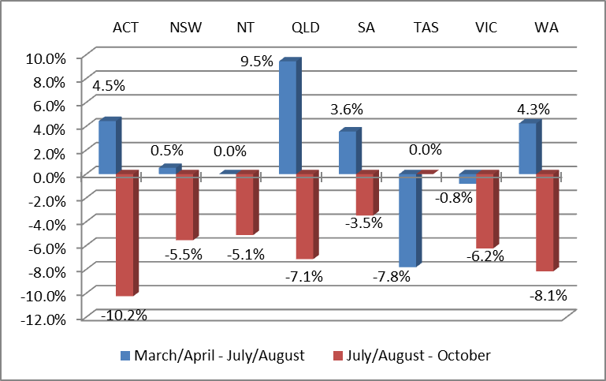
On the aggregated information above, it can be difficult to isolate the impact of the carbon tax repeal on retail electricity prices:
- Different retailers have adjusted their electricity prices to account for the carbon tax repeal at different times – some adjusted their prices in anticipation of the carbon tax repeal, and therefore the removal of the carbon tax for these retailers was included in the average price change from March-April to July-August. A majority of retailers, however, removed the carbon component from their prices post repeal, and therefore the carbon tax removal for these retailers is included in the average price change from July-August to October.
- Retailers in Queensland, NSW, ACT, South Australia and Tasmania usually adjust prices around July each year. The timing of these price changes is typically annual and coincided with the repeal of the carbon tax.

Average price changes attributable to the carbon tax repeal
In order to isolate the reduction in prices attributable to the carbon tax repeal to the greatest extent possible, the ACCC compared carbon cost inclusive July-August 2014 prices for residential customers with October 2014 prices that had carbon costs removed. This analysis is in Graphs 6 and 7 below. The following retailers or products were excluded from this analysis:
- Retailers whose products’ prices had always been carbon exclusive – Diamond Energy and Momentum Energy’s SmilePower product are clean energy products and do not contain carbon costs.
- Retailers that had removed carbon by 1 July 2014 in anticipation of the repeal –Powershop, Aurora and Red Energy.
- Retailers who combined price adjustments to take account of changes to network and other wholesale costs with the removal of carbon in a single price change – Alinta in South Australia, Dodo Power & Gas in Queensland and South Australia, Momentum Energy in South Australia and NSW, Simply Energy in Queensland, South Australia and NSW.
Graph 6: Average price change from July-August to October 2014 attributable to the carbon tax repeal – residential standing offers
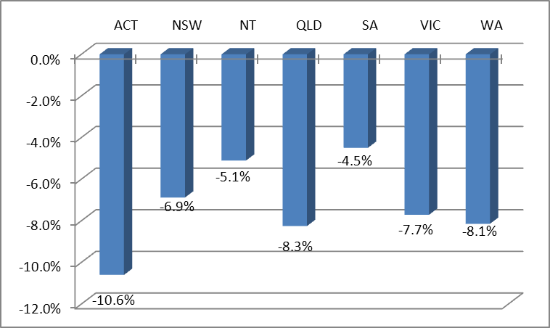

Graph 7: Average price change from July-August to October 2014 attributable to the removal of carbon – most common residential offers

Graphs 6 and 7 above show the average price decreases that occurred in each state and territory where the impact of the carbon tax could be isolated. Both the standing offer and common offer graphs show a difference in price decreases between jurisdictions. There are a number of factors that may have contributed to these differences, including:
- the impact of government and regulatory decisions in jurisdictions where prices are regulated,
- variance in the average carbon intensity between jurisdictions, and
- variance in the overall level of electricity prices across jurisdictions, meaning that the carbon tax component will differ when expressed as a percentage.
It is important to note that the ACCC has calculated average changes in annual bills for each jurisdiction, and the impact on individual consumers will vary. Within each jurisdiction prices will vary between distribution zones and between retailers. In addition, changes in an individual consumer’s bill will be affected by the consumer’s consumption volume and tariff structure.

Average price changes for residential tariffs
Graphs 8 and 9 below present average price changes for residential tariffs between March-April and October 2014. These graphs illustrate the net effect of the carbon tax repeal on prices and the annual price adjustments that account for network and other changes in the cost of supplying electricity. All retailers have been included in this analysis except for clean energy products, or products that were carbon free in March 2014.
Victorian electricity price data has not been included in these graphs because data for Victoria does not include the effect of network and other cost changes, whereas other jurisdictions do. Retailers in Victoria typically adjust prices in January. The ACCC will provide an update on the net effect of the carbon tax removal and January 2015 price adjustments for Victoria in its next report.
Graph 8: Average price changes from March-April to October 2014 – residential standing offers
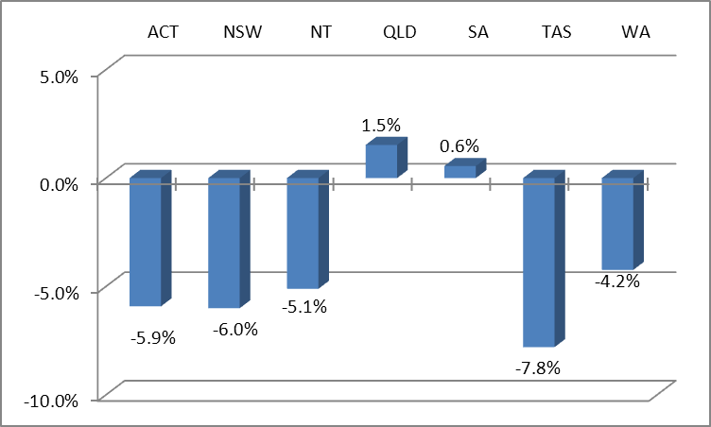

Graph 9: Average price changes from March-April to October 2014 – most common residential offers
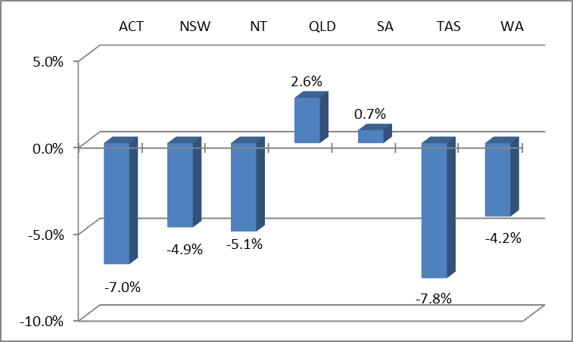
Graphs 8 and 9 above show overall decreases for most jurisdictions. There has been an increase in Queensland in line with the Queensland Competition Authority’s pricing determination. There has also been a small increase in South Australia. As the South Australian market is unregulated it is unclear what all of the factors affecting prices were, however, increasing network costs would have been one factor. In addition, the average decrease in price for carbon in South Australia was smaller than other jurisdictions.
Overall, Graphs 6 and 7 show the average effect of the removal of the carbon tax on retail electricity prices in isolation, while Graphs 8 and 9 also include retailers’ mid-year price adjustments and therefore reflect what customers have experienced over the 6-month period from March-April 2014.

Changes to discounts
The ACCC has examined complaints that several retailers had reduced customer discounts around the time of the carbon tax repeal. It was alleged that reductions in discounts could be used to offset carbon tax repeal savings being passed back to consumers. The ACCC sought further information from these retailers. From this information, the ACCC notes that the timing of some retailers offering a lower discount was due to the customer’s contract expiring, rather than a pricing change during the term of the contract, driven by the carbon tax repeal. Other retailers indicated that they increased discounts in the lead up to the end of a financial year to help meet sales targets, returning to normal discounting level afterwards. Based on the information provided, the ACCC was satisfied that the retailers were not engaging in price exploitation by reducing the discounts offered to customers. The ACCC will continue to examine concerns raised on a case by case basis.

Commercial & Industrial customers
The ACCC has received a number of queries from Commercial & Industrial (C&I) customers and their own downstream customers regarding carbon cost savings associated with carbon inclusive C&I contracts. Queries came from businesses in a variety of sectors, including irrigators, glass manufacturing, mining companies, food manufacturers, recreational facilities and primary industry.
As indicated in the ACCC’s October 2014 report to the Treasurer, the impact of the carbon tax repeal for C&I customers depends on the terms of their contracts. The ACCC understands that in general, carbon inclusive contracts have a single all-inclusive price that does not separately identify a carbon component. They generally do not provide for a price adjustment upon the repeal of the carbon tax and customers on these contracts will not have their price adjusted until the term of the contract expires. Often fixed energy charges are calculated with reference to a number of forward looking factors, including the expectation of the repeal of the carbon tax. That is, the all-inclusive energy charges under carbon inclusive contracts would have factored in expectations of the carbon tax repeal.
Electricity wholesale prices are volatile, and retailers commonly manage their exposure to forward price risk by entering hedge contracts. In general, those hedge contracts match the types of contracts their customers are on; that is for customers on carbon inclusive contracts retailers often entered carbon inclusive hedge agreements that did not identify a separate carbon component and did not change upon the repeal of the carbon tax. As such, with these types of contracts retailers do not have cost savings to pass on to their C&I customers, who in turn do not have cost savings to pass on to their downstream business customers.

Electricity on-sellers or private electricity networks
In the December 2014 quarter, the ACCC extended its focus to electricity on-sellers.
Now that electricity retailers are passing through their cost savings relating to the repeal of the carbon tax, electricity on-sellers, also known as private network operators, must also pass on any cost savings received from retailers to their own customers.
Private electricity networks are electricity distribution networks used by large site owners or operators to on-sell electricity to on-site users. Sites that may have private networks include shopping centres, large residential or commercial building complexes, and caravan parks. Private electricity networks allow site owners to purchase the aggregate electricity usage of the site in bulk (or have another entity do so on their behalf) and on-sell it to the site’s occupants, without being authorised as an electricity retailer.
On-sellers are generally not covered by the definition of a retailer in section 60A of the CCA and therefore were not caught by the requirements for carbon tax removal substantiation notices, carbon tax removal substantiation statements and customer statements. However, electricity on-sellers do need to comply with section 60C of the CCA which prohibits price exploitation and applies to all supplies of electricity, not just supplies by an electricity retailer. This means that electricity on-sellers are required to pass on all cost savings attributable to the carbon tax repeal to their customers.
For electricity on-sellers, cost savings attributable to the repeal of the carbon tax may include reduced prices from electricity retailers and refunds for the amount charged for carbon after 1 July 2014. Electricity on-sellers must ensure that those carbon tax cost savings are passed on to customers.
The ACCC wrote to larger private electricity network operators and contacted relevant industry associations to inform them about the obligations of electricity on-sellers under the CCA. The ACCC provided guidance material to industry associations and their members. Further, the ACCC also discussed its approach with state and federal small business commissioners. The ACCC will report on its engagement with electricity on-sellers in its next report to the Minister.
The ACCC encourages customers to ask their electricity on-seller how it is passing on carbon tax cost savings, and to contact the ACCC if they are not satisfied with the response.

The ACCC’s monitoring activities
The ACCC will continue to monitor retail electricity prices to ensure that carbon savings are passed through to consumers.

Natural gas
As part of its price monitoring activities, the ACCC is collecting pricing data as at March-April, July and October 2014 from natural gas retailers, including for standing offers and the most common offers that customers were on in March 2014. This data has allowed the ACCC to monitor prices across all states and territories. The ACCC has used the pricing information provided by retailers to calculate annual gas bills based on an average estimated annual usage of 45GJ. The ACCC has then used these estimated annual bills to calculate average price changes. This information is presented below.
As with the electricity sector, the ACCC is in the process of considering individual retailers’ price movements in light of the information they provided in response to the substantiation notices to determine whether all carbon tax costs have been removed from their natural gas prices. The result of this analysis will be provided in the next report to the Minister.
Graph 10 below shows the percentage changes in natural gas prices for residential standing offers from March-April to July 2014 and July to October 2014.
Graph 10: Average price changes for natural gas residential standing offers

The ACCC makes the following observations:
- Retailers adjusted their natural gas prices to account for the carbon tax repeal at different times. Three retailers, Aurora, Red Energy and Kleenheat, removed the carbon component from their prices from 1 July 2014 in anticipation of the carbon tax repeal. Other natural gas retailers removed the carbon component from their prices by 1 October 2014.
- In National Electricity Market (NEM) jurisdictions except Victoria, retailers usually adjust prices around July each year, as network tariffs change at this time.

Average price changes between July and October 2014 attributable to the carbon tax repeal
The ACCC has compared residential price data from natural gas retailers for July and October 2014 where price changes were only attributed to the removal of the carbon component. This analysis is presented in Graphs 11 and 12 below. The following retailers were excluded from the analysis:
- Retailers who had already removed the carbon component from their prices on 1 July – Aurora, Red Energy and Kleenheat.
- Retailers who combined the annual price adjustment to take account of changes to network and other wholesale costs and the removal of carbon in a single price change – Simply Energy in South Australia.

Graph 11: Average price changes in residential standing offers from July to October 2014 attributable to the carbon tax repeal

Graph 12: Average price changes in the most common residential offers from July to October 2014 attributable to the carbon tax repeal

The above graphs show a difference in average price decreases between jurisdictions. There are a number of factors that may contribute to the different percentages across jurisdictions including:
- differences in price levels of natural gas between jurisdictions, and as such the removal of carbon tax costs as a percentage of the overall price differs, and
- difference in carbon charges from different natural gas supply source basins and gas pipeline networks.
The average price change in each jurisdiction will not necessarily match an individual customer’s annual gas bill change. Individual customer’s cost savings will depend on the customer’s tariff structure, location and consumption.

Average price changes between March and October 2014
Graphs 13 and 14 below present average price changes between March and October 2014 and therefore illustrate the net effect of the carbon tax repeal and any mid-year price adjustments by retailers.
Victorian natural gas price data has not been included in the below graphs because there has been no annual price adjustment in Victoria. Retailers in Victoria typically adjust prices in January. The ACCC will provide an update on the net effect of the carbon tax removal and January 2015 price adjustments for Victoria in its next report.

Graph 13: Price changes from March to October 2014 – residential standing offers

Graph 14: Price changes from March to October 2014 – most common residential offers

Graphs 13 and 14 above show that in the ACT, NSW, South Australia and Queensland, the net effect of the annual price adjustments and the carbon tax repeal is an increase in residential retail gas prices. As indicated in the ACCC’s October 2014 report to the Treasurer, a key factor affecting retail gas prices is the increase in wholesale gas prices towards international commodity levels. This was particularly noted as a reason for regulated gas price increases in NSW in the Independent Pricing and Regulatory Tribunal’s (IPART) June 2014 price decision.
Overall, Graphs 11 and 12 show the average effect of the removal of the carbon tax on retail gas prices in isolation, while Graphs 13 and 14 also include the retailers’ mid-year price adjustments and therefore reflect what customers have experienced over the 6-month period from March-April 2014.

The ACCC’s monitoring activities
The ACCC is continuing to monitor natural gas prices to ensure that carbon savings are being passed through to consumers.

Synthetic Greenhouse Gases
The ACCC has provided some background information on SGGs in the last two monitoring reports. The information in this report primarily focuses on the supply of bulk SGGs for refrigerant and air conditioning applications. The vast majority of bulk SGGs are imported into Australia for this purpose.

Bulk SGGs
Since the last report, the ACCC has sought information from various SGG importers and wholesalers in order to gain a better understanding of the effect of the levy and its repeal on the industry. The ACCC also sought to clarify information previously provided by the entities in price monitoring responses, carbon tax removal substantiation statements, and carbon tax removal substantiation notice responses. From meetings with industry participants, the ACCC gained a greater understanding of how the carbon tax affected the industry, and how the carbon tax was factored into pricing. A number of outstanding issues were clarified, these are explained below.
The ACCC also obtained data from the Department of the Environment about imports of SGGs prior to, during and following the carbon tax period. The import data shows that imports started to increase again in the September 2014 quarter. This aligns with what entities have been saying in relation to demand increasing following the carbon tax repeal. However, due to a stockpile of hydrofluorocarbon (HFC) refrigerants still remaining from the pre carbon tax period, as well as changes in usage and buyer behaviour discussed in more detail later in this assessment, imports in the quarter following the removal of the levy are still below the quarterly import average from 2011. The ACCC expects import levels to increase but SGG importers consider that it may not return to the levels observed prior to the introduction of the carbon tax.
Refrigerants are seasonal products, with peak usage occurring in the warmer months. The ACCC will continue to seek information from refrigerant suppliers about the state of the market to observe how low to peak seasonal demand compares to that before the levy’s introduction.

Stockpiling
Many entities in the refrigerant and air conditioning industry reported being principally concerned with and affected by uncertainty associated with the carbon tax introduction and eventual repeal. The principal risk mitigation strategy employed was to maximise imports of SGGs prior to the commencement of the levy.
Information obtained from SGG importers, wholesalers and the Department of the Environment confirmed that there was significant stockpiling of SGGs (primarily R-134a, R-404A and R-410A) prior to the carbon tax scheme, and that there was a significant drop off in imports after the introduction of the levy as shown in the following graph.
Graph 15: Selected bulk SGG importers’ quarterly HFC imports between 1 January 2012 and 30 September 2014

Widespread stockpiling of SGG refrigerant prior to the introduction of the carbon tax in July 2012 led to more than 2.7 years’ worth of average supplies of HFCs being stockpiled in Australia. However, there has been a large drop in demand during the carbon tax period which has meant the total industry stockpile has lasted longer than this initial estimate and is yet to be fully depleted. At the time of the carbon tax repeal, entities reported there were still over 1100 tonnes of R-134a, R-404A and R-410A remaining in the industry stockpile. This represents approximately 40% of the average annual consumption of these SGGs.

Reflection of the levy in prices
Most bulk SGG importers indicated in their substantiation statements that they would have little to no cost savings attributable to the carbon tax repeal. This was because they were able to avoid paying the levy by stockpiling SGGs. The ACCC sought to clarify this position given the large price increases observed in the industry after the levy came into effect.
Bulk SGG importers have told the ACCC that they have not typically priced on a cost-plus basis. Instead, they generally charge market prices with reference to:
- any direct levy paid on imports,
- their wholesaler customers’ alternative costs to import directly for themselves (import parity pricing), and
- other market factors including the pricing expectations of buyers.
Import parity pricing appears to be a significant factor that drove the initial SGG price increase after the levy came in. Wholesalers faced the choice either to bypass importers and pay the levy on SGGs they imported themselves, or purchase from importers. Stockpiling meant that importers were able to avoid paying the levy on nearly all of the SGGs they supplied during the carbon tax period. The ACCC is concerned that limited competition at the import level enabled importers to sustain prices at levels that reflected the inclusion of a levy component even though there was not a carbon tax cost component on stockpiled SGGs. There was also an industry expectation that prices for SGGs would increase at the time of the introduction of the carbon tax. Public comments about price expectations leading up to the introduction of the carbon tax may also have played a role. The ACCC has taken legal action in relation to Actrol’s statements about the impact of the carbon tax on SGG prices.
With the removal of the levy, the effect of each of the above pricing considerations appears to have been reversed. The import parity price has fallen substantially as wholesalers have the viable countervailing power to import stock without paying the levy. This is assisted further by the removal, in the interim, of intellectual property protections leading to additional global sources of supply and lower international market pricing. In addition, public commentary and regulatory activity is likely to have contributed to the expectations that prices for SGGs would go down. Importers have reported that market prices have fallen substantially in the lead up to and following the carbon tax repeal, and this aligns with ACCC expectations that the carbon tax repeal will be reflected in importers’ prices.

Actrol Parts Pty Ltd
On 30 April 2014, the ACCC instituted proceedings against Actrol, a wholesaler of refrigerant gas, alleging that it made false or misleading representations and engaged in misleading or deceptive conduct in contravention of the Australian Consumer Law. The ACCC’s allegations relate to a letter distributed by Actrol to its customers concerning the reasons for significant increases in the price of certain types of refrigerant gas effective from 1 July 2012. The ACCC alleges that the letter made false or misleading representations, including a representation that the price increases were due to the introduction of the carbon tax scheme. The ACCC expects judgment in this matter to be handed down in early 2015.

Indirect costs and structural changes
The ACCC sought to clarify information relating to indirect cost savings, such as energy cost savings. A number of wholesalers previously stated that the increased value of stock due to the carbon tax caused structural changes to the industry that imposed permanent cost increases to inputs such as security and finance. The ACCC sought to clarify the extent to which these factors influenced pricing, and why the entities considered them permanent.
The entities told the ACCC that increased stock value meant that it became a target for theft, and wholesalers had to enhance onsite security to deal with the risk. Those entities reported insurance costs also increased because replacement costs if stock was stolen or damaged were more expensive. There were some savings of insurance costs following the carbon tax repeal, based on lower stock replacement values. Other measures, like investments in physical security infrastructure, imposed capital costs which could not be rolled back following the carbon tax repeal. Such security measures may have helped to offset higher insurance premiums.
The entities told the ACCC that they do not directly allocate these indirect carbon tax costs to the particular products they sell due to their market pricing practices referenced above. In addition, most said that the effect of all of their indirect carbon tax costs, which includes security and insurance costs, was insignificant compared to the impact of the levy, and were immaterial in pricing considerations.
Following consultation with entities, the ACCC considers that the increased stock value is likely to have had an effect on the indirect costs related to the measures undertaken by wholesalers. The ACCC also expects that the reduction in stock value will likewise reduce such costs, ensuring the current downward pressure that market forces are having on prices in the industry is passed through.
The sector has also reported that the overall effect of SGG price increases during the carbon tax has led to some operational and behavioural changes among contractors and end users such as:
- increased recycling of SGGs,
- a preference for smaller cylinders purchased more frequently,
- a focus on early maintenance and repair of equipment, and
- increased adoption of next generation or alternative refrigerants.
Entities reported that some of these changes are unwinding following repeal and others could be longer term structural changes in the industry. As this is a particularly seasonal industry, a better view of the permanence of such changes may be available in subsequent monitoring.

SGG prices following the repeal
SGG importers, wholesalers and some SGG equipment suppliers have stated that they are issuing refunds or credits of the levy component of prices charged between 1 July 2014 and the repeal date. In some cases this has occurred regardless of whether the levy was an explicit line item or regarded as a component of a market price or import parity price paid.
Importers say that the international market prices for SGGs are now lower than they were before the carbon tax was introduced. For example, one SGG importer reported that R-134a fell from $12/kg in 2012 to $4/kg in 2014. SGG importers reported to the ACCC that increased competition between overseas manufacturers caused by the removal of intellectual property protections is one of the primary drivers behind falling international prices.
The ACCC expects that market forces will see the lower prices currently seen at import and wholesaler level flow through to all other levels of the supply chain. The cheaper purchase price of SGGs means that customers can get lower prices as there are limited stocks which attracted the carbon tax. The ACCC will seek confirmation that these cost savings are being passed through all levels of the supply chain and will provide an update in the next report to the Minister. In those limited cases, the extent to which wholesalers and contractors recover carbon tax costs may be dictated by competition with suppliers selling SGGs purchased post repeal that are carbon tax cost exclusive.

SGG equipment
Suppliers of equipment containing SGGs are also subject to the carbon price reduction obligation. The ACCC has received a small number of complaints concerning the carbon tax repeal related savings offered by SGG equipment suppliers. The ACCC sought clarification from one SGG equipment supplier that had charged a carbon tax fee after the date of the carbon tax repeal. In that case, the ACCC considered that the charge represented a genuine recovery of the carbon tax levy incurred by the supplier.
In other cases, the ACCC contacted suppliers that had also continued to pass through a carbon tax charge after repeal and reminded them of the carbon tax price reduction obligation. The ACCC understands that those suppliers ceased charging those carbon fees and issued credits to customers for equipment which did not incur a carbon component. The ACCC will continue to assess and monitor for further complaints, and seek further explanation from SGG equipment suppliers as required.

The ACCC’s monitoring activities
The ACCC will continue to seek information from bulk SGG importers and from entities at each level of the supply chain in order to confirm all carbon tax cost savings are being passed on.

Landfill facility operation
Landfill facility operators are not suppliers of regulated goods so the carbon tax price reduction obligations of the CCA do not apply to them. Landfill facilities are generally operated by private companies or local councils. Many landfills did not exceed the relevant emissions threshold and therefore the operators of these landfills are not liable entities.

Removal of carbon tax cost components from landfill facility gate fees
In the October 2014 report, the ACCC noted that of the 45 landfill facility operators that are liable entities, only two had not yet taken any steps to remove the carbon tax cost components from their gate fees. These entities had, however, advised that they engaged a consultant to assist them to determine the steps they needed to take due to the repeal of the carbon tax. The ACCC has now received further information from these entities who have advised:
- They removed carbon tax cost components from some waste types on 1 July 2014, and removed the carbon tax cost components from the remaining waste types effective 1 January 2015.
- On or before the end of January 2015, credits will be provided to account customers that have paid any carbon tax cost components in the gate fees from 1 July to 31 December 2014.
- As they cannot be readily identified, any revenue collected from cash paying customers who paid carbon tax cost components in the gate fees in the same period will be used to fund landfill environmental management projects, such as old site regeneration.
The October 2014 report to the Treasurer also noted that the ACCC would continue to engage with West Australian Landfill Services Pty Ltd (WALS), having regard to the maintenance of its pre 1 July 2014 standard price list after the carbon tax was repealed. Since that time WALS has provided further information to the ACCC in relation to its pricing decisions in the carbon tax repeal period. Based on the information provided, the ACCC is not satisfied that WALS has passed on all cost savings arising from the repeal of the carbon tax to customers that are subject to the standard price list. WALS indicates that it has reviewed its pricing taking into account the carbon tax repeal.
As the landfill industry is not covered by the carbon tax price reduction obligation, the ACCC does not intend to continue to report on WALS’s pricing decisions in future monitoring reports, but will continue to monitor this industry for complaints and to ensure misrepresentations do not occur.

Money collected for future carbon tax liabilities that will no longer eventuate
Out of the 45 landfill operators that are liable entities, six never passed through any carbon tax costs. The remaining 39 liable entities charged a carbon tax cost component to a customer or rate-payer at the time they deposited waste which included an amount for the continued emissions produced by this waste. However, as these future emissions no longer attract a future carbon tax liability, these entities have collected monies for future carbon tax liabilities that will no longer eventuate. The total money collected by landfill operators for future liabilities is reported to be approximately $200 million.
The ACCC’s monitoring this quarter sought updates from the 39 liable entities that charged a carbon tax cost component as to how they had determined they would deal with any money collected for future carbon tax liabilities that will no longer eventuate.
Of these 39 liable entities:
- 10 liable entities that hold these excess funds have, or will be, providing refunds to account and contract customers for the portion of the carbon components they paid from 1 July 2012 that account for the future emissions of the waste deposited. These entities noted that there will be some funds remaining after these refunds are provided as not all customers are account or contract customers. Most of these entities advised that they are waiting on the outcome of discussions between ALOA and the Department of the Environment as to what they should do with the remaining excess funds after making these refunds (see discussion of the Framework on the next page). Others advised they intend to use the remaining excess funds for landfill remediation or environmental damage prevention works, invest the money in landfill gas capture infrastructure projects, or had incorporated the remaining excess funds into refunds provided to rate-payers.
- 12 local council liable entities that hold excess funds advised that they do not intend to provide any refunds of this money, rather they intend to use it in the following ways:
- to fund waste related environmental management programs,
- to fund the installation and operation of landfill gas collection and flaring infrastructure, or other emissions abatement measures,
- to lower operating or capital costs for the landfill facility in the future,
- to fund future improvements or redevelopments to the landfill facility, such as waste diversion facilities,
- to offset against loan debt in its waste business functions, or
- to fund environmentally sustainable design initiatives in new council developments.
- 17 liable entities that hold excess funds had not yet determined what they would do with this money. Of these entities:
- nine advised they are waiting on the outcome of discussions between ALOA and the Department of the Environment as to what they should do with the excess funds (see discussion of the Framework below),
- four advised they are examining options and may use the money to:
- lower gate fees and collection charges in future,
- fund infrastructure projects with positive environmental impact,
- fund remediation of old landfill sites, and/or
- fund capital works at the landfill to prevent environmental damage,
- four have not yet made any consideration as to what they will do with this money.
Following discussions with ALOA and the Australian Local Government Association (ALGA), the Department of the Environment released a consultation paper on 22 December 2014 regarding a proposed landfill industry-wide voluntary framework for the use of money collected for future carbon tax liabilities that will no longer eventuate (the Framework). For the purposes of consultation, the Framework makes the following proposal:
- Landfill operators should refund customers where it is possible to do so. The discussion paper notes that ALOA and ALGA consider this can occur where landfill operators are contractually obliged to refund customers, and where there is a direct relationship between a landfill operator and an end customer (for example, a local council depositing its rate-payers’ waste directly at a privately owned landfill).
- Where there is no direct relationship, it is difficult to ensure that any refund of this money will make its way down the supply chain to reach the end consumer. Therefore, where it is not possible to ensure that end consumers will benefit from refunds, any remaining funds should be invested to reduce greenhouse gas emissions.
- The consultation paper suggests that funds should be invested or acquitted by the end of 2016, and such investment could include:
  - the purchase of an equivalent amount of Australian Carbon Credit Units and retiring them to a Commonwealth registry account on a voluntary basis, or
  - utilising the money for new and additional eligible emissions abatement projects. The consultation paper sets out suggested eligibility criteria for such projects.
The closing date for comments on the discussion paper is 12 February 2015.

The ACCC’s monitoring activities
The carbon tax price reduction obligation does not apply to the landfill industry, however the ACCC expects landfill operators to be transparent with customers and rate-payers about the impact of the carbon tax repeal on their prices and how they will deal with any money collected for future carbon tax liabilities that will no longer eventuate.
The ACCC considers that the Department of the Environment’s proposed Framework is appropriate for the use of money collected for future carbon tax liabilities that will no longer eventuate, and is in line with the ACCC’s recommendations in the October 2014 report to the Treasurer regarding the use of such money.
In its monitoring role, the ACCC will continue to seek information from some entities within this industry. Subsequent information gathering will include confirming entities’ decisions regarding the use of any money collected for future carbon tax liabilities that will no longer eventuate. The ACCC will continue to monitor the industry for complaints.

Local councils that are not liable entities
As noted in the October 2014 report to the Treasurer, the majority of Australian local councils are not liable entities. Many local councils operate landfills that did not produce enough emissions to exceed the relevant threshold, and many local councils do not operate landfills at all. Local councils that are not liable entities did not face direct carbon tax costs. Their carbon tax costs generally arose from third party suppliers passing through their carbon tax costs to the local councils, such as suppliers of electricity and landfill services.
The ACCC’s price monitoring role to date has not covered the impact of the carbon tax, and its repeal, on local councils that were not liable entities. However given the public interest in the response by local councils to the carbon tax scheme and its repeal, the ACCC provided information on this matter in the October 2014 report to the Treasurer.

IPART rate peg determination in NSW
As an update to the October 2014 report to the Treasurer, the ACCC notes the Independent Pricing and Regulatory Tribunal’s (IPART) recent announcement of its rate peg determination for 2015/16.
General rates are regulated in NSW by IPART. IPART sets a rate peg each financial year which determines the maximum allowable percentage increase in general income (mainly rates income) for NSW’s 152 local councils.
Generally, NSW local councils had a carbon tax cost component included in their 2012/13 rates due to IPART’s rate peg determination made in December 2011. In making the December 2011 rate peg determination, IPART took into account the rise in the Local Government Cost Index (LGCI). Recognising that the effects of the carbon tax on inputs will, in time, be reflected in the LGCI, but not until after the 2012/13 rate peg was determined, IPART determined that it would make a specific carbon price related advance of 0.4% to the 2012/13 rate peg to assist NSW local councils in meeting an increase in costs due to the introduction of the carbon tax. IPART then reversed this rate peg over two years by removing 0.1% from the 2013/14 rate peg and 0.3% from the 2014/15 rate peg, as the effects of the carbon price on inputs would be measured in the LGCI by that time.

IPART has recently announced its rate peg determination for 2015/16. IPART explains that it does not include any specific allowance in relation to the carbon tax repeal for the following reasons:
- Given the way the LGCI is constructed, the impact of the repeal will be captured in the LGCI as council suppliers remove carbon from their prices. Consequently, the LGCI and the rate pegs for 2015/16 and 2016/17 will include this pass through of repeal cost savings.
- Further, IPART was able to apply a carbon related advance to the 2012/13 rate peg as it was able to base that advance on the Commonwealth Treasury’s estimates of the impact of the carbon tax on prices. However the timing of the carbon tax repeal meant that if IPART had dealt with the repeal in a similar manner, it would have had to consider an adjustment after the removal of carbon costs from prices had already commenced and with no published estimates of the effect on prices.

Paper, glass and plastic
Almost all carbon tax costs have been removed from liable entities’ prices in this sector.
Some entities reported that they continued to pass on carbon tax costs for stock on hand that legitimately incurred carbon tax costs when it was manufactured. Savings due to the repeal of the carbon tax were passed on once carbon tax inclusive stock depleted. All of these carbon tax costs were removed from prices by 1 September 2014.
There will be no price changes for one entity with a clean contract as the carbon tax and its repeal are factored in to its prices (see below).

Carbon inclusive electricity contracts
Some entities in this sector entered into carbon inclusive contracts, also known as clean contracts. Carbon inclusive contracts have a single all inclusive price that does not identify a carbon component. The prices under these contracts were generally fixed with reference to a number of forward looking factors, including the expectation of the repeal of the carbon tax. Entities that have entered into carbon inclusive contracts with electricity retailers may not have received any carbon tax cost savings under these contracts. As the prices for carbon inclusive contracts, at the time they were negotiated, typically factored in future carbon risk, including the expectation that the carbon tax would be repealed, prices under these contracts will not be adjusted until the fixed term of the contract expires.

Abatement technology investment
The introduction of the carbon tax created an incentive for entities to invest in emission abatement technology projects. The capital costs of these projects will continue to be amortised over a number of years, in accordance with Australian Accounting Standards. These costs are not directly attributable to the carbon tax and therefore no associated savings have been realised as a result of the repeal of the carbon tax.

The ACCC’s monitoring activities
The ACCC will cease reporting on this industry in future monitoring reports, but will continue to monitor for complaints.

Food – dairy and ingredients
Excluding one entity, entities in the dairy and ingredient manufacturing industry have removed the carbon tax component from their prices. The one remaining entity will do so as part of its semi-annual contract price negotiation process, which will occur in February 2015. All entities have provided or will provide refunds of any revenue earned from the carbon tax component of their prices during the refund period. Some entities provided explicit information to their customers about the effect of the carbon tax repeal on their prices, while others did not provide any detail to their customers as to what, if any, impact the carbon tax repeal had on their prices.

The ACCC’s monitoring activities
The ACCC will cease reporting on this sector in future monitoring reports, but will continue to monitor for complaints.

Explosives
The ACCC is satisfied that carbon tax costs have been removed from liable entities’ prices in this sector.
The impact of the carbon tax on this sector was minimal. Following the repeal of the carbon tax, some customers who had carbon tax inclusive contracts had a small price decrease. However entities reported that explosives prices have otherwise generally decreased, not because of the carbon tax repeal but due to a downturn in mining activity.

The ACCC’s monitoring activities
The ACCC will cease reporting on this sector in future monitoring reports, but will continue to monitor for complaints.

Construction
Entities in this sector are not suppliers of regulated goods so the carbon tax price reduction obligations of the CCA do not apply to them.
As noted in the October 2014 report to the Treasurer, some products in this industry have had no change in prices directly due to the carbon tax repeal because there was not a carbon tax cost component in these prices when the carbon tax scheme was in place.
The October 2014 report to the Treasurer also noted that those entities which acknowledged a carbon tax component in their prices expressed the intention to remove that component. Most of those entities that acknowledged a carbon tax component in their prices advised that removal has now occurred, and customers have been provided with refunds for the carbon tax component charged between 1 July 2014 and the date of removal.
In some instances, it appears that the repeal of the carbon tax has meant that prices have not risen as much as they otherwise would have, because other costs have risen and demand for some construction materials has risen due to increasing construction activity in some areas, offsetting the impact of carbon tax repeal.

Outstanding issues around the carbon tax repeal
In relation to the prices of bricks and related products which rose at the introduction of the carbon tax, for some entities, it is not yet clear to the ACCC that recent price adjustments have adequately reflected the pass through of any cost savings from the carbon tax repeal.
Prior to the introduction of the carbon tax, one entity made public statements that it intended to raise its prices due to the impact of carbon tax. However, shortly before the commencement of the carbon tax, that entity announced a price rise and explicitly advised its customers that there would be no separate price rise due to the carbon tax. The ACCC notes that the entity’s advice to its customers did not state specifically that the increased prices either included or excluded any carbon tax component. This entity has advised the ACCC that, as of 1 July 2014, its prices contain no carbon tax components and that none of the price rises implemented during the carbon tax period were made in order to recover its carbon tax costs. It has raised its prices since repeal. The ACCC will seek further information regarding the entity’s pricing decision making process, whether it has identified any carbon tax cost savings, and how those savings compare to other cost increases.
In the case of another entity, subsidiaries of Boral Limited (Boral) wrote to customers advising that as a result of the carbon tax, from 1 July 2012, the price of clay and terracotta products would increase by 3 per cent, and the price of concrete products would increase by 1 per cent. These Boral entities have not made any changes to their prices in response to the carbon tax repeal. Boral has provided the ACCC with some of its pricing decisions. However based on the information provided to date, it is not clear to the ACCC whether Boral has passed on all cost savings arising from the carbon tax repeal. In continuation of its role in monitoring liable entities, the ACCC will seek further information from Boral in the next quarter to better understand why no changes have been made to the prices of Boral’s brick products in response to the carbon tax repeal.

The ACCC’s monitoring activities
The ACCC will discontinue monitoring those entities in this industry who have been able to clearly demonstrate the impact (or lack thereof) of the carbon tax repeal on their prices, but will continue to actively assess others.

Liquid fuels
The ACCC is satisfied that carbon tax costs have been removed from liable entities’ prices in this sector.
Prices for liquid petroleum gas (LPG) delivered to homes via reticulation or in cylinders have increased because of non-carbon tax related costs associated with the delivery systems. These price increases have been larger than the savings obtained from the removal of carbon tax costs from prices. The net effect is that LPG delivered via reticulation or cylinder has increased in price but by less than it would have without the repeal of the carbon tax. Bulk LPG has had the carbon tax cost element removed and now tracks closely with the international Saudi Contract Price.
Additional information provided to the ACCC by entities that sell aviation fuel and non-transport diesel has clarified that some entities paid the effective carbon charge to the Australian Tax Office (ATO) and recovered the costs from customers, while others left the charge to be paid directly to the ATO by their customers. In all cases, these carbon tax costs are no longer being charged and carbon tax costs collected after 1 July 2014 have been refunded.

The ACCC’s monitoring activities
The ACCC will cease reporting on this sector in future monitoring reports, but will continue to monitor for complaints.

Transport
Transport operators and freight forwarders monitored by the ACCC reported that effective from 1 July 2014 they had removed their carbon surcharges in full. Entities reported that they had decreased their prices to their customers as a result of the carbon tax repeal.
Participants in the transport industry paid carbon costs through increases in fuel excise or customs duty (for aviation fuel) or decreases in fuel tax credits (for off-road vehicle, sea and rail fuel).
Following the repeal of the carbon tax, there was a decrease in fuel excise or customs duty for aviation fuel equivalent to the original increase when the carbon tax was introduced. Likewise, there was an equivalent increase in fuel tax credits available to users of off-road vehicle, sea and rail fuel.

Transport operators
All transport operators reported that they had removed their carbon tax surcharges in full effective from 1 July 2014. There were a number of different approaches to the removal of carbon tax surcharges; for example:
- One transport operator removed its carbon tax surcharge on 1 July 2014 in anticipation of the repeal of the carbon tax.
- One transport operator removed its carbon tax surcharge following the repeal of the carbon tax, and customers were not invoiced for the surcharge for all movements on or after 1 July 2014.
- Another transport operator also removed its carbon tax surcharge following the repeal of the carbon tax, and issued refunds to its customers for all movements on or after 1 July 2014.

Freight forwarders
All freight forwarders reported that they had removed their carbon tax surcharges in full. The removal of these surcharges was enabled by the relatively swift pass on of savings from most transport operators.
One freight forwarder reported that it had removed its carbon surcharge from its pricing prior to the repeal of the carbon tax. This was because its transport operator ceased applying a carbon surcharge effective 1 July 2014 in anticipation of the repeal.
Other freight forwarders reported that they had removed their carbon surcharges following the announcement of the repeal of the carbon tax. In all cases the removal of the surcharge was effective from 1 July 2014.

The ACCC’s monitoring activities
Transport companies monitored under the carbon tax repeal monitoring program have removed their carbon tax surcharges and delivered savings to their customers following the repeal of the carbon tax. The ACCC will therefore not include transport operators and freight forwarders in future carbon monitoring reports.

Domestic passenger air transport services
Domestic airlines have publicly stated that that they were unable to increase air fares to recover carbon tax costs and that domestic air fares have not fallen because of the carbon tax repeal.
The ACCC is continuing its assessment of the representations made by domestic airlines about the effect of the carbon tax, and the carbon tax repeal, on their airfares and whether any statements made by the airlines may be misleading.
Any further activities will be covered in the enforcement section of future monitoring reports.

Compliance
Since the repeal of the carbon tax in July 2014, the ACCC’s role has focused on ensuring that businesses understand and comply with their carbon tax price reduction obligations so that consumers benefit from the pass through of carbon tax cost savings.
In the December 2014 quarter, the ACCC:
- Met with stakeholders in the energy, landfill and retail sectors.
- Conducted a compliance and education campaign to ensure electricity on-sellers understand their obligations. The ACCC has:
  - sent over 100 letters to electricity on-sellers, and
  - provided information through the Small Business Information Network and directly to associations, energy and water ombudsmen, as well as state and federal small business Commissioners.
- Released one publication on 29 October 2014: October 2014 report to the Treasurer.
- Issued two media releases relating to the ACCC’s engagement with electricity on-sellers in the next stage of the carbon tax repeal role, and the release of the October 2014 report to the Treasurer.
- Received the following carbon related complaints and inquiries:
Table 1: December 2014 quarter complaint summary – conduct
Alleged Conduct | Description | This Period | Total Since  1 July 2014
False or misleading representations or  Misleading or deceptive conduct | In relation to the effect of the carbon tax/repeal  (s.60K CCA, ss.18, 29 ACL) | 15 | 34
Price exploitation | Failure to pass on all savings from carbon tax repeal (s.60C) | 110 | 158
Scams related to carbon tax | Scams related to the carbon tax/repeal | 14 | 27
General carbon related enquiries | Requests for information or guidance about the carbon tax/repeal | 40 | 187
General carbon tax complaints | General complaints about the carbon tax/repeal | 60 | 200
Total |  | 239 | 606
Small Business | Subset of above related to small business | 10 | 71

Table 2: December 2014 quarter complaint summary – industry
 | Industry |  | This Period | Total Since  1 July 2014
Regulated | Energy | Electricity | 70 | 146
 |  | Natural Gas | 10 | 31
 |  | Unspecified | 79 | 182
 | Synthetic Greenhouse Gas |  | 12 | 51
Unregulated | Waste or landfill |  | 5 | 17
 | Transportation or Fuel |  | 7 | 16
 | Manufacturing or Construction |  | 9 | 13
 | Government |  | 21 | 76
 | Retail |  | 0 | 5
 | Food and Grocery (FMCG) |  | 2 | 6
 | Other |  | 24 | 63
 | Total |  | 239 | 606
The numbers were lower than the volume of contacts received during the introduction of the carbon tax. In this quarter, contacts mainly focused on consumers enquiring about their energy bills such as whether their discounts were in line with expectations. As anticipated, the majority of contacts received by the ACCC related to the electricity and natural gas industries.
As noted in the October 2014 report to the Treasurer, the ACCC observed full compliance with responding to the carbon tax removal substantiation notices, but the levels of information provided in these responses varied. The ACCC continues to work with entities to assure itself that the information provided in the carbon tax removal substantiation notice responses is comprehensive and accurate and that all carbon tax cost savings are being passed through. Where appropriate, the ACCC may issue statutory notices in order to obtain information and documents to assess matters further.

Enforcement
The ACCC is generally pleased with the high levels of compliance with the carbon tax price reduction obligation legislation and consequently, has not undertaken any enforcement activities in the December 2014 quarter.
The ACCC does however continue to assess compliance with the carbon tax removal substantiation notices, for which the penalty for non-compliance is $34,000 and the carbon tax removal substantiation statements, which carries a penalty for non-compliance of $85,000.
To date, the ACCC has not issued any notices to aid prevention of price exploitation in relation to the carbon tax repeal (pursuant to section 60E of the CCA).
In April 2014, the ACCC instituted proceedings against Actrol, relating to misleading or deceptive conduct regarding the impact of the introduction of the carbon tax on prices (for further detail, see page 25).

Annexure 1: Electricity and natural gas entities for price monitoring
ActewAGL
AGL
Alinta
Aurora
Blue NRG
Click Energy
Commander Power & Gas
Diamond Energy
Dodo Power & Gas
EnergyAustralia
Ergon Energy
ERM Power
GoEnergy
Jacana Energy
Kleenheat
Lumo
Momentum
Origin
People Energy
Power & Water Corporation
Powerdirect
Powershop
QEnergy
Red Energy
Simply Energy
Synergy
Tas Gas

Annexure 2: Glossary
Abatement measures | Measures an entity has put in place in order to reduce its direct emissions and therefore its direct carbon tax costs.
ACCC | Australian Competition and Consumer Commission
Additional entities | Entities which made public statements about the impact of the carbon tax on their prices, upon, or during, implementation and are not suppliers of regulated goods or liable entities.
AEMO | The Australian Energy Market Operator (AEMO) operates the wholesale and retail electricity and gas markets across eastern and south-eastern Australia.
AER | Australian Energy Regulator
ALGA | Australian Local Government Association
ALOA | Australian Landfill Owners Association
ATO | Australian Taxation Office
Carbon tax | The carbon price mechanism which came into effect on 1 July 2012. It was a cap-and-trade emissions trading scheme, beginning with a three-year fixed price and then transitioning to a full emissions trading scheme in 2015. It applied to entities producing more than 25 000 tonnes per year of CO₂-e emissions.
Carbon tax price reduction obligation | Under section 60C of the CCA, an entity must not engage in price exploitation in relation to the carbon tax repeal. An entity engages in price exploitation if and only if:  - it makes a regulated supply, and  - the price for the supply does not pass through all of the entity’s cost savings relating to the supply that are directly or indirectly attributable to the carbon tax repeal.
Carbon tax removal substantiation notice | A notice issued by the ACCC pursuant to section 60FA of the CCA, to an electricity retailer or producer, a natural gas retailer or bulk SGG importer that sells to customers, requiring the entity to give to the ACCC a written statement that explains:  - how the carbon tax repeal has affected, or is affecting, the entity’s regulated supply input costs, and  - how reductions in the entity’s regulated supply input costs that are directly or indirectly attributable to the carbon tax repeal are reflected in the prices charged by the entity for regulated supplies of electricity, natural gas or synthetic greenhouse gas.  The entity must provide the ACCC with information that substantiates the explanation set out in the statement, and/or produce to the ACCC documents that substantiate the explanation set out in the statement.
Carbon tax removal substantiation statements | A written statement pursuant to section 60FD of the CCA from an electricity retailer or producer, natural gas retailer or bulk SGG importer that sells to customers, provided to the ACCC that sets out:  - the entity’s average annual percentage price basis, or an average annual dollar price basis of the entity’s cost savings that have been, are, or will be, directly or indirectly attributable to the carbon tax repeal, and  - that have been, are being, or will be, passed on to each class of its customers during the financial year that began on 1 July 2014.
Carbon tax repeal transition period | Under section 60A of the CCA, means the period:  - beginning at the start of 1 July 2014, and  - ending at the end of 30 June 2015.
CCA | Competition and Consumer Act 2010
Clean energy products | Contracts for the supply of electricity where the electricity is generated from renewable sources.
Direct carbon tax cost | An entity’s financial liability under the carbon tax arising from emissions produced by that entity.
Electricity on-sellers | Private electricity networks that purchase the aggregate electricity usage of the site in bulk (or have another entity do so on their behalf) and on-sell it to the site’s occupants, without being authorised as an electricity retailer.
Equivalent carbon price levy | SGGs listed under the Kyoto Protocol were subject to an equivalent carbon price levy (the levy), applied through the Ozone Protection and Synthetic Greenhouse Gas Management Act 1989. The levy was based on the carbon price tax and the global warming potential of each gas relative to carbon dioxide.
HFC | Hydrofluorocarbon (HFC) is a type of SGG.
Indirect carbon tax cost | An entity’s cost which arises wholly or in part from the carbon tax, but not as a result of emissions produced by the entity.  Indirect carbon tax costs may include:  - an input cost of the entity which increases due to a third party passing through its own increased costs under the carbon tax, such as electricity,  - costs incurred by the entity and paid to a third party in relation to ensuring the entity’s compliance with the carbon tax, such as an accountant, and  - the entity’s internal administrative costs for ensuring its compliance with the carbon tax.
IPART | The Independent Pricing and Regulatory Tribunal (IPART) is the independent regulator that determines the maximum prices that can be charged for certain retail energy, water and transport services in NSW, and also determines NSW local government rates.
IPART’s rate peg | IPART sets a rate peg each financial year which determines the maximum allowable percentage increase in general income (mainly rates income) for NSW’s 152 local councils.
kWh | Kilowatt-hour
LGCI | Local government cost index
Liable entity | An entity listed on the Liable Entities Public Information Database for the 2012/13 and/or 2013/14 financial years (within the meaning of the Clean Energy Act 2011, which has since been repealed).
Most common offers | Most common offers were identified by electricity retailers and natural gas retailers as the offers that are most commonly taken up by customers as at March 2014.
NEM | The National Electricity Market (NEM) is Australia’s principal electricity grid. The NEM covers southern and eastern Australia. Electricity generators in the NEM sell their electricity through a central pool. The market sets a separate spot price for each of the five NEM regions: Queensland, NSW, Victoria, South Australia and Tasmania.
Part V of the CCA | Carbon tax price reduction obligation now contained in the CCA.
Price | Under section 60A of the CCA, in relation to a supply, includes:  - a charge of any description for the supply, and  - any pecuniary or other benefit, whether direct or indirect, received or to be received by a person for or in a connection with the supply.
Price monitoring | Pursuant to section 60G of the CCA the ACCC may monitor prices to assess the general effect of the carbon tax repeal on prices charged by entities for supplies, in the carbon tax repeal transition period, of relevant goods.
Refund period | The period from 1 July 2014 to the date that a given entity removed the carbon component from its prices, given the retrospective application of the carbon tax repeal legislation. See definition of ‘retrospective application’.
Regulated goods | Natural gas, electricity, SGGs and SGG equipment (section 60B of the CCA). Other goods may be specified by legislative instrument by the Minister pursuant to subsection 60B(2).
Regulated supply | Supply of regulated goods that occurs during the carbon tax repeal transition period.
Relevant goods | Regulated goods and other goods of a kind specified in a legislative instrument by the Minister pursuant to subsection 60G(12) of the CCA.
Reticulation | A piped gas network used to supply LPG to households.
Retrospective application | The carbon tax repeal legislation will affect carbon liabilities dating back to 1 July 2014, although the legislation was passed by Parliament on 17 July 2014. For this reason the carbon tax repeal legislation has been commonly referred to as having a ‘retrospective application’. When the word ‘retrospective’ is used in this report it should be understood in its common usage rather than its technical legal usage. Retrospective in its technical legal usage refers to legislation taking effect at an earlier point of time before it was passed.
Saudi Contract Price | The Saudi Contract Price is the international benchmark price for propane.
SGG | Synthetic greenhouse gas (SGG) or commonly referred to as refrigerant gases, which are used in refrigerators and air conditioning units, means a hydrofluorocarbon (HFC), a perfluorocarbon (PFC) or sulfur hexafluoride (section 7 of the Ozone Protection & Synthetic Greenhouse Gas Management Act 1989).
SGG equipment | Equipment which already contains synthetic greenhouse gas. Includes items such as refrigerators, automobiles and air conditioning units which will ordinarily contain synthetic greenhouse gases when imported.
Standing offer | A standing offer refers to a basic contract for electricity or natural gas. All retailers are required to have a standing offer and in some jurisdictions the standing offer tariff is regulated.
Windfall gain | If between the period 1 July 2014 to 17 July 2014 (when the carbon tax was repealed) an entity charged a carbon component to cover a potential carbon tax liability, which no longer arises, and they do not refund the carbon component charged to customers in this period, the entity has made a benefit they otherwise would not have. This is a windfall gain.

Australian Energy Market Commission, Final Report: 2014 Residential Electricity Price Trends,5 December 2014, http://www.aemc.gov.au/getattachment/ae5d0665-7300-4a0d-b3b2-bd42d82cf737/2014-Residential-Electricity-Price-Trends-report.aspx
Alviss Consulting, Tax on, Tax off: Electricity prices before and after the repeal of the carbon tax, November 2014, https://www.vinnies.org.au/icms_docs/206343_Tax_on_Tax_off_Electricity_prices_before_and_after_the_repeal_of_the_carbon_tax.pdf. This report was funded by grant from the Consumer Advocacy Panel. St Vincent de Paul Society was an advocacy partner of the project. Alviss Consulting specialise in researching energy issues, including network and retail tariff analysis, assessing the cost impacts of energy policy initiatives, energy regulation, and energy affordability.
Australian Bureau of Statistics, Consumer Price Index Australia September Quarter 2014, 22 October 2014, http://www.ausstats.abs.gov.au/ausstats/meisubs.nsf/0/25478CA5005E9BFACA257D78000F9D8E/$File/64010_sep%202014.pdf
The figures in this table are based on the ACCC’s annual bill calculations using a consumption of 6500kWh per annum and pricing data provided by electricity retailers. The actual impact on individual consumers will vary, depending on the consumer’s location, choice of retailer, actual consumption and tariff structure.
Tasmanian electricity retailer Aurora removed carbon from its pricing as at 1 July 2014.
Price changes for this table are based on average annual bill calculation using pricing data provided by natural gas retailers and an annual usage of 45 GJ. The actual impact on individual customers will vary, depending on the customer’s tariff structure, location and consumption.
Lisa Cox, Tom Arup, Landfills set to pocket millions from carbon tax repeal, Sydney Morning Herald, 12 May 2014, http://www.smh.com.au/federal-politics/political-news/landfills-set-to-pocket-millions-from-carbon-tax-repeal-20140511-zr8bx.html
Amy Remeikis, Brisbane public transport fares cheaper today: Premier, Brisbane Times, 3 November 2014, viewed 10 December 2014, http://www.brisbanetimes.com.au/queensland/brisbane-public-transport-fares-cheaper-today-premier-20141103-11fzwq.html
News.com.au, Public transport fares cut across Qld, 3 November 2014, viewed 10 December 2014, http://www.news.com.au/national/breaking-news/public-transport-fares-cut-across-qld/story-e6frfku9-1227110537782
See the October 2014 report to the Treasurer, page 44.
Note that some retailers were unable to provide a full data set at each point in time.
Annual bill calculations are inclusive of GST.
For further discussion on the timing of annual price changes coinciding with the repeal of the carbon tax see the October 2014 report to the Treasurer, page 47-48.
Ibid page 45-46.
Ibid page 46-48.
Momentum Energy’s standing offers for Victoria have also been excluded from this analysis because the tariff was restructured at the same time that the carbon component was removed.
Exclusions include Diamond Energy, Momentum Energy’s clean energy products and Powershop.
Queensland Competition Authority, Final Determination – Regulated retail electricity prices 2014-15, May 2014 http://www.qca.org.au/getattachment/25696fbc-b4ed-42c4-8d16-fd3efddb563e/Final-Determination.aspx.
See pages 48-49.
Average consumption of natural gas per jurisdiction can vary above or below the 45GJ used to generate the data in this section.
All retailers have been included except Kleenheat who was not covered in the ACCC price monitoring before July 2014.
See October 2014 report to the Treasurer, page 51.
IPART, Regulated gas prices will increase from 1 July 2014, media release, 14 July 2014, http://www.ipart.nsw.gov.au/files/6dd849d8-4810-48d4-a409-a346009d76ef/Media_Release_-_Regulated_retail_gas_prices_from_1_July_2014.pdf
Department of the Environment, Cold Hard Facts 2 – A study of the refrigeration and air condition industry in Australia, July 2013, viewed 2 December 2014, http://www.environment.gov.au/protection/ozone/publications/cold-hard-facts-2
Note: Importers selected by the ACCC on the basis that the imported HFCs are for resupply.
Department of the Environment, Cold Hard Facts 2 – A study of the refrigeration and air condition industry in Australia, July 2013, viewed 2 December 2014, http://www.environment.gov.au/protection/ozone/publications/cold-hard-facts-2, page 44.
Ibid page 54. Based on an average annual consumption of 2990 tonnes in 2012.
As noted in the July 2014 report to the Treasurer, in estimating the future emissions of a tonne of waste over its ‘life’ in a landfill facility, the periods of time liable entities used ranged from 30 years to 100 plus years.
Lisa Cox, Tom Arup, Landfills set to pocket millions from carbon tax repeal, Sydney Morning Herald, 12 May 2014, http://www.smh.com.au/federal-politics/political-news/landfills-set-to-pocket-millions-from-carbon-tax-repeal-20140511-zr8bx.html.
The following figures differ from those provided in the October 2014 report to the Treasurer as a number of entities that had not made a decision on this issue during the September 2014 quarter, have now made decisions.
IPART, Fact Sheet – Rate peg for NSW councils 2015/16, 2 December 2014, http://www.ipart.nsw.gov.au/Home/Industries/Local_Govt/Rate_Peg/Fact_Sheet_-_Rate_peg_for_NSW_councils_for_201516.
See the Electricity sector assessment on page 18.

